Process Document

GST Audit User Manual (version 1.0)
(updated as on 01/04/2022)

Central Board of Indirect Taxes and Customs (CBIC)

Creation Date | : | 25/03/2022
Version | : | 1.0

Contents
1. Introduction 4
2. Purpose and Objectives 4
3. Acronyms 4
4. Procedure 5
4.1 Upload Unit 5
4.2 Allocate Units 14
4.3 Set Case Lead 27
4.4 Issue ADT 01 36
4.4.1 Approval process 41
4.5 Initiate Audit Case 45
4.6 Desk Review 49
4.7 Create Audit Plan 54
4.8 Create Verification Report 60
4.9 Create Draft Audit Report 68
4.9.1 MCM Date and Venue 74
4.9.2 Pending for Approval 77
4.9.3 View-DAR 81
4.10 Capture MCM Decision 84
4.11 Create Final Audit Report 88
4.12 Issue ADT 02 93
4.13 Audit Closure 98
4.14 View Audit Case 100
5. Document Control Information 102

Revision History
Version (x.yy) | Date of Revision | Description of Change | Reason for Change | Affected Sections | Approved By

Affected Groups

List of Reference Documents
Name

- Introduction
GST Audit is a process in which all the documents, records and returns maintained and filed by taxpayers is examined by the CBIC officials.
The purpose of audit is to verify proper revenue payment and adherence to the legal procedures in the business transactions of a taxpayer. Whether the taxpayer has paid the taxes correctly to the government needs to be verified. Audit is a process to achieve that goal.
To achieve that goal, the auditor needs to understand the business activities and transactions of the taxpayer thoroughly. For this, the auditor needs to verify the taxpayers’ books of accounts, the purchase / sales invoices, any other documents involving business transactions, financial ratios and compare this documents / information with the information submitted through the returns filed by the taxpayer.
By this process, the auditor will identify whether the taxpayer has followed the laws, procedures, rules and regulations and identify discrepancies, if any. The findings will be documented, taxpayer will be intimated. The taxpayer will have to pay the taxes with interest / penalty if any as per the law.
- Purpose and Objectives
This document provides an overview of the workflow in "Audit Module".
- Acronyms
- CBEC/CBIC: Central Board of Excise and Customs / Central Board of Indirect Taxes and Customs
- CDR: Commissionerate, Division and Range
- GST: Goods and Services Tax
- GSTIN: Goods and Services Tax Identification Number
- GSTN: Goods and Services Tax Network
- DG ARM: Directorate General of Analytics and Risk Management

- Procedure
- Upload Unit
It involves the uploading of the list of units selected for audit. The format can be downloaded from the Upload units option in the Audit task list. The file should be downloaded in excel format and all the fields should be necessarily filled before upload. This activity It is preceded by the assignment of risk score to the registered persons selected for Audit by the DGARM. It is based on the risk evaluation method prescribed by the Directorate General of Audit in consultation with the Directorate General of Analytics and Risk Management (DGARM). The format will have columns for the risk score also.
- Click on the Menu tab to display more options.
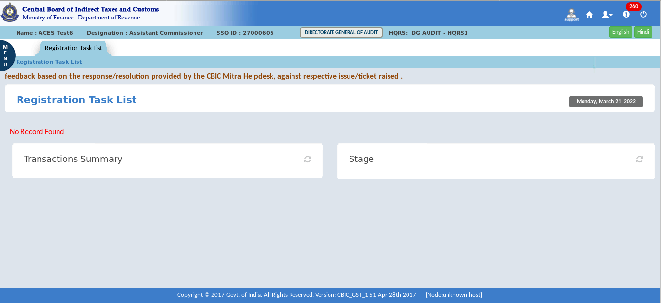
- Click on the Audit.
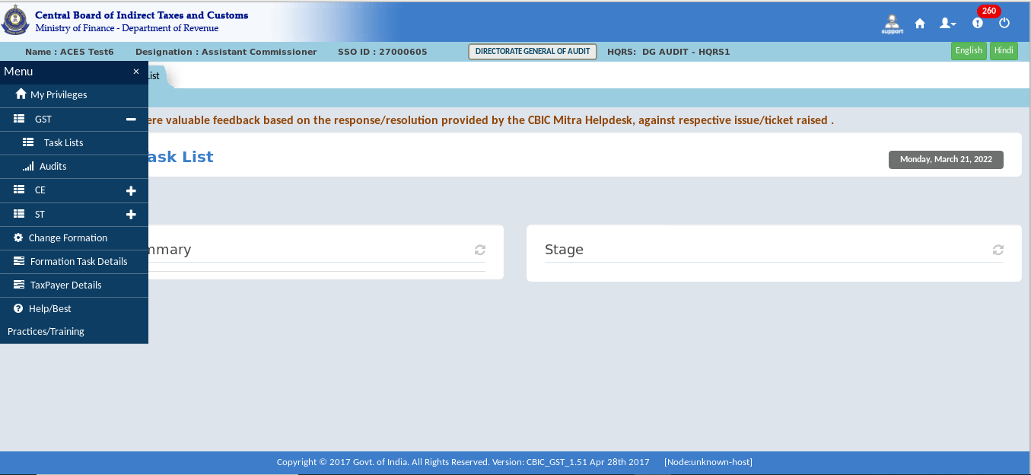

- Click on the Upload unit to view the details.
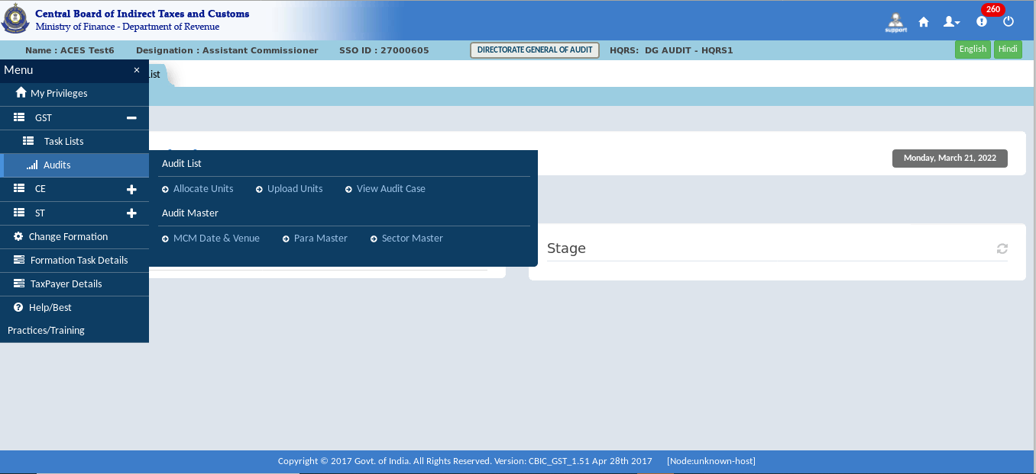
- It displays Upload Taxpayer List and Download Template in Upload unit data.
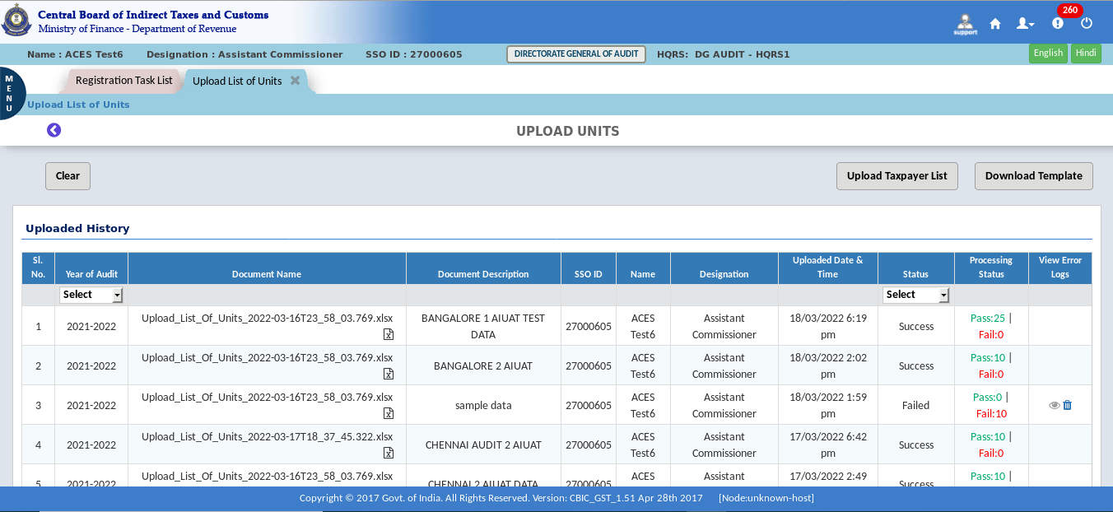
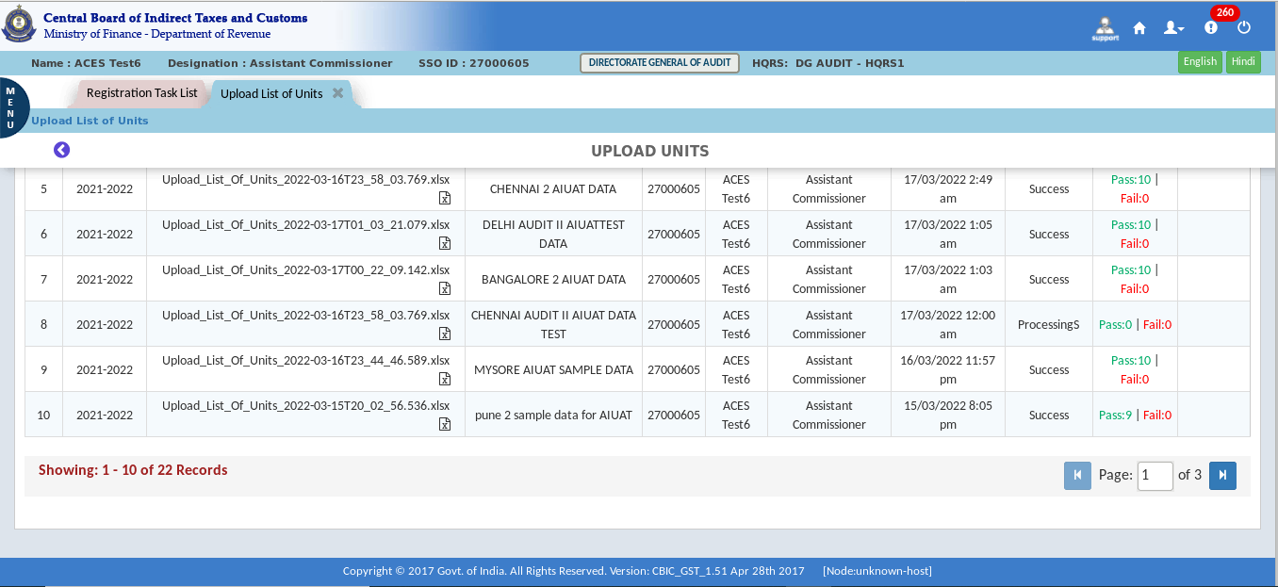
The Dashboard – Upload unit screen displays as shown in the figure above. Initially it will be blank. On uploading the screen will display the data as shown above.
- Click on the Download Template for downloading the Excel file.
- Click on the OK button.
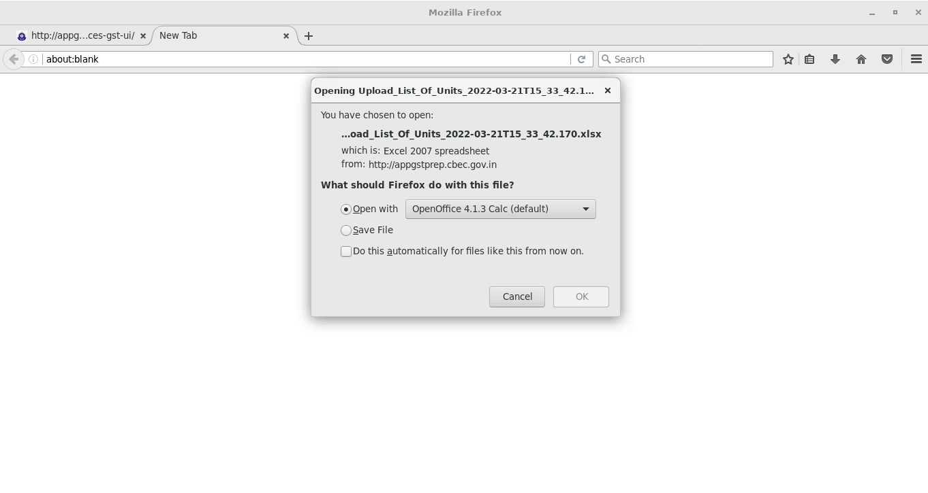

- Fill all the columns in the excel format. Then click on Upload Taxpayer List for Uploading the Excel Template.
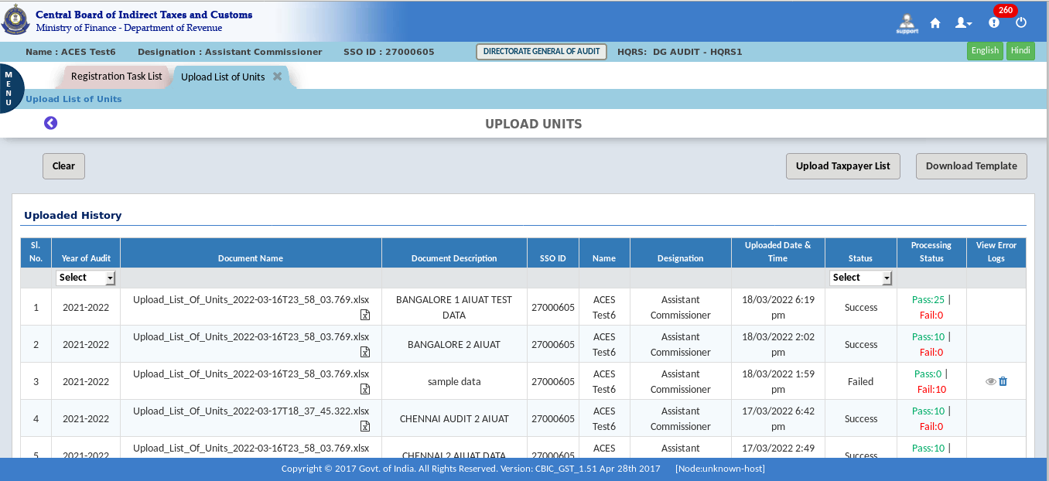
- Click on the Year of Audit.
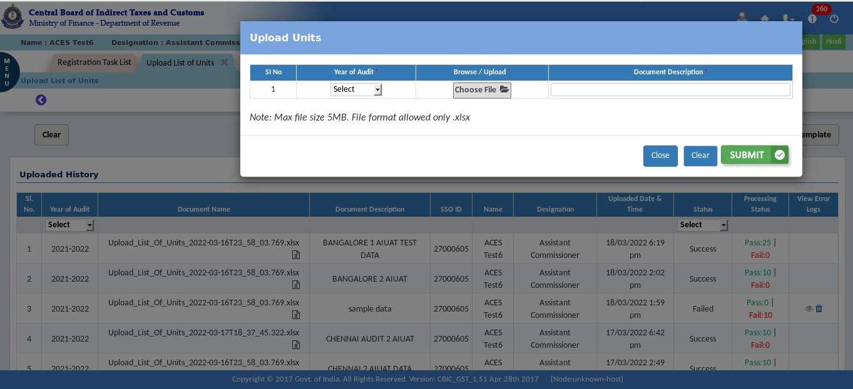
The Dashboard – Upload unit pop-up screen displays as shown above.

- Select the Year of Audit.
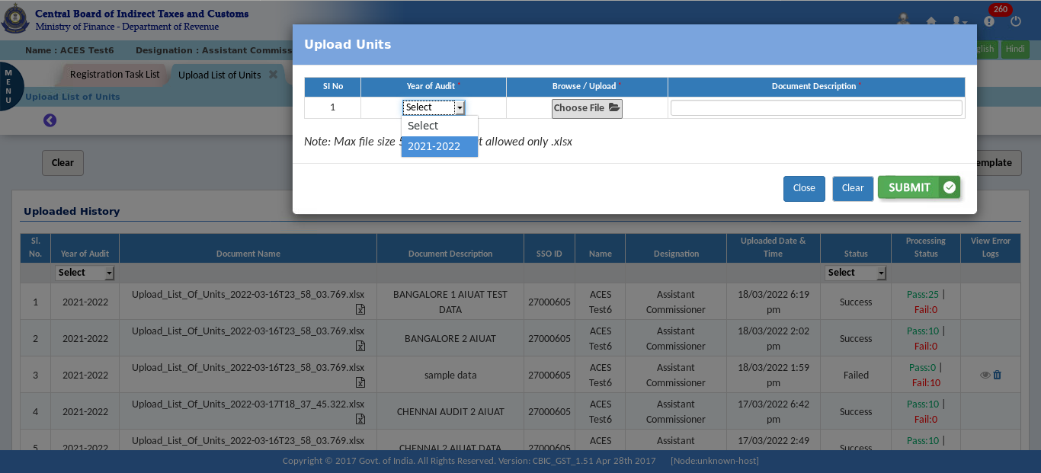
- Click on the Browse/ upload and browse the file.
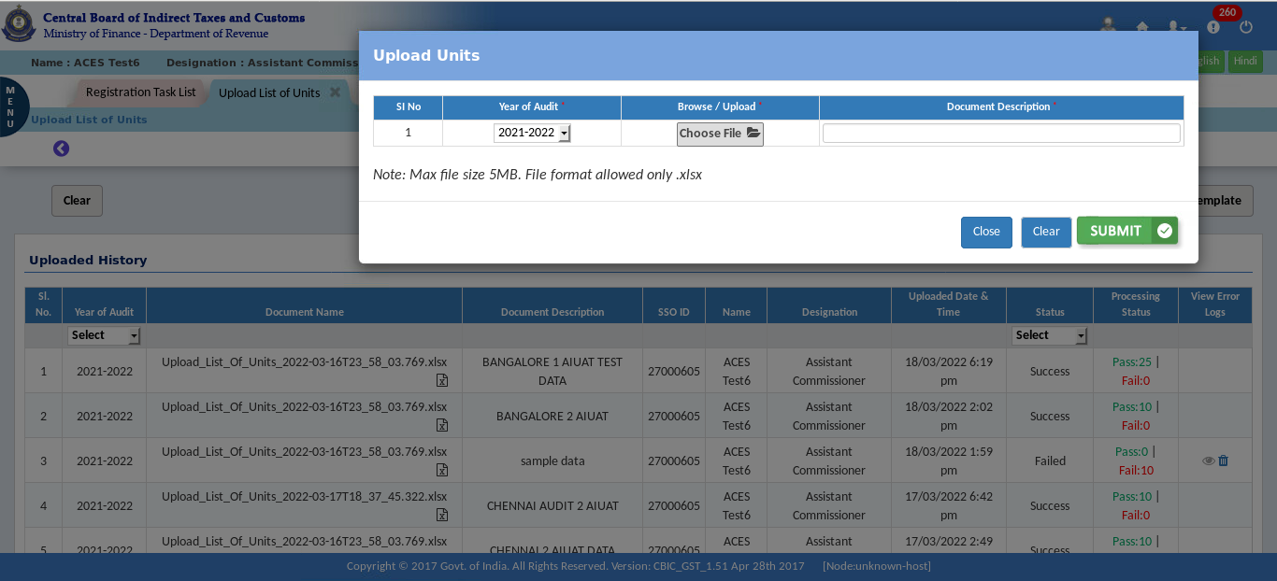

- Select the file and then click on the open button.
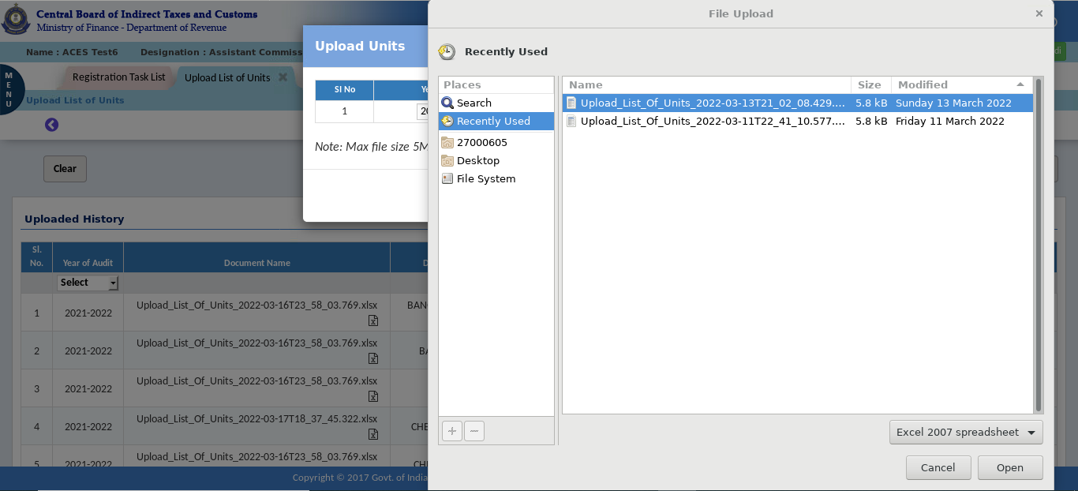
- Fill the document description as required. Check that the excel file is not more than 5MB.
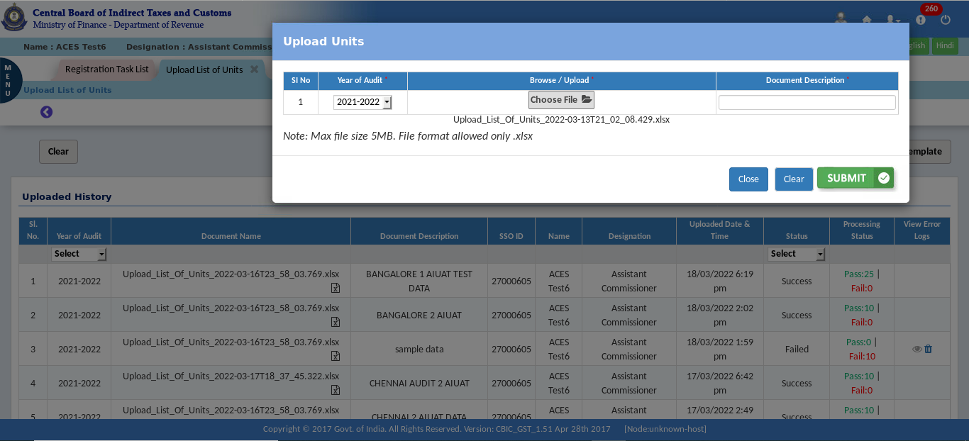

- Click on the Submit button.
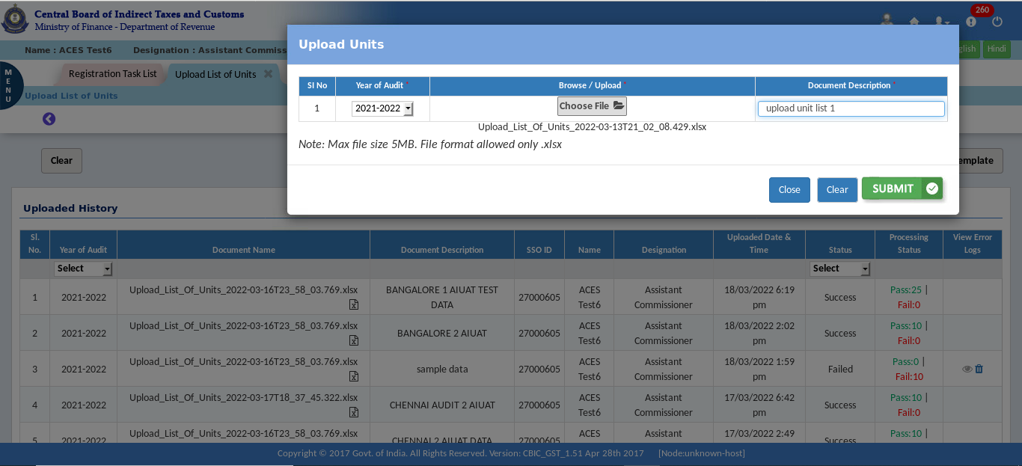
- A Confirmation pop-up appears, Click on the YES button.
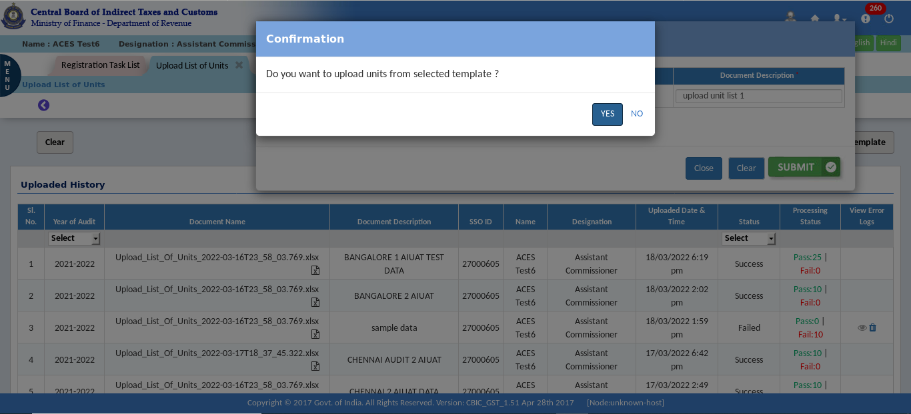

- A success message pop-up appears.
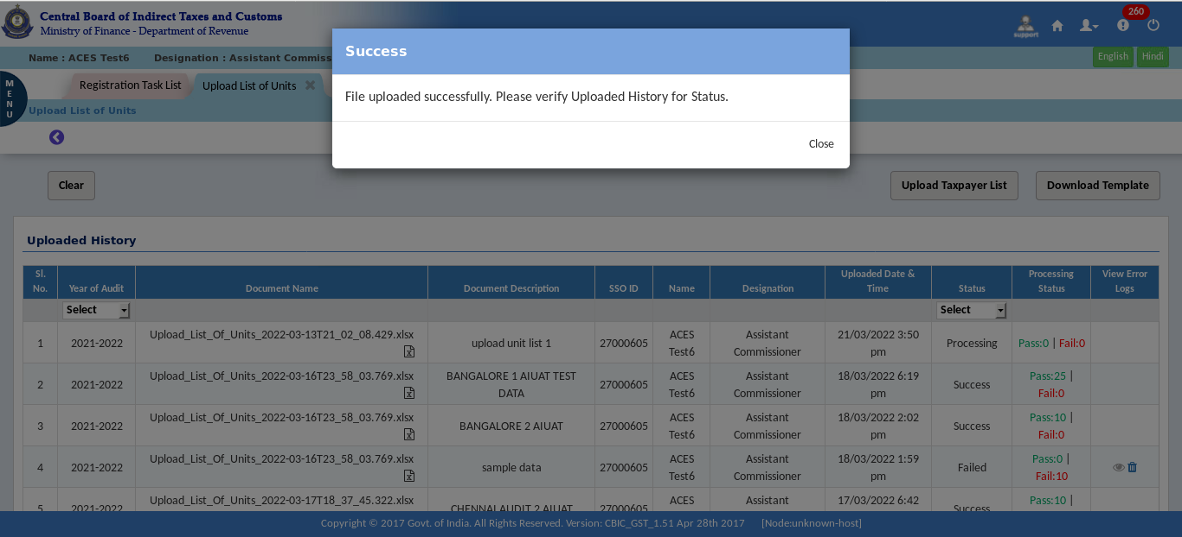
Note: Tax Officer will Upload the unit details and finally submit the request and then system will display the Success Message.
- Click on the Select option Under ‘Status’ column (there are three options Processing, Success and Failed for filtering the upload list.)
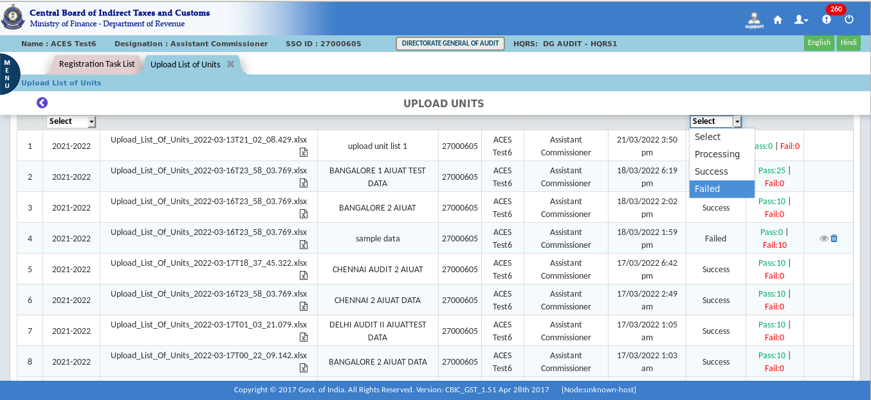

- Click on View Button in the ‘View Error logs’ column for Error Logs.
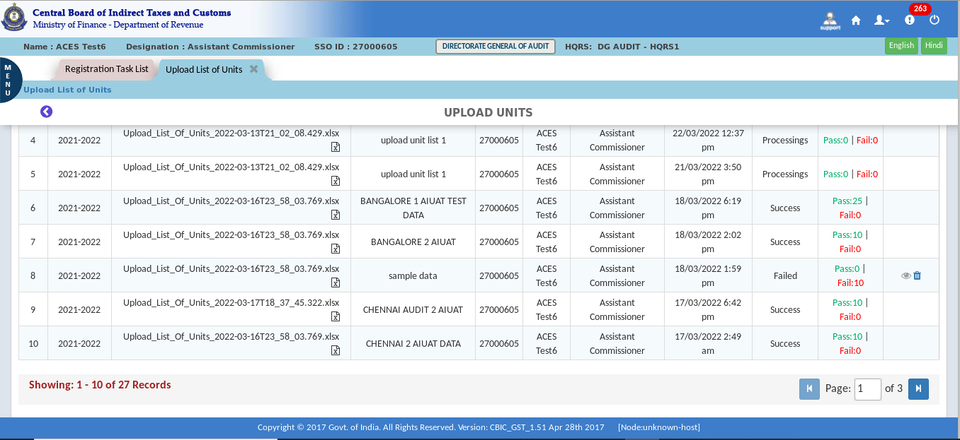
The Dashboard – Upload History screen displays as shown above.
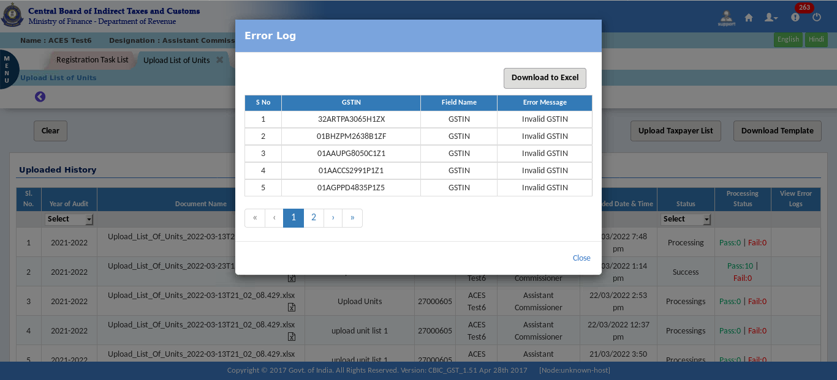
The Dashboard – Upload Unit-Error Log History pop-up screen displays as shown above.

- Allocate Units
Once the units to be audited are uploaded by DGARM / DG Audit they are transferred to the Planning Cells of the Audit Commissionerates based on Jurisdiction as per the Registration Module. In ‘allocate units’ functionality we will be able to allocate these uploaded units to the Audit Circles/Groups within Audit Commissionerate.
Note: From the list of uploaded units, officer from planning cell will have option to delete any unit uploaded by the respective commissionerate/planning cell, if required. (Only the units uploaded in the Category – local by the planning cell can be deleted)
- Click on the Menu tab to display more options.
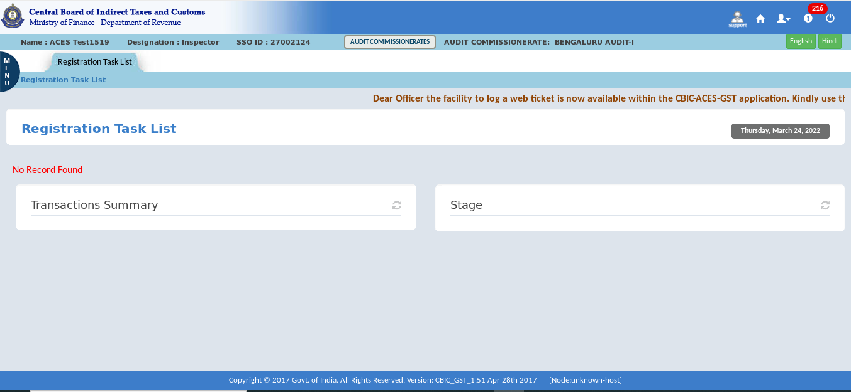
- Click on the Audit tab.
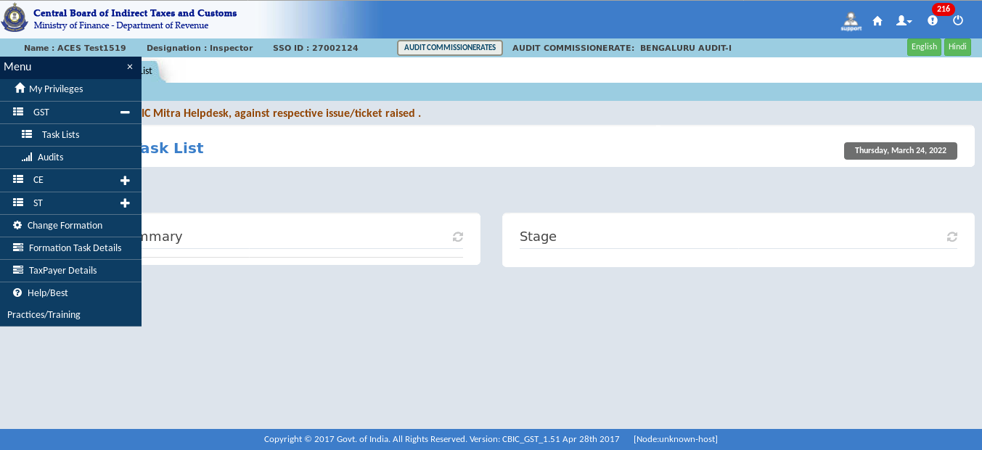

- Click on the Allocate Units for accessing Allocate Unit page.
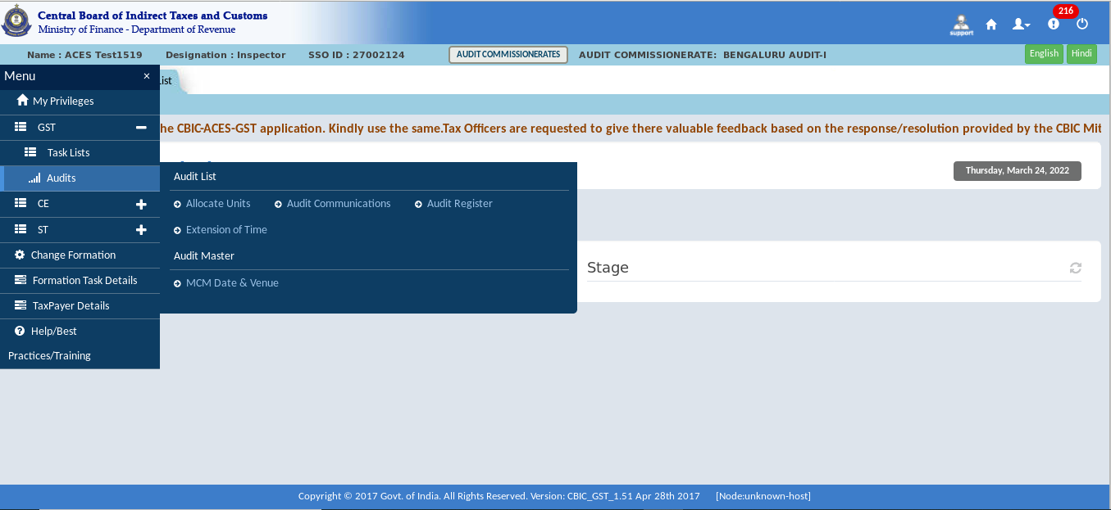
- Click on the Year of Audit and select the year.
- Click on the “Allocate” Button.
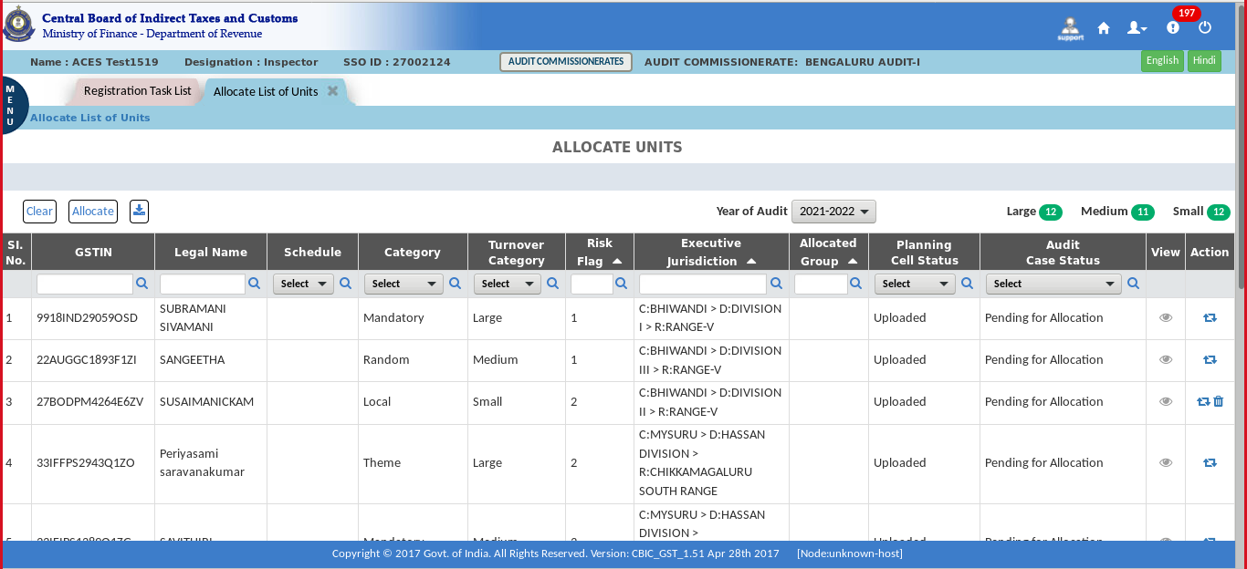
Note: System Displays the Units with their Flag score and audit case status.

- The allocation takes place in two ways, either Random or Custom. By default, the allocation is Random in the system. After selecting the method of allocation select the schedule and the jurisdiction. Custom Allocation, as the name indicates, is the facility to allocate a particular unit/units to a particular Audit Circle/Group. For ‘Custom allocation’ the following procedure should be followed. Click on the Custom under Allocation Type, Select the “Schedule” by clicking on it. After that, click on the "Select Jurisdiction" button. Select Commissionerate / Circle / group.
- Select the officer as approving authority. Click on Submit button.
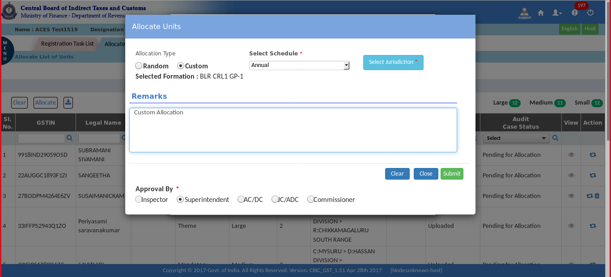

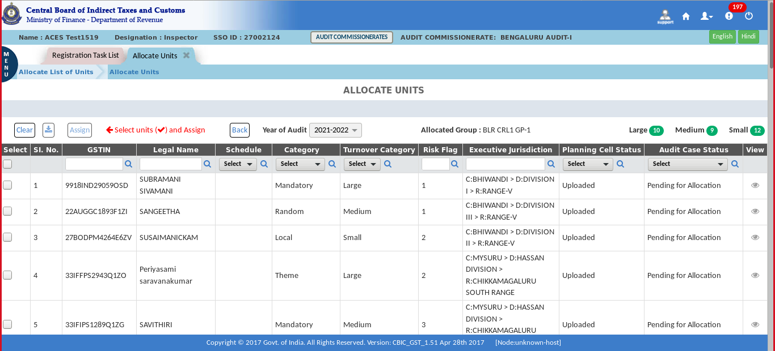

- You can select the units for allocation. Click on the View icon for taxpayer details.
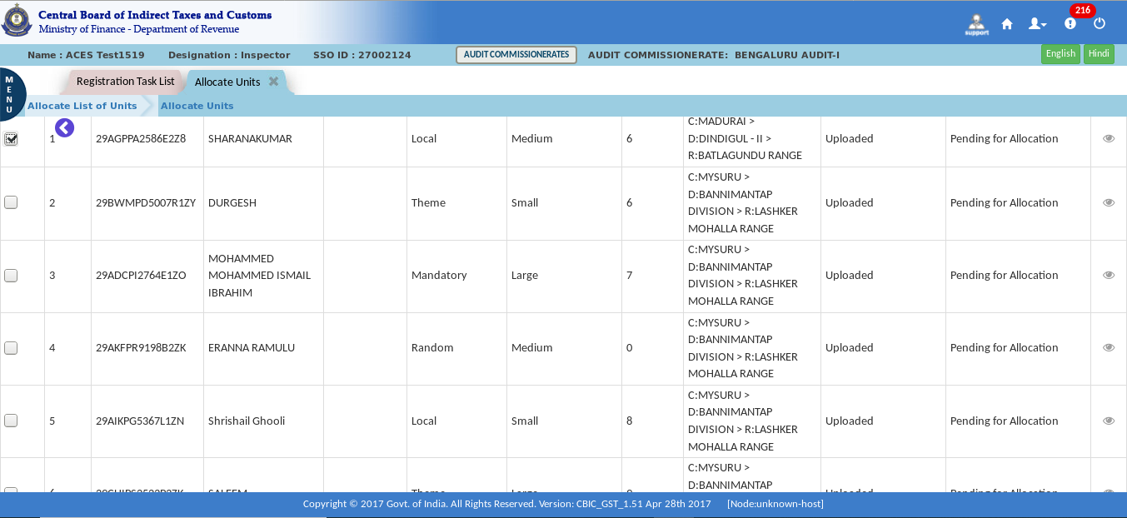

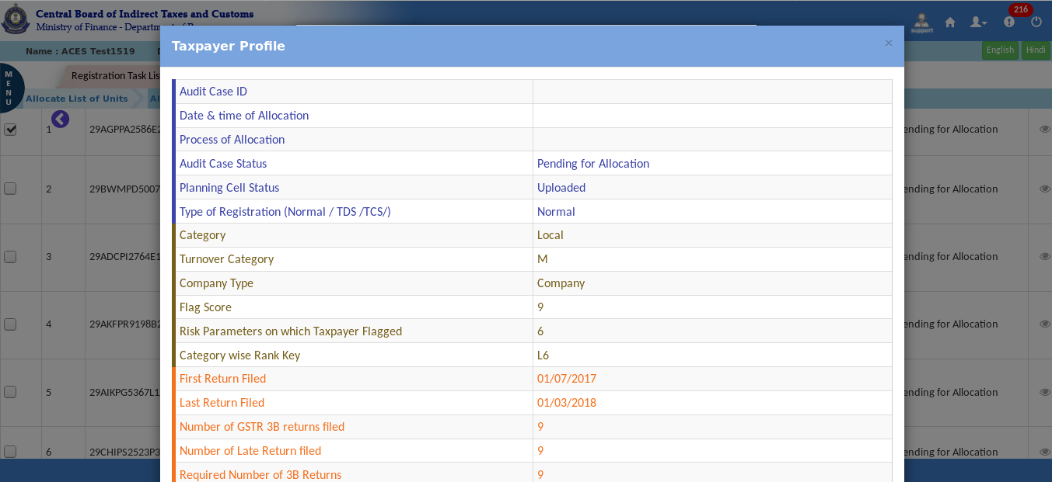
The Dashboard – Taxpayer Profile pop-up screen displays as shown above.

- Enter the GSTIN under GSTIN tab and click on the search icon (A facility to search a particular GSTIN)
- Select the GSTIN and click on Assign Tab.
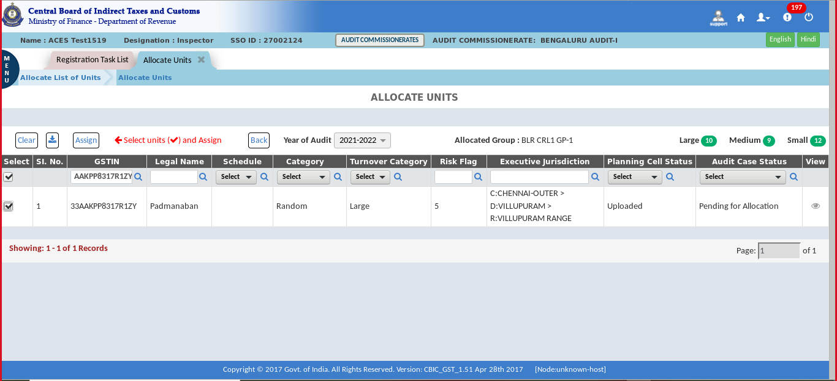
- Confirmation pop-up appears, click on Yes for confirmation.
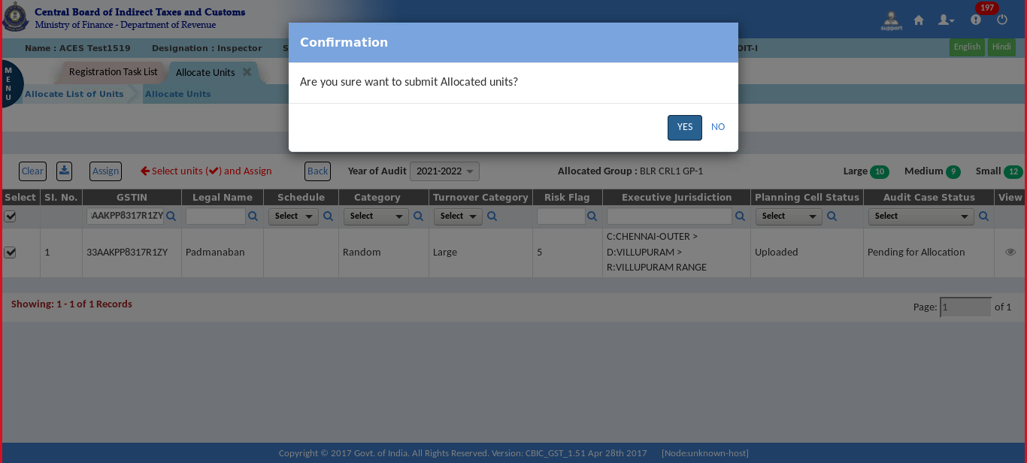

- A success message pop-up appears.
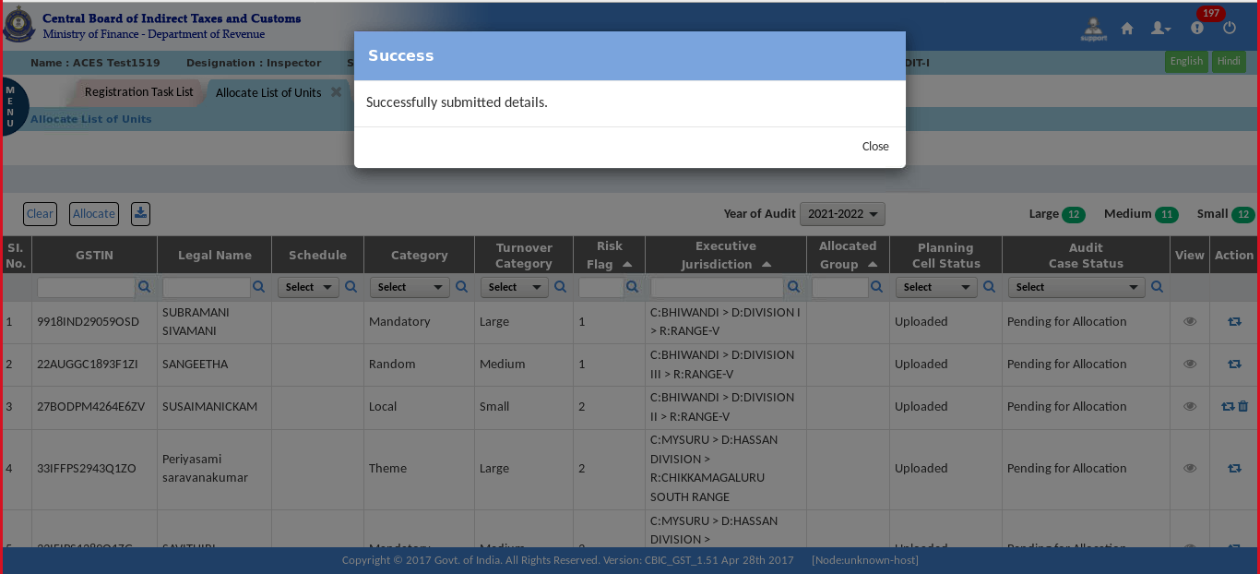
Random Allocation:
- Click on “Random” in the Allocation Type.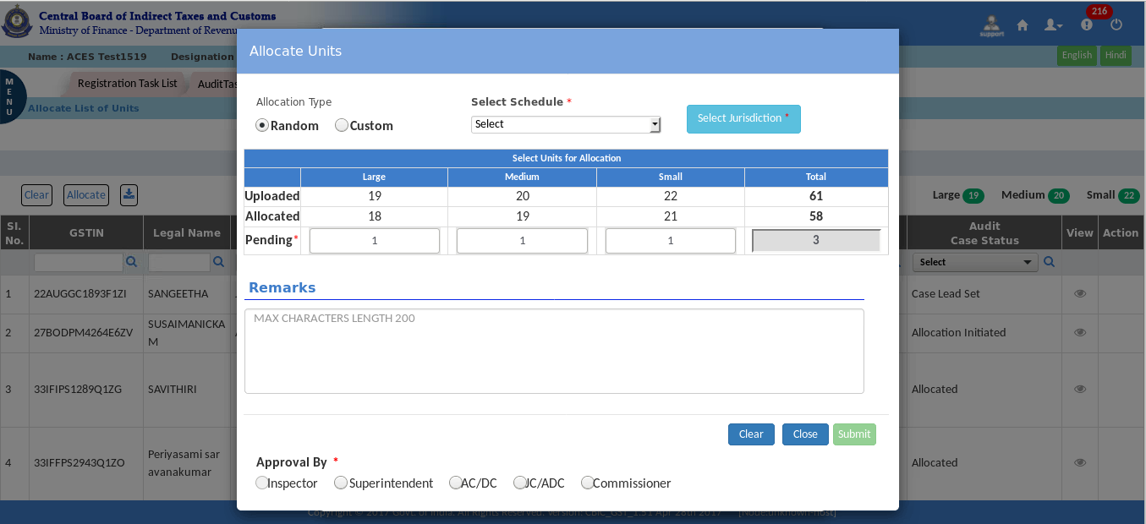

- Click on the Select Schedule. And select the required option (Annual, JFM, AMJ, JAS, OND).
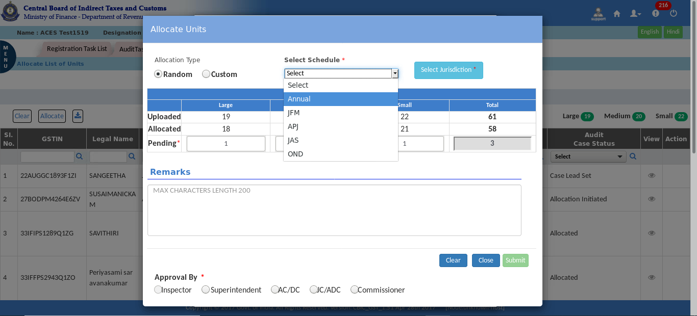
- Click on the Jurisdiction and select the respective jurisdiction – Commissionerate, circle and group.
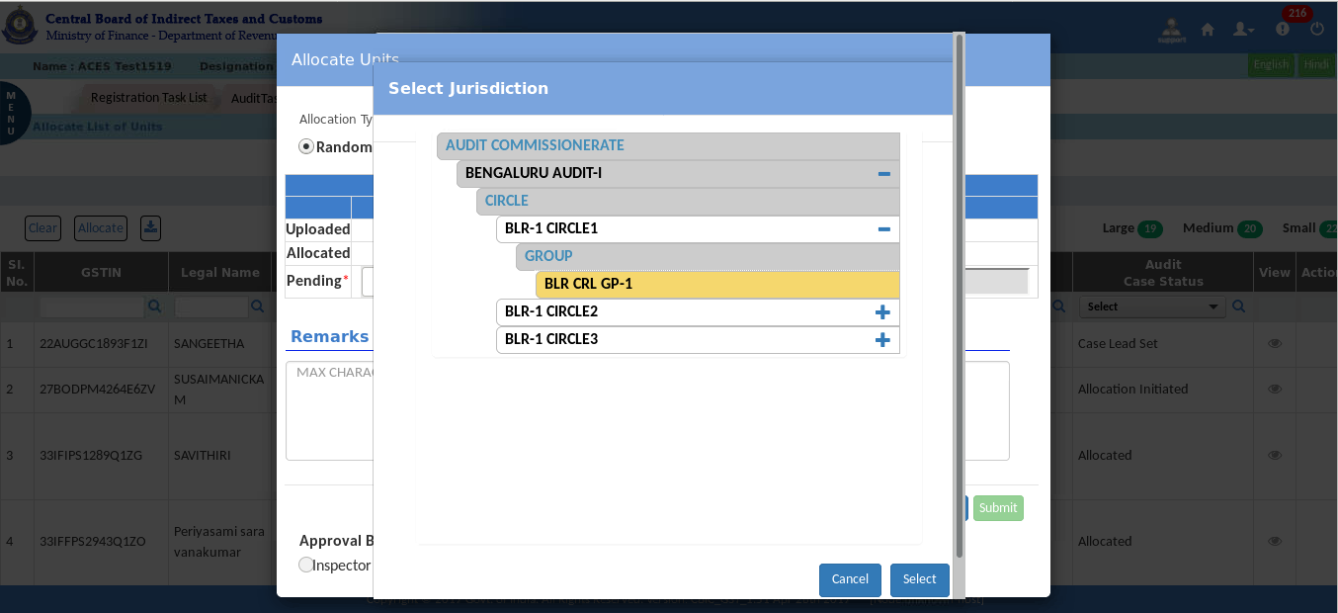

- Select the approval officer and click on the submit button.
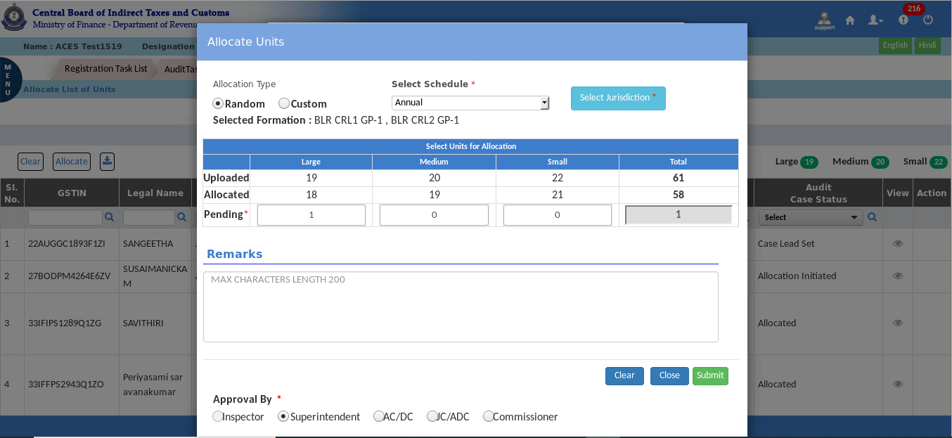
- Confirmation pop-up appears, click on Yes for confirmation.
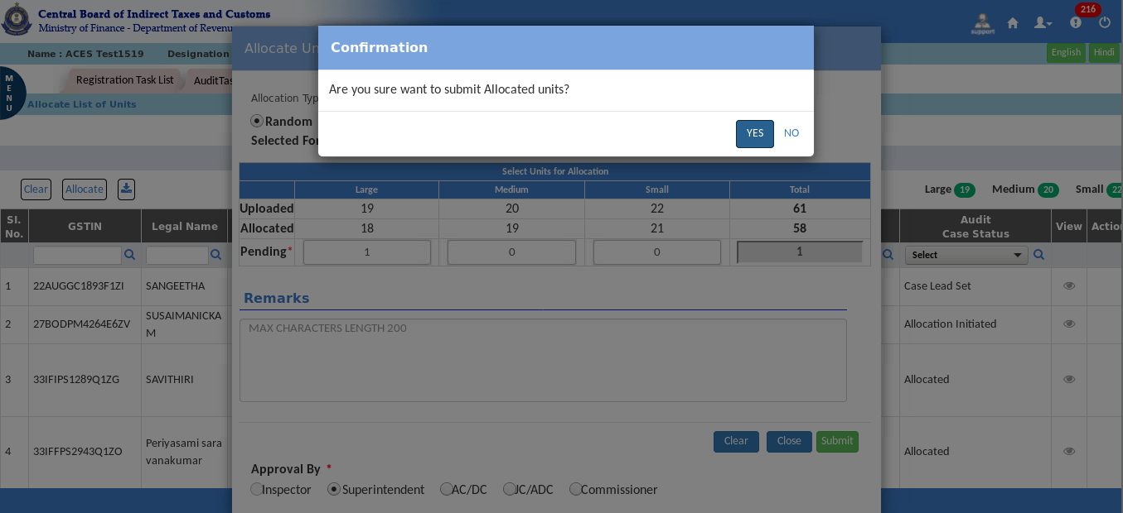

- A success message pop-up appears.
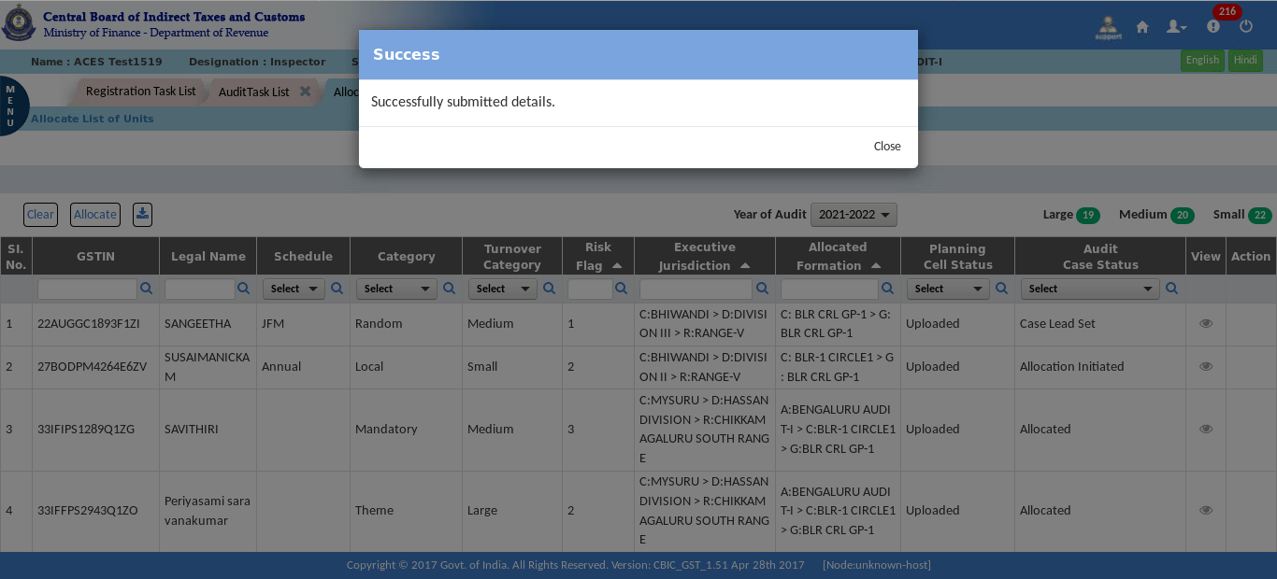

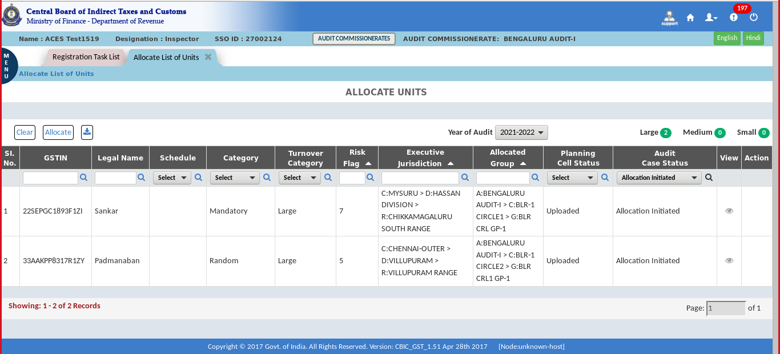
Note: After submitting the request, allocation process is pending for the approval of the officer selected for approval. The approval process is the task-based action. The list will be pending as task in the next level officer. Only the officer selcted for approval at the time of initiation can approve the allocation. (In the above illustration Superintendent has been selected as the approval authority)

RSP (Superintendent) Login:
- Click on the Menu > Task Lists > Audit.
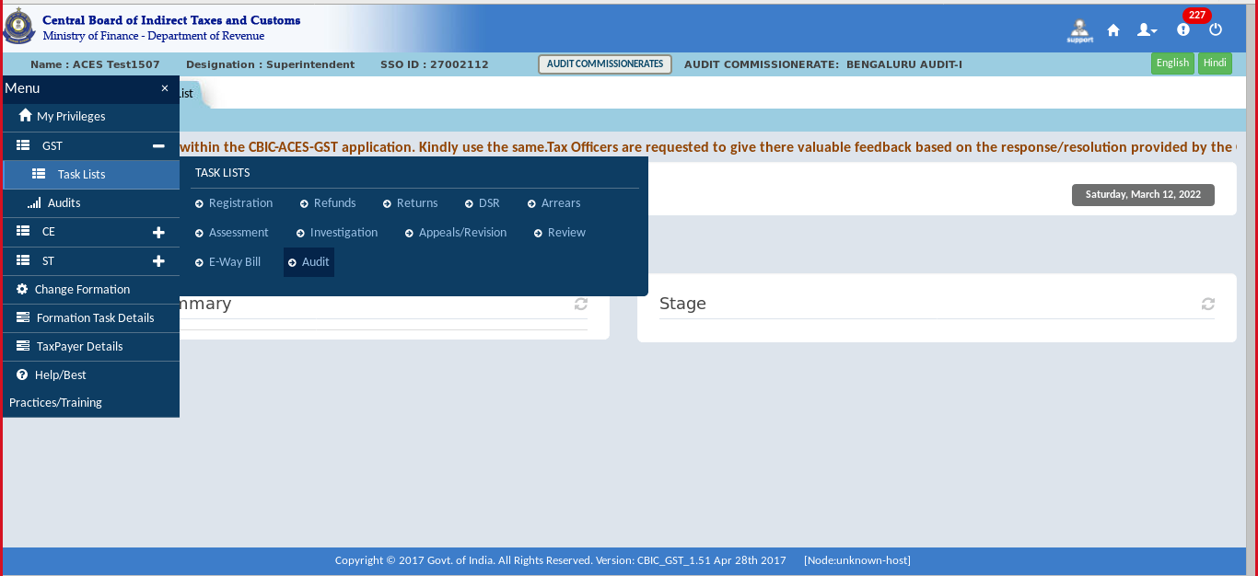
- The ‘Audit task list’ screen will be displayed. In the stage section for the Audit Allotment, click on "Pending for the approval with Supdt."
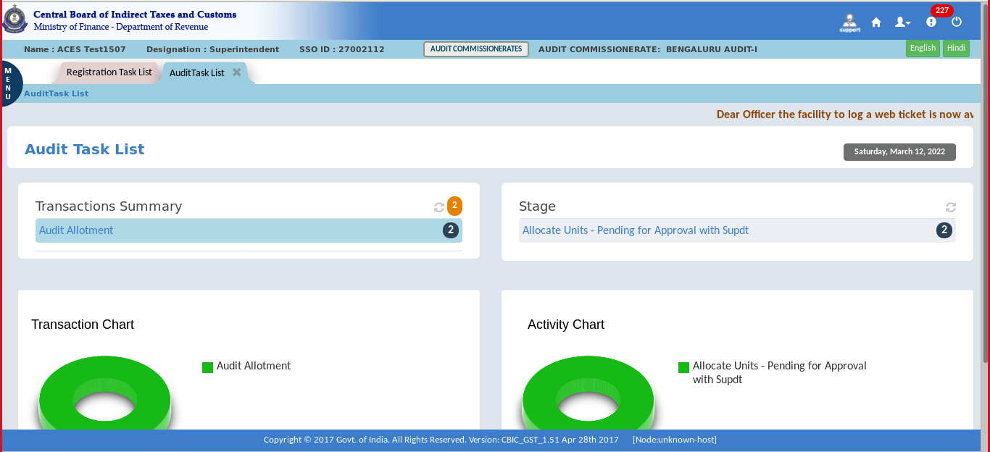

- As the approval authority has been selected as ‘Superintendent’ in the illustration Superintendent can either approve or he can change the approval authority and submit the request to AC. Click on the Request Number.
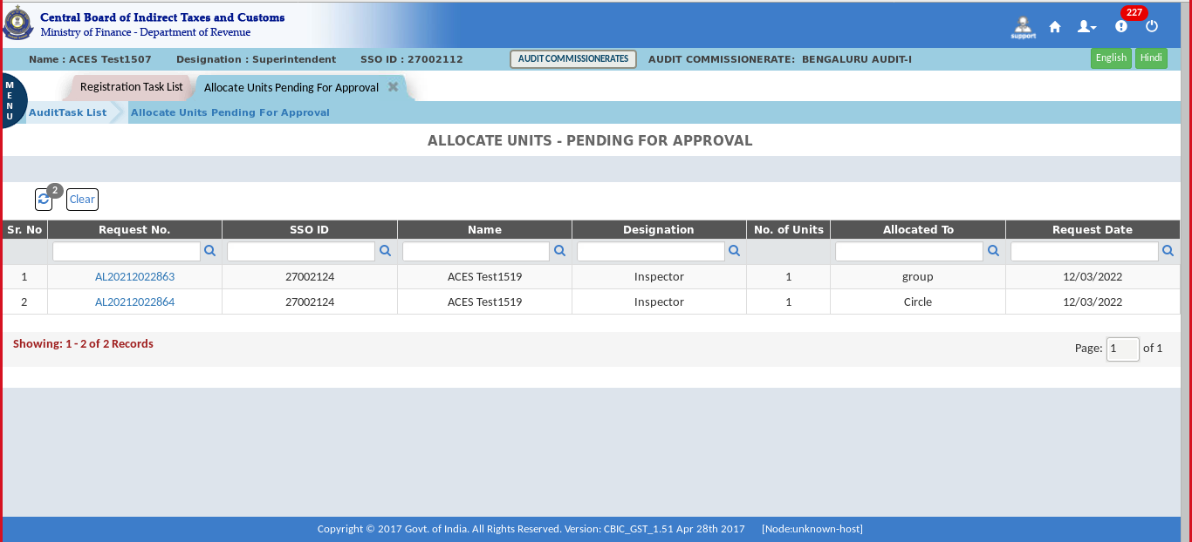
- Select the Approval Authority by clicking on the given option.
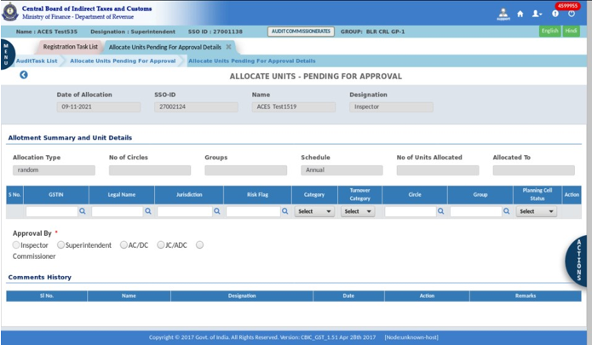
Note: Approval authority should be selected at the time of Random or custom allocation process. Here the option is given for selecting a higher authority for approval.

- Click on the Submit for the approval.
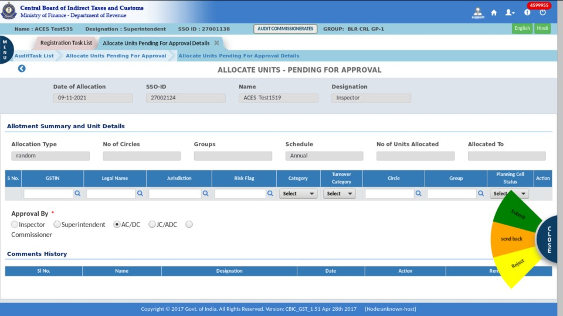
- Click on “Yes” for submitting the request for approval.
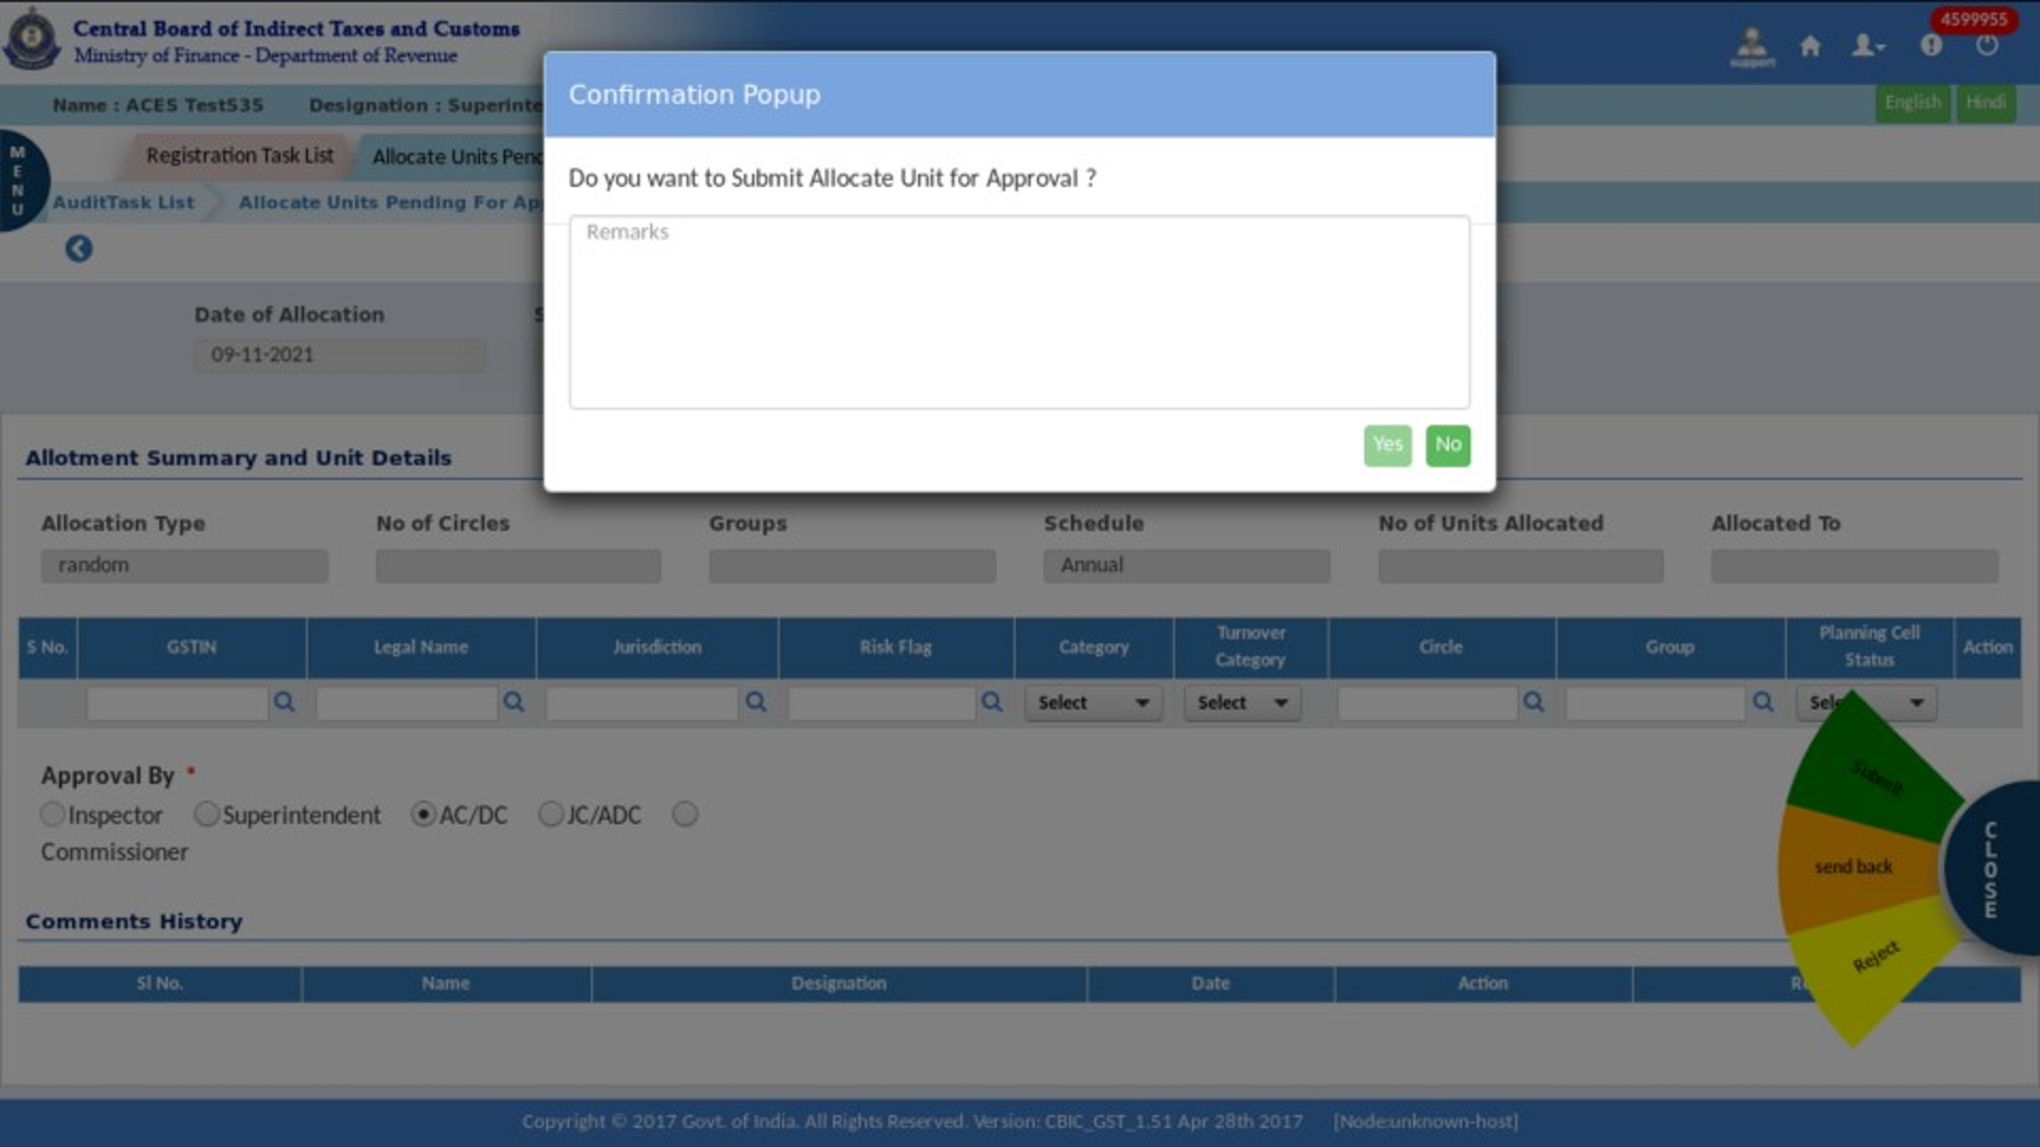

- For sending back to the officer, select the "send back" option and then click on "yes" for confirmation.
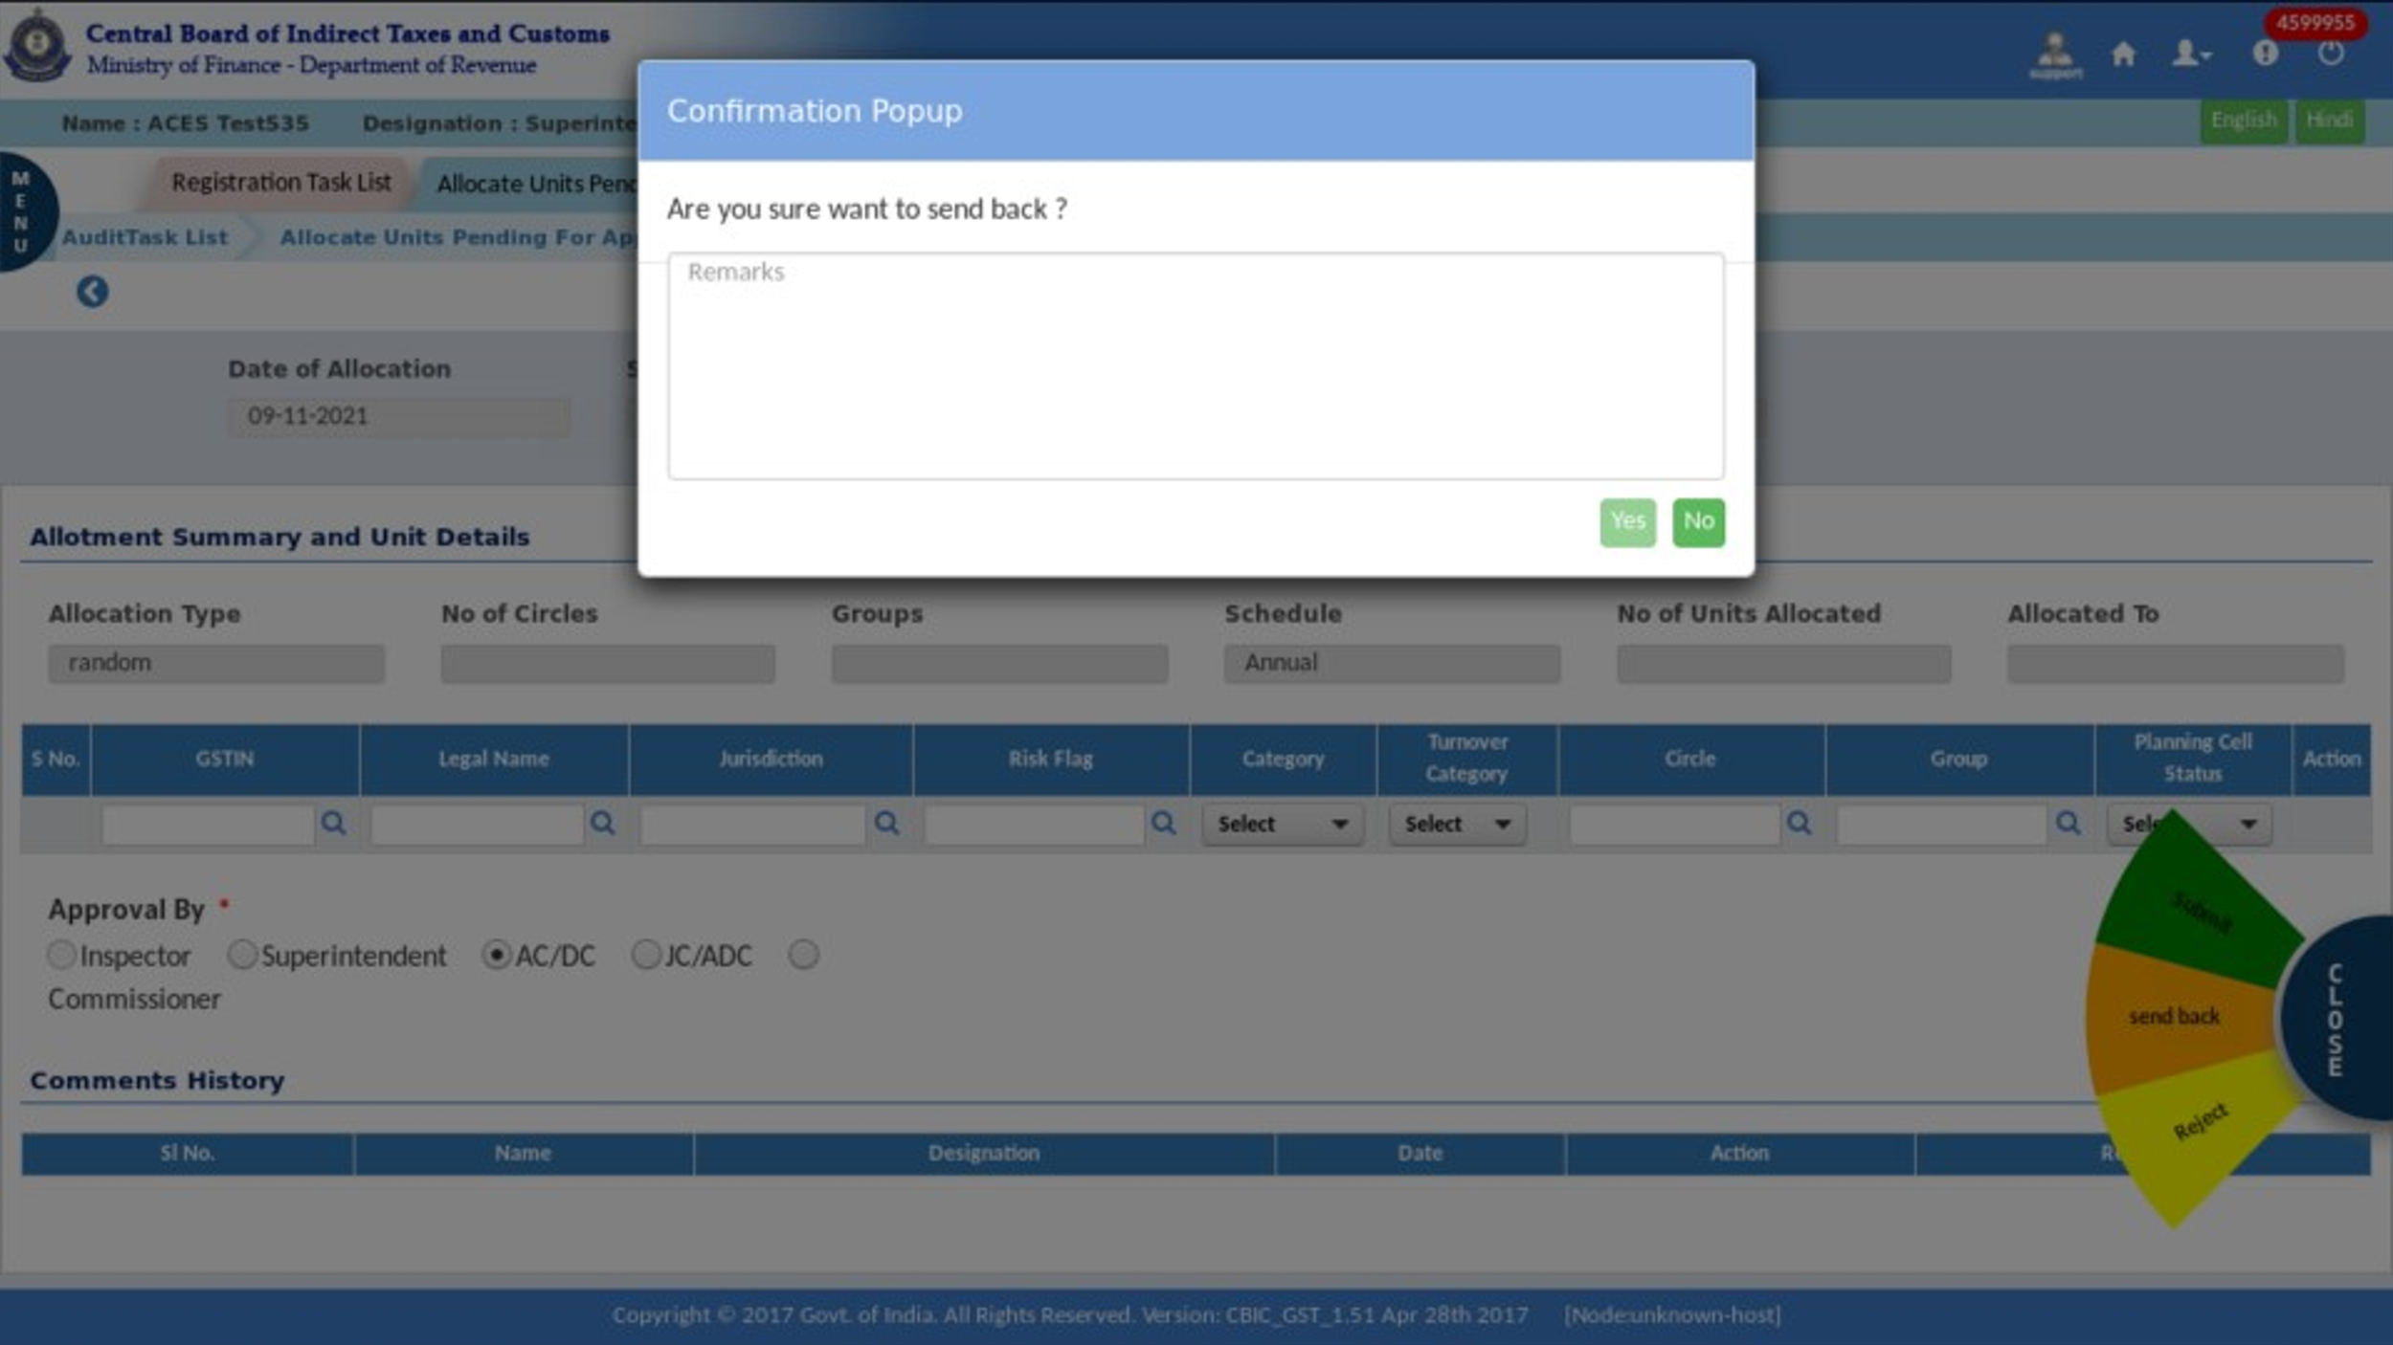
- For rejecting, select the "Reject" option and then click on "yes" for confirmation.
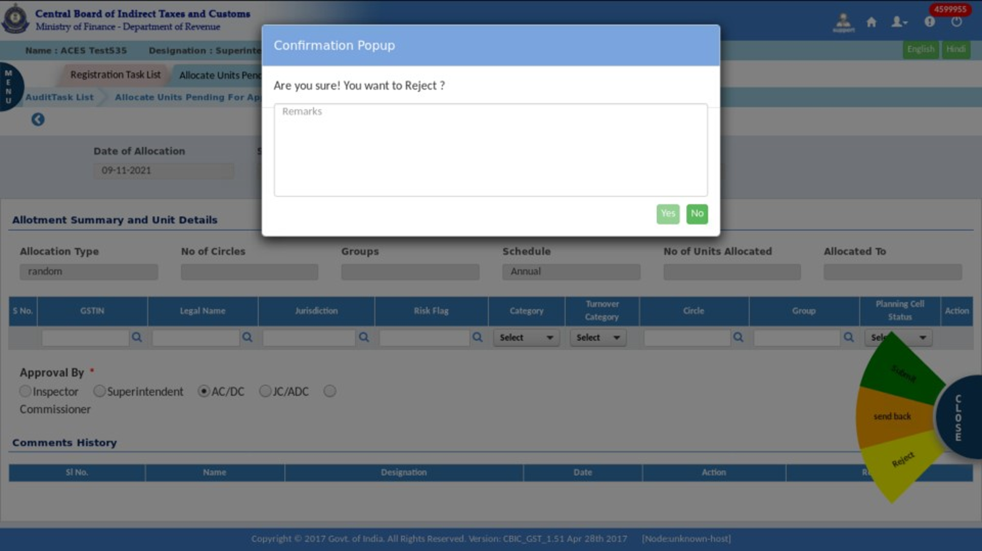
Note: The process of approval of the Allocate Unit is the same in both cases, whether it is "Random" or "Custom".
- Set Case Lead
Once the allocation is done in the group, the units will move to the the Circle AC/DC/Planning cell screen for assigning a Case Lead for the Audit Case. Circle AC/DC will select the case lead and list of auditors.
- Set case lead/auditor is task based.
- This transaction will be permission based, so whoever given permission will be able to access and perform actions.

- Click on the Menu > Task Lists > Audit.
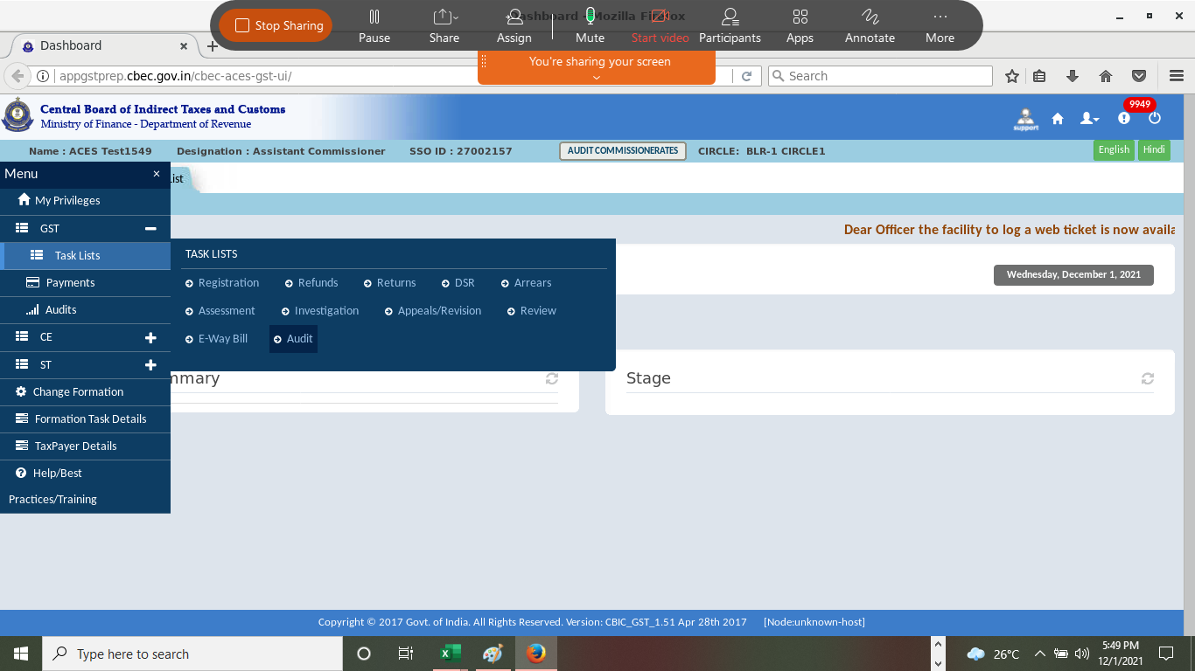

- In the stage section for the Set Case Lead, click on "Pending for the approval with AC."
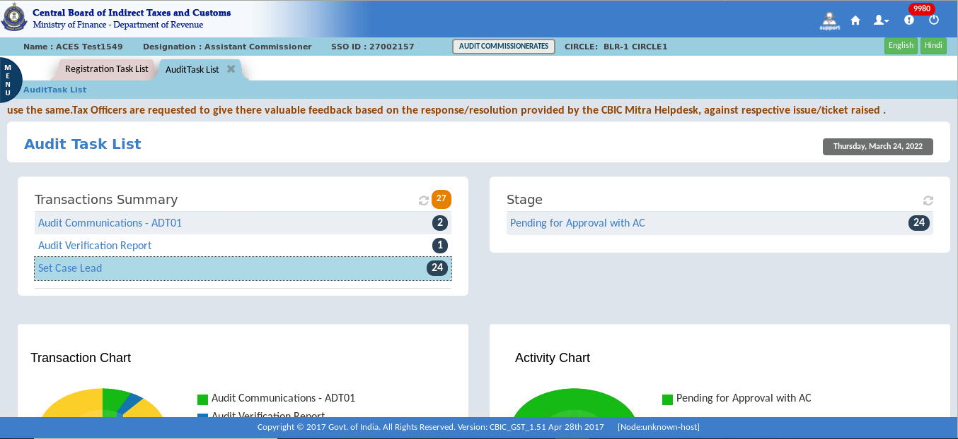
- The list of units allocted to the particular Circle will be displayed. From this list units can be selected for assiging a Case Lead. First, we have to select the required "Year of Audit”. And then click on “GSTIN.”
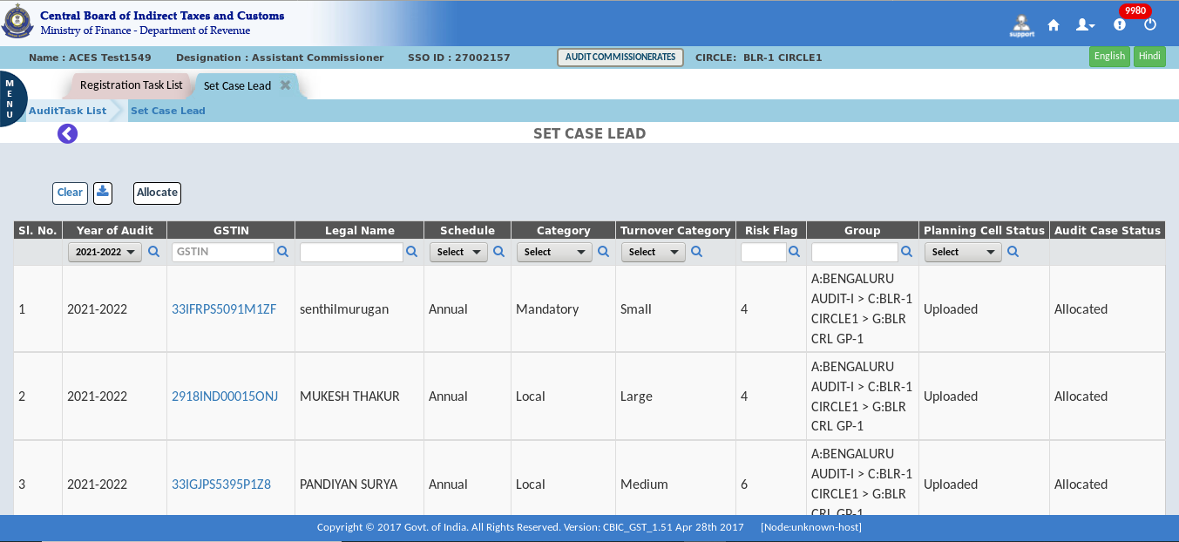
The Dashboard – Set Case Lead screen displays as shown above
Note: The officer can select the required "Year of Audit” ( or GSTIN, Legal Name, Schedule, Category, etc.) from the above drop down, so that the system will validate/filter and only display the units based on the selected Year of Audit and logged in formation. This is a search facility where we can use various inputs to get the data required. Set Case Lead functionality can be used for one GSTIN at a time.

- Once you click on the GSTIN the screen displays the following screen. The Case Lead tab displays the Case Lead and Auditor tabs. Click each tab to see the detailed information.
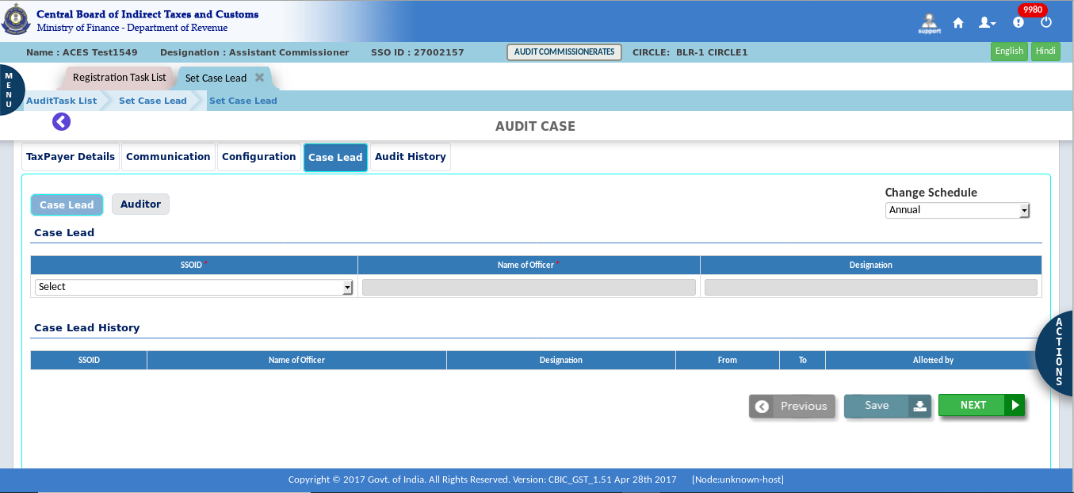
- Click Case Lead. Then Select the SSO ID or Name of Officer for set case lead from the available list. Officers mapped to the jurisdiction will figure in the list.
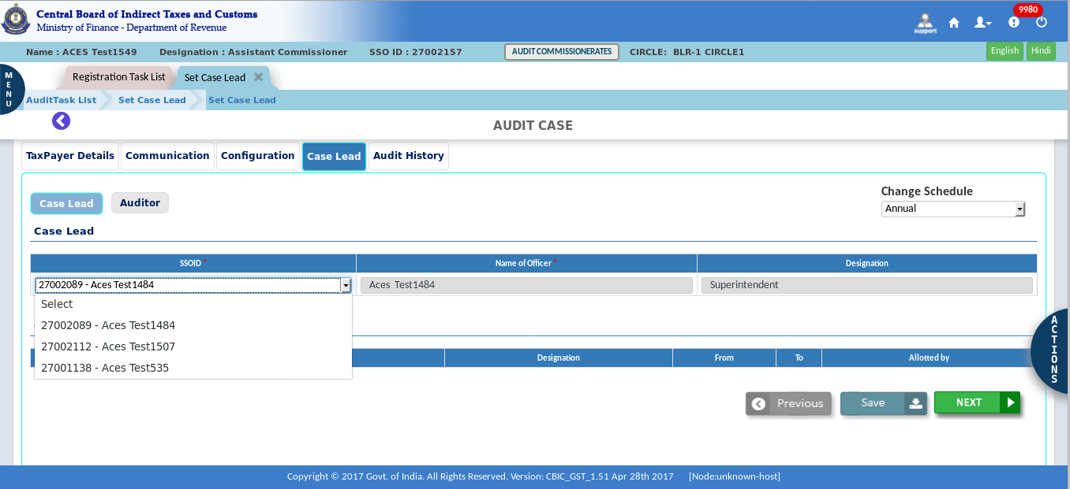

- Click on the Save button and then the confirmation pop-up appears.
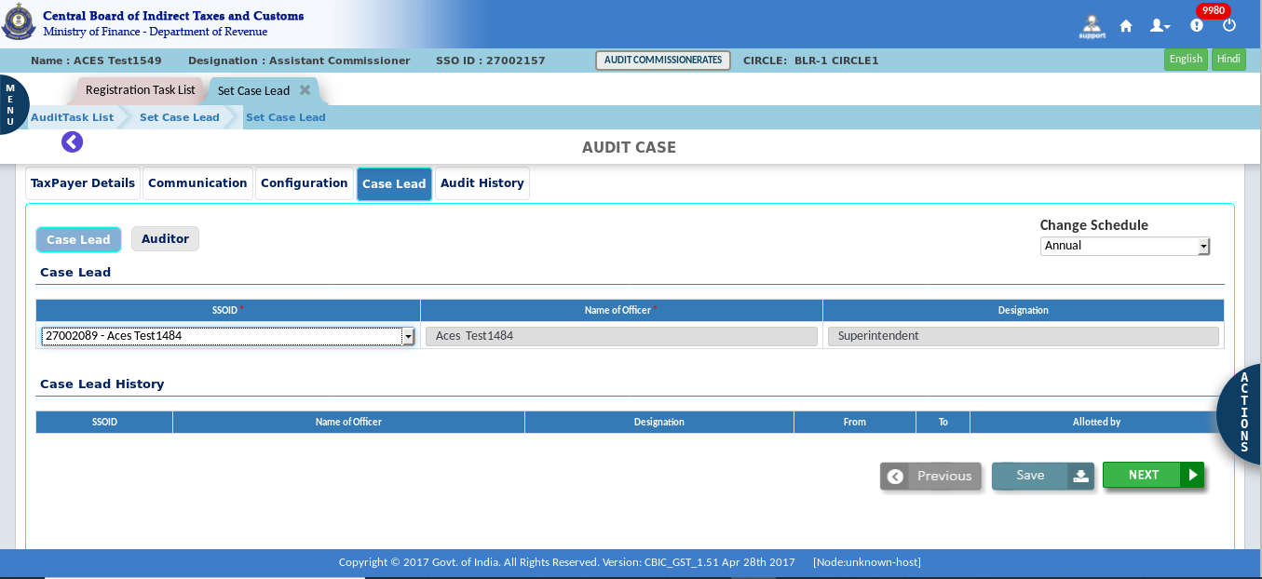
- Click “yes” to save records.
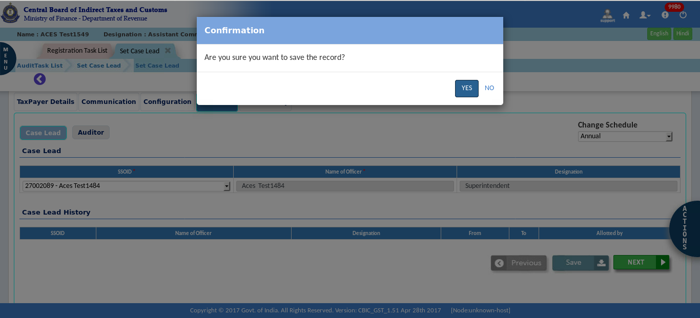

- A success message pop-up appears on the screen.
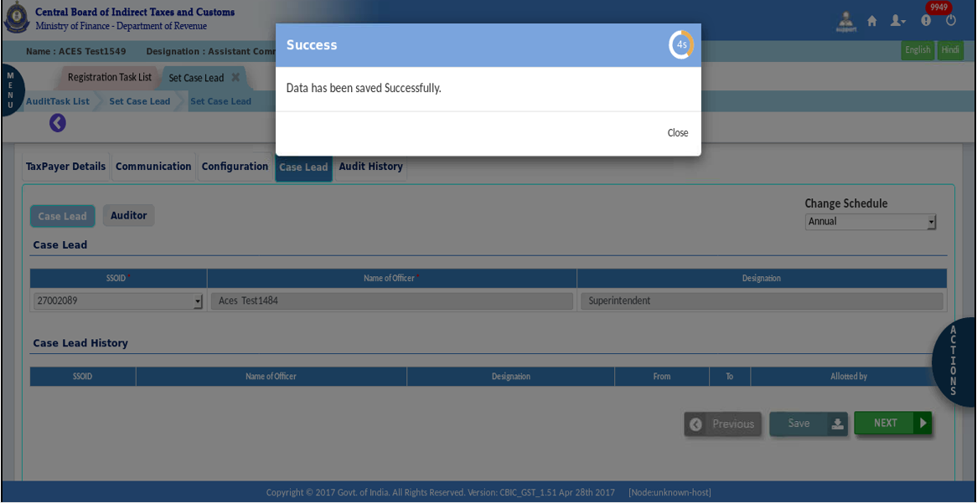
- Click on the Auditor tab to select the auditor. The procedure is the same as Set Case Lead. Select officers from the drop down and save.
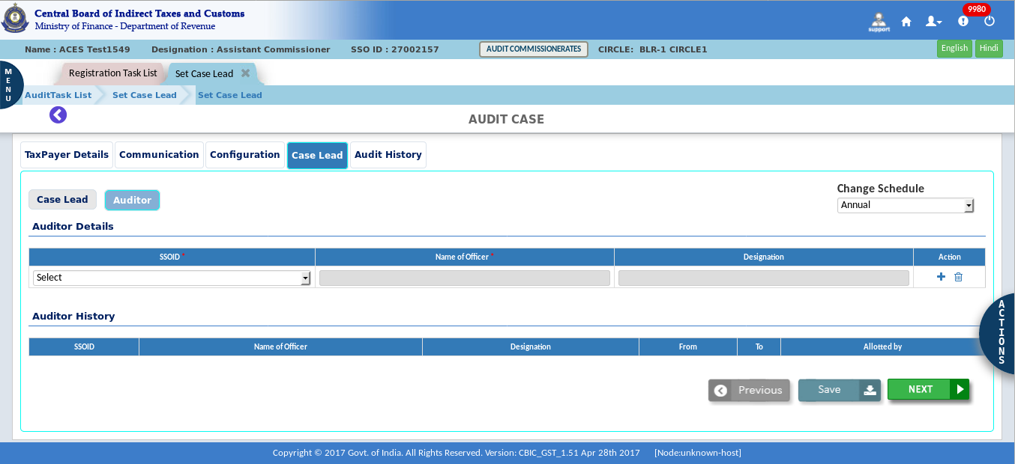

- Click on the Plus Button for adding multiple auditors.
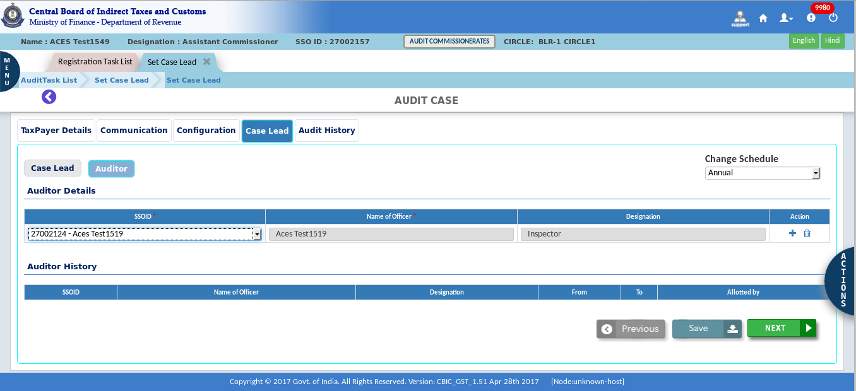
- Select the second auditor.
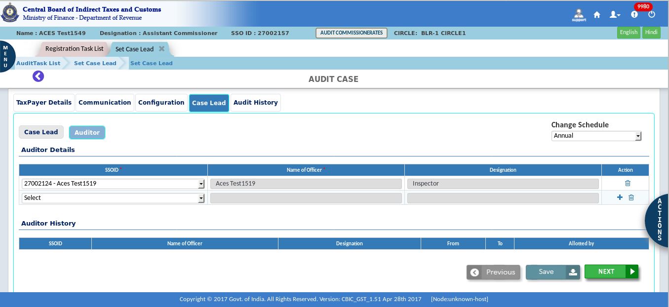

- Click on the “yes” button to save records.
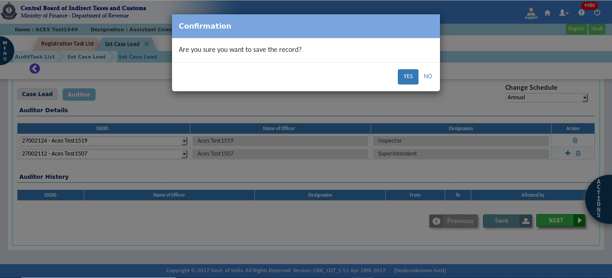
- A success message pop-up appears on the screen.
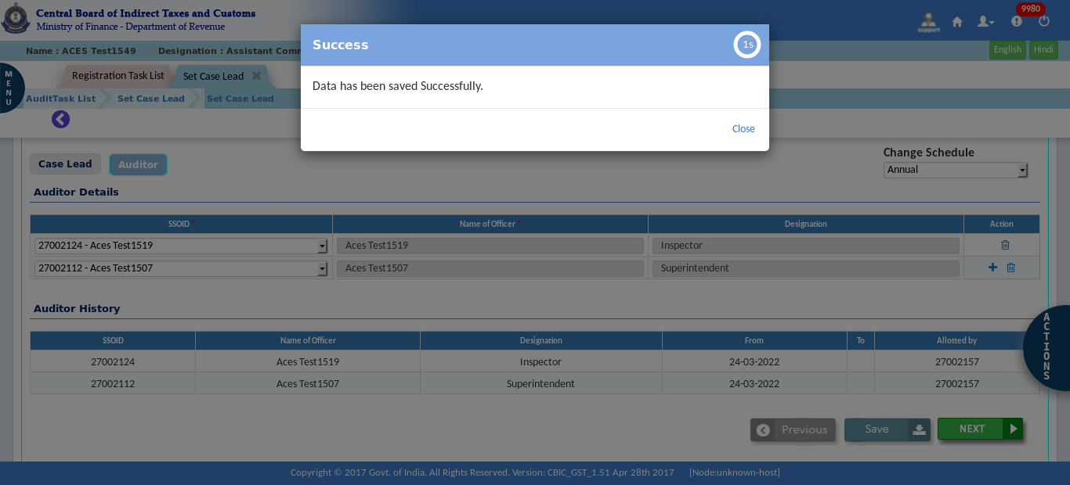

- Click on the “Submit”. On clicking Submit button the Case Lead and Auditors details are saved. No further approval process is required. A Case reference number is generated internally and the unit will be available for the Case Lead to generate ADT-01.
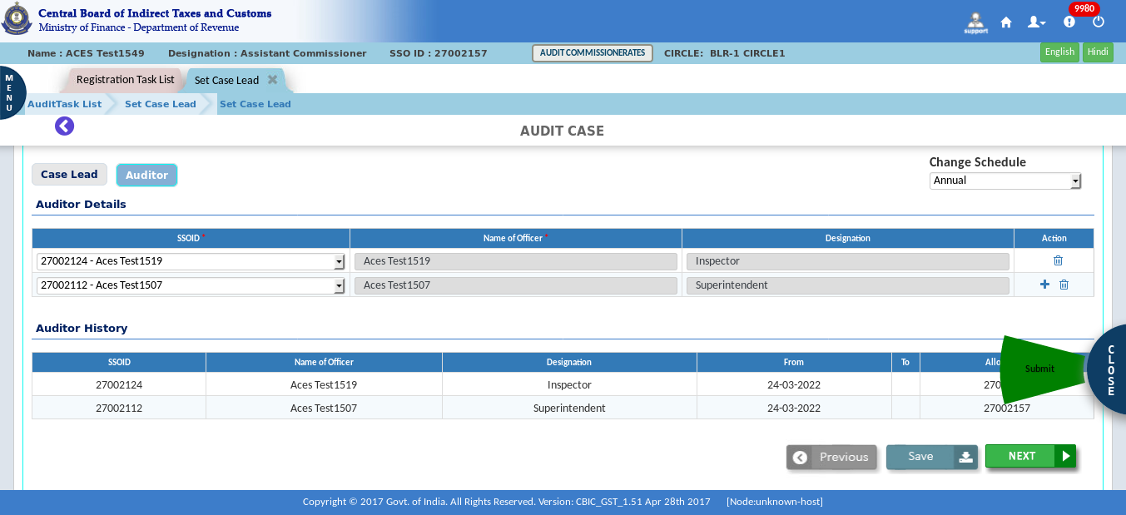
- Confirmation pop-up appears. Write remark and click on the “Yes”.
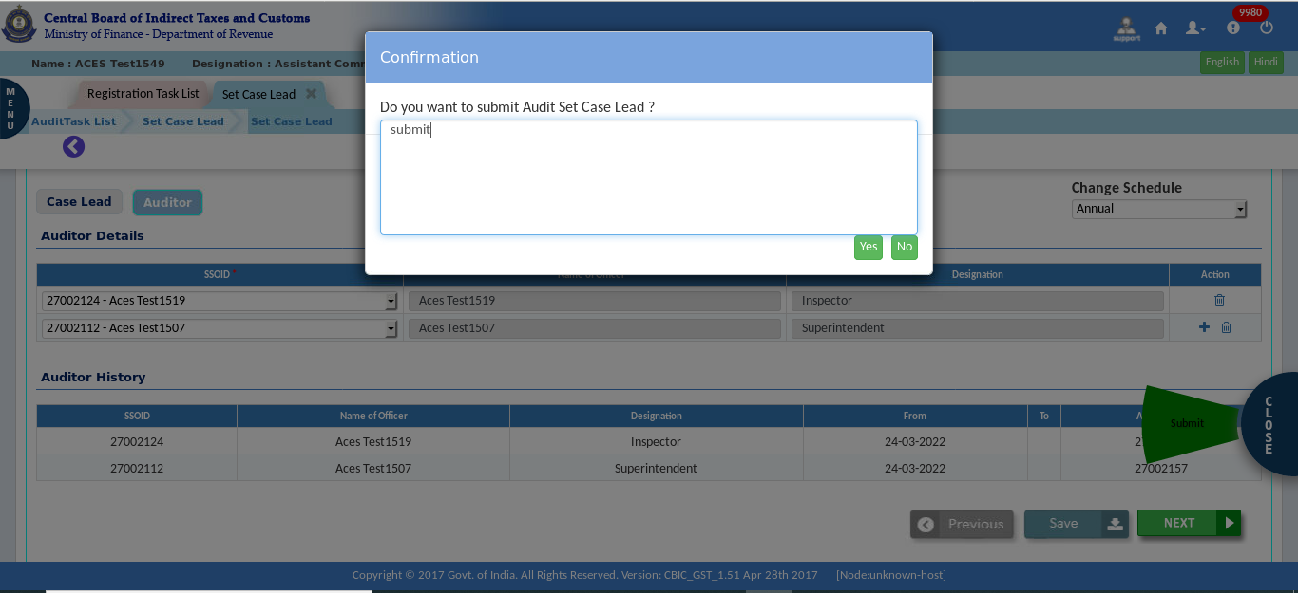

- A success message pop-up appears on the screen.
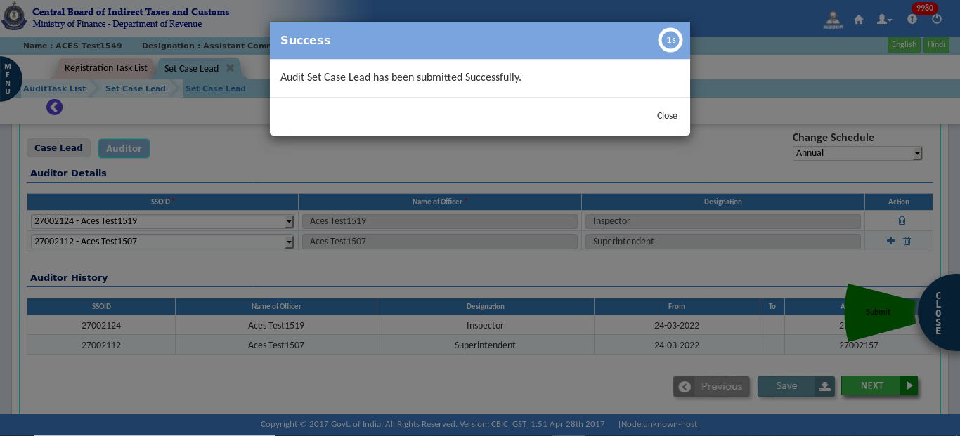

- Issue ADT 01
Once the case lead is defined in the system and audit Case Number is created, the issue of ADT01 will be a menu option. The Tax Officer at Group Level will draft the ADT 01 and submit the same to Circle AC for final approval. Finally, Circle AC will issue the ADT 01 to the taxpayer through the GSTN API. Validation will happen in the other process to check if ADT01 was issued.
Once ADT 01 is issued to the taxpayer, then the tax officer can enter the details such as the date of visit of the premises, document submitted dates, etc.
Note: At the group level, the Tax Officer (here Inspector) can also send back/submit and approve this ADT01.
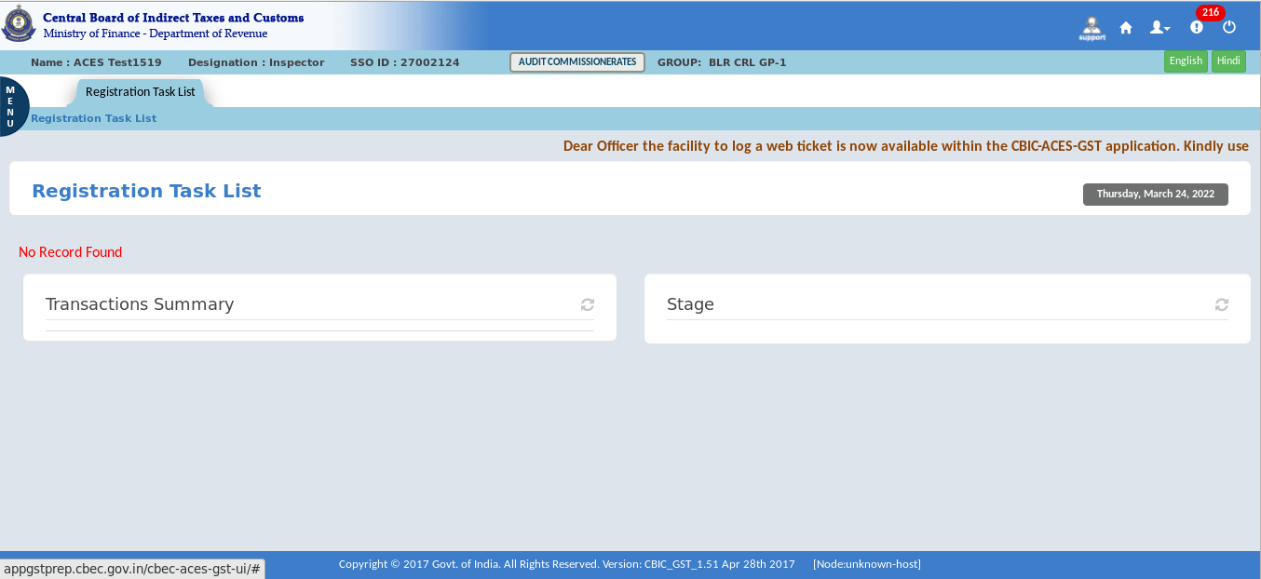

- Click on the Audit > Audit Communication.
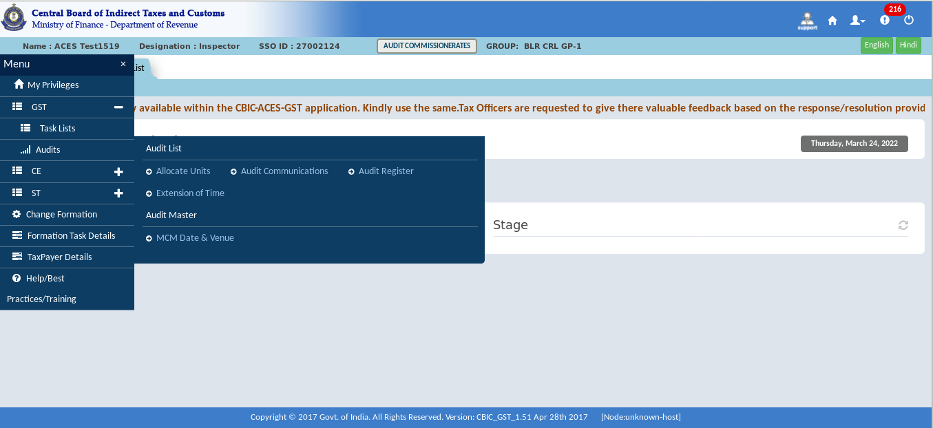
- To issue ADT 01, click on “Select Form” and then ADT – 01.
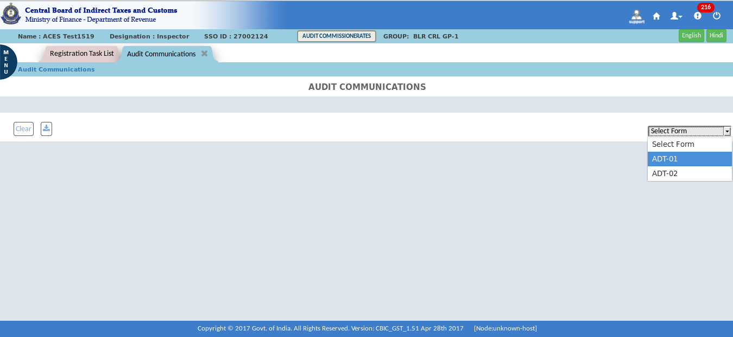
The Dashboard – Audit communication screen displays as shown above

- The list of units pending for issue of ADT-01 will be displayed. Click on the GSTIN.
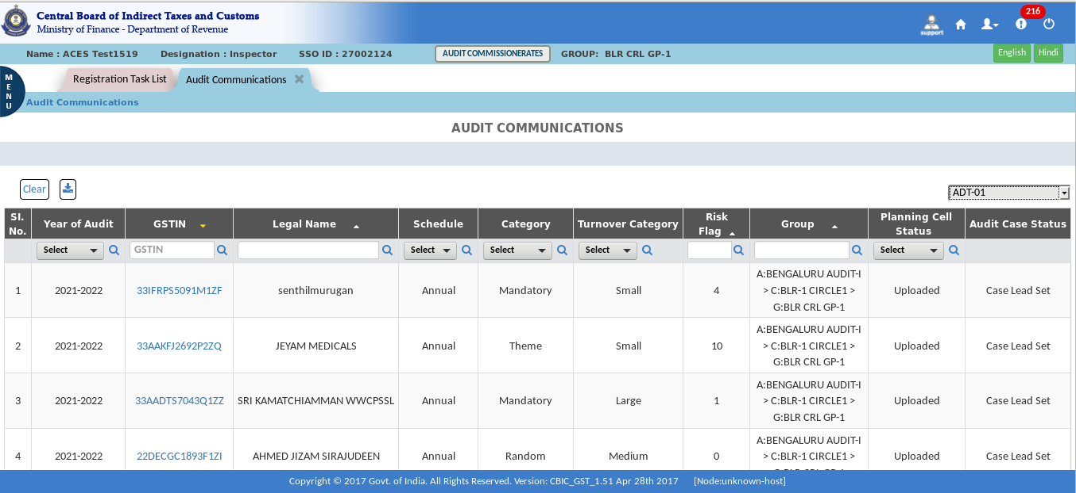
- Enter the mandatory fields - Place of Audit, Proposed date of audit, scheduled date for submission of documents and the address where the documents should be submitted and then click on submit.
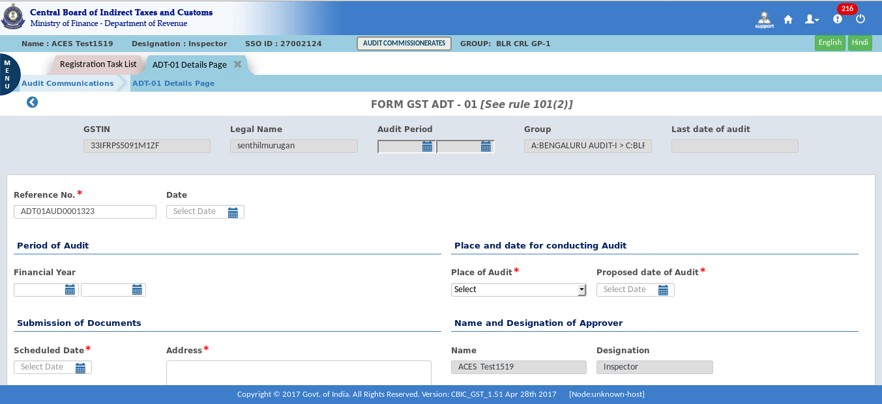
Note: Wherever possible, the data required for ADT-01 will be auto-populated.

- Select the approval authority - Superintendent or AC/DC, save and then submit (note that here in the illustration the approval authority is selected as Superintendent)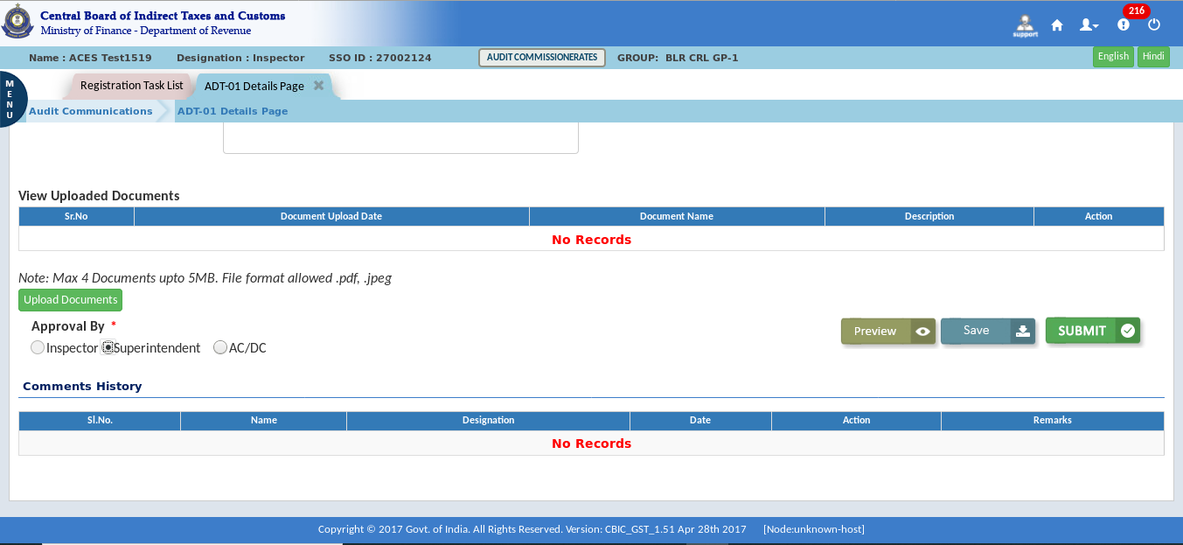
- Confirmation Popup appears.
- Click on the “Submit” button for approval.
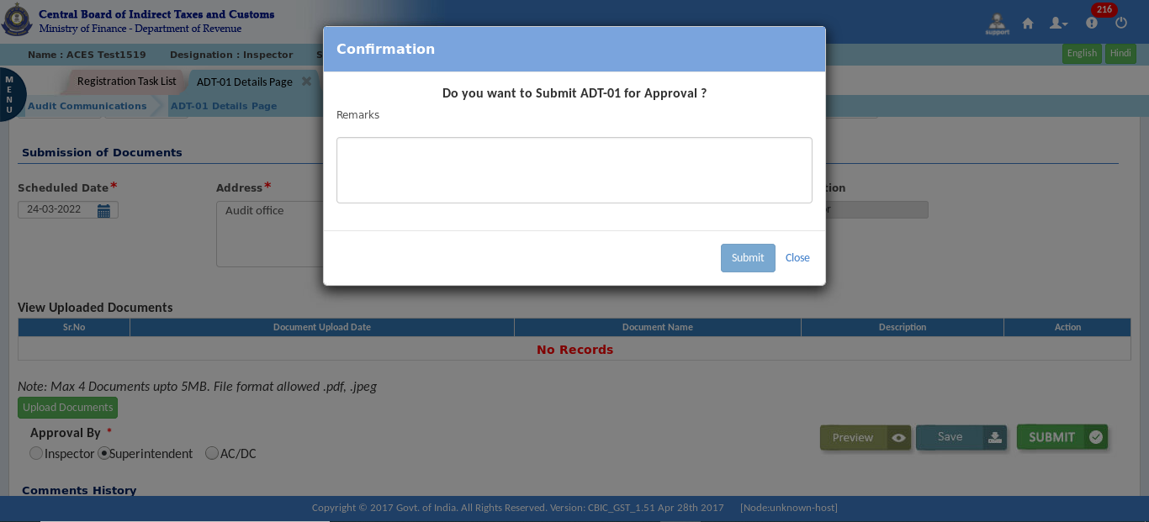

- The Success Message pop-up appears.
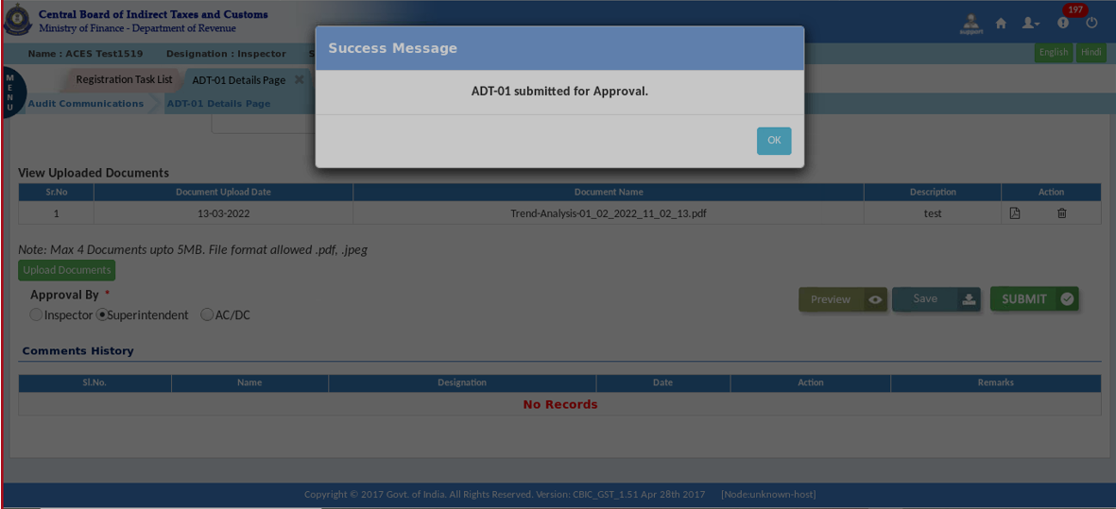

Approval process
- Click on the Menu > Task Lists > Audit.
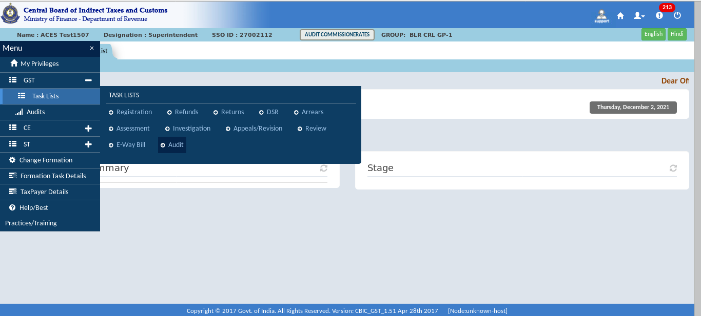
- In the stage section for the Audit Communication – ADT01, click on "Pending for approval with SP."
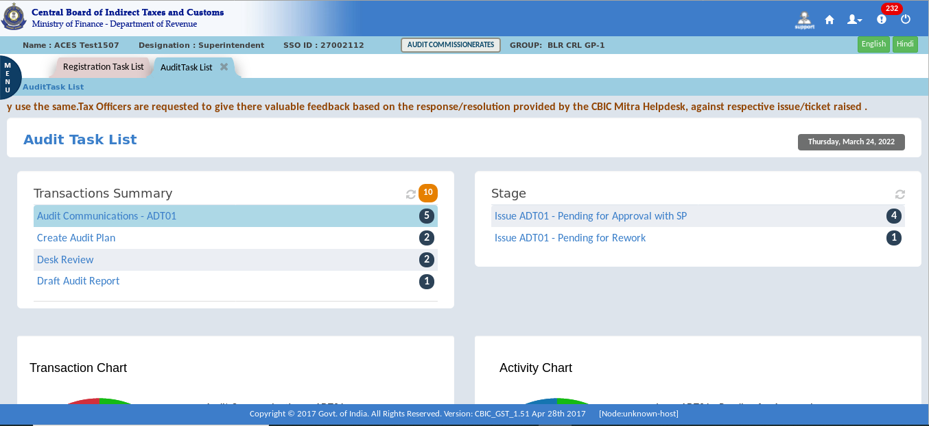

- Click on the GSTIN.
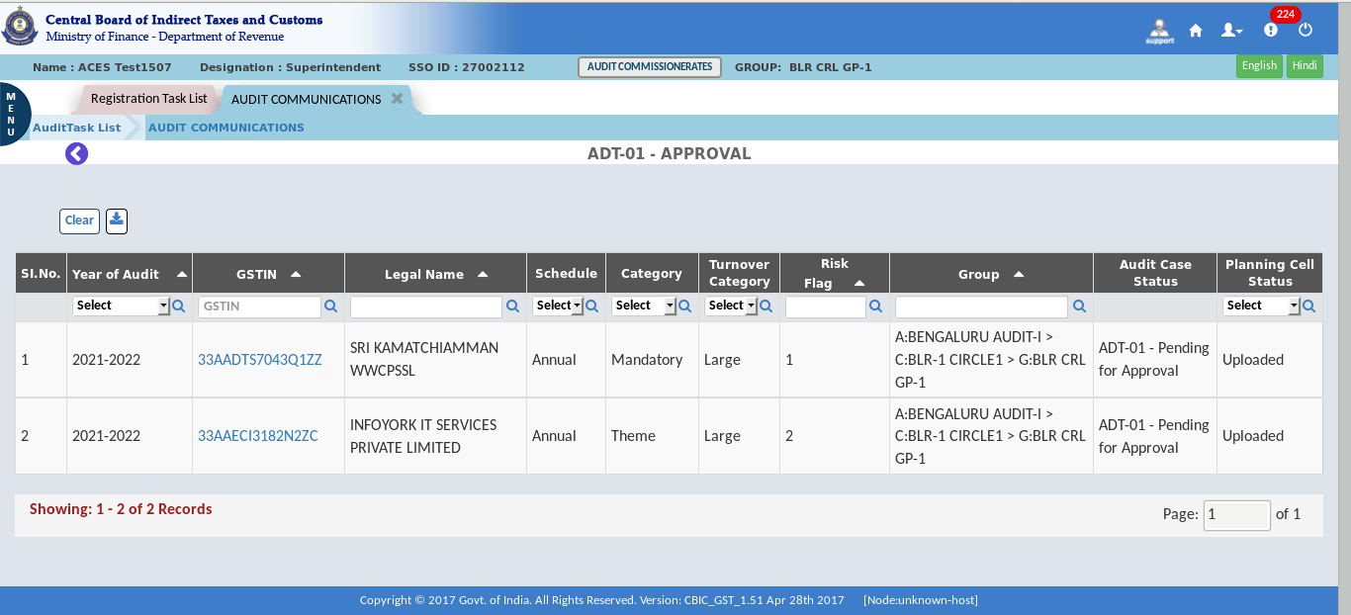
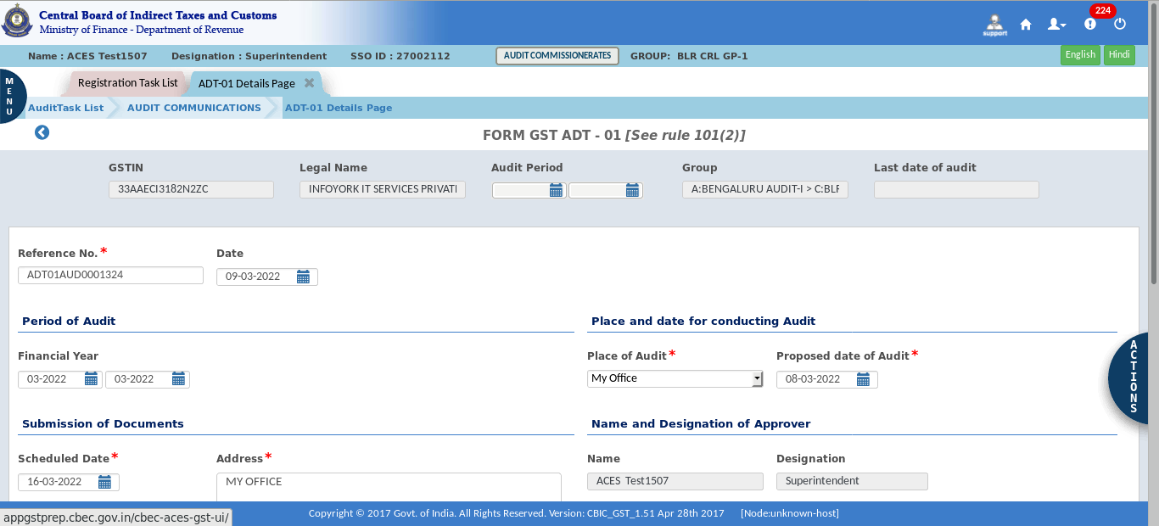
Note: The audit form will open and show the details that are already filled in. The approving officer needs to verify (or fill in if required) the date, time, and place of the audit before approving. Wherever possible, the data required for ADT-01 will be auto-populated.

- To approve request, select an option "Approve" in the "Action tab".
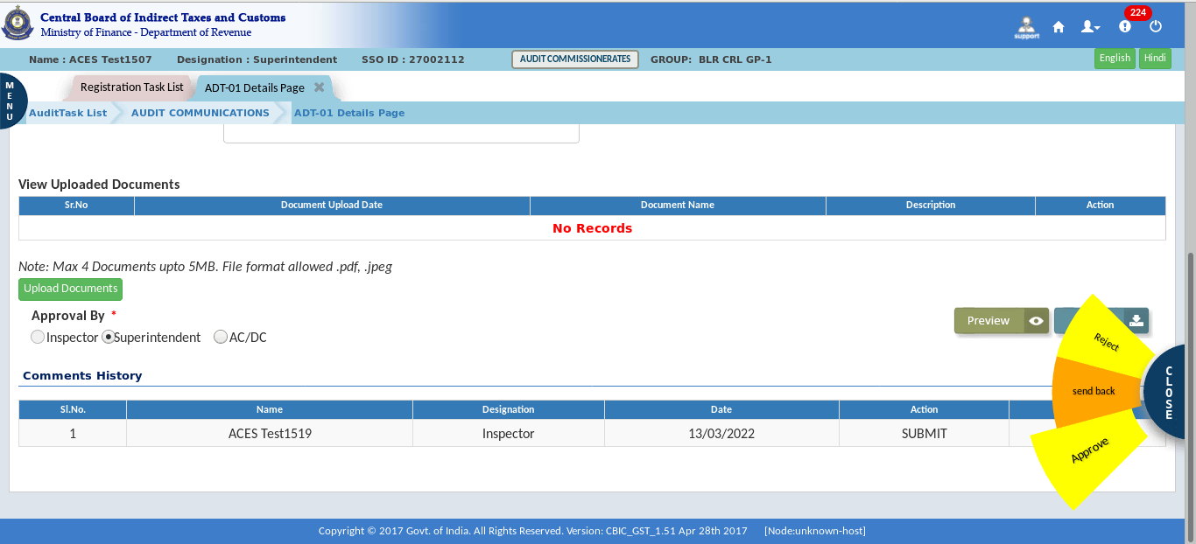
- Confirmation Pop-up appears. Click on the Yes button for approval.
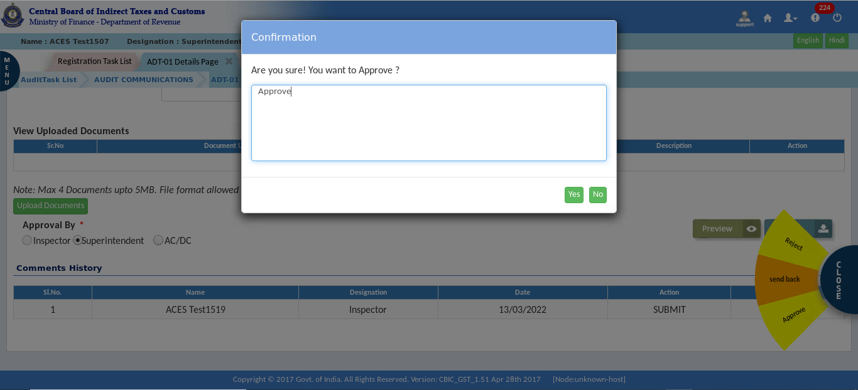

- The Success Message pop-up appears.
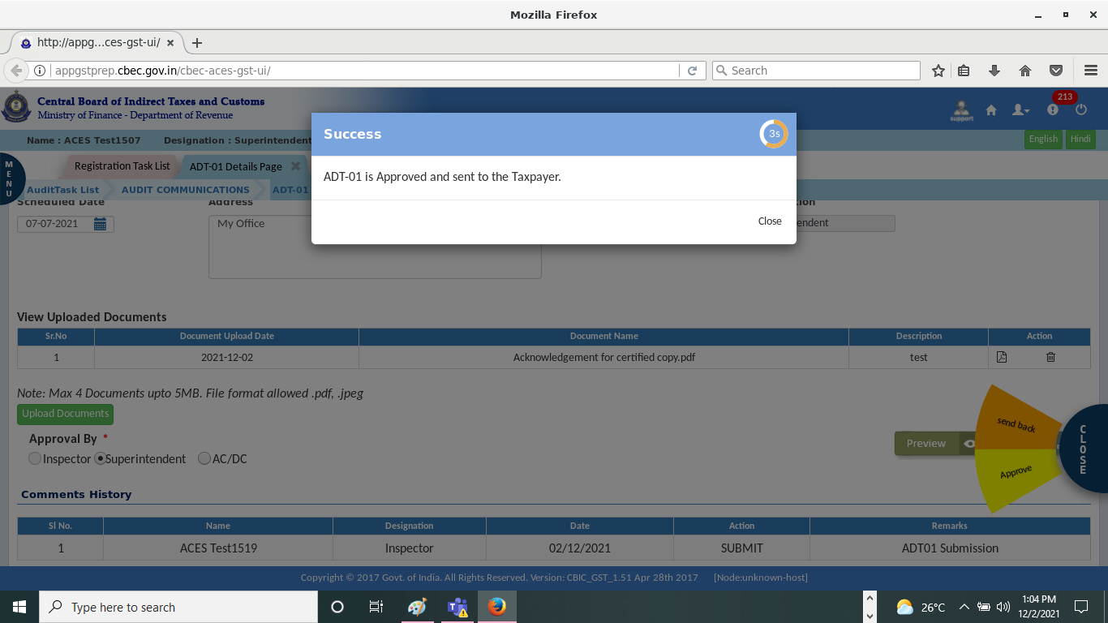
Note: Till the Integration of GSTN APIs the ADT-01 will not go online to the taxpayer’s front end directly. The approved ADT-01 can be downloaded and sent to the taxpayer by email or post as required.
Alternative Flow (Send Back for Correcting ADT 01): Circle AC will send back the Request to Group with Comments, Group will make the changes and submit again for approval.
Alternative Flow (Circle AC/DC can issue ADT 01): Circle AC will issue ADT 01 to taxpayer. There is no approval process when circle AC/DC will issue ADT 01.

- Initiate Audit Case
Once ADT-01 is issued the Audit case will start appearing in the respective groups “Initiate Audit Case” menu page for further process. Auditor will update the audit case details to determine start date and time of audit & audit period. The Auditor at group level will update the audit case & initiate audit process.
- Click on the Audit > Initiate Audit Case.
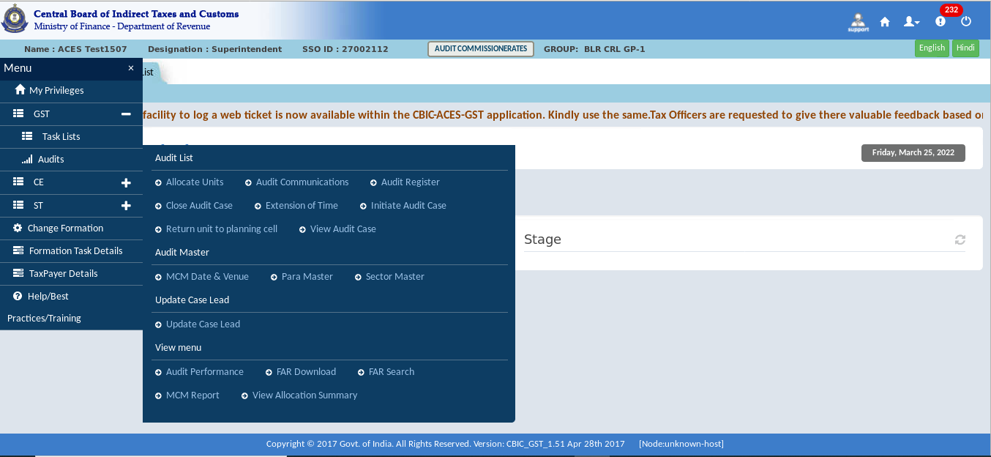
- Click on “GSTIN” number for Initiate Audit Case.
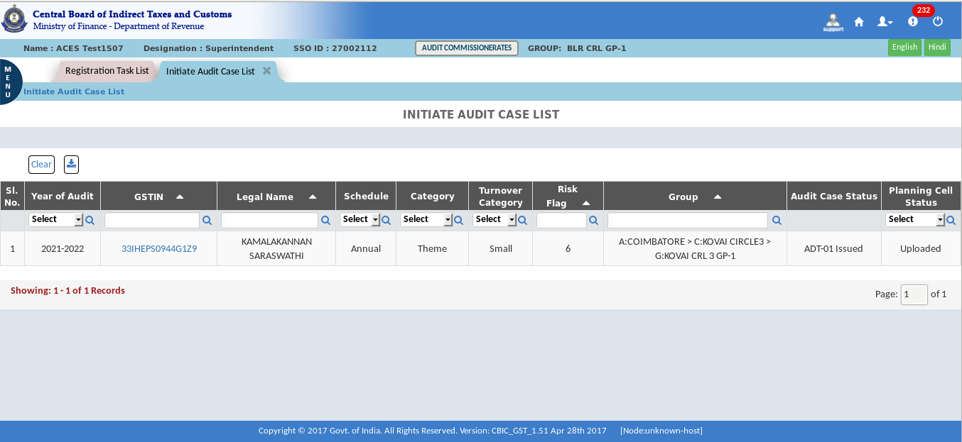
The Dashboard – Initiate Audit Case list screen displays as shown above

- The Configuration tab further displays the Audit Profile and Timelines tabs. Click Audit profile to see the detailed information on the audit process.
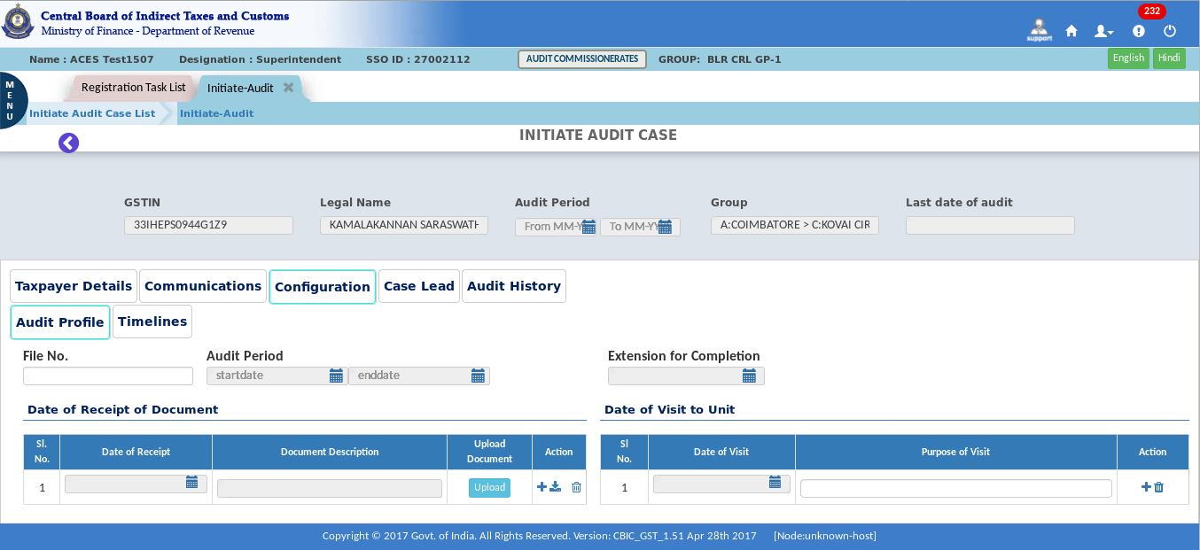
- Under Configuration tab, Click Timelines tab to see the detailed information regarding the timelines.
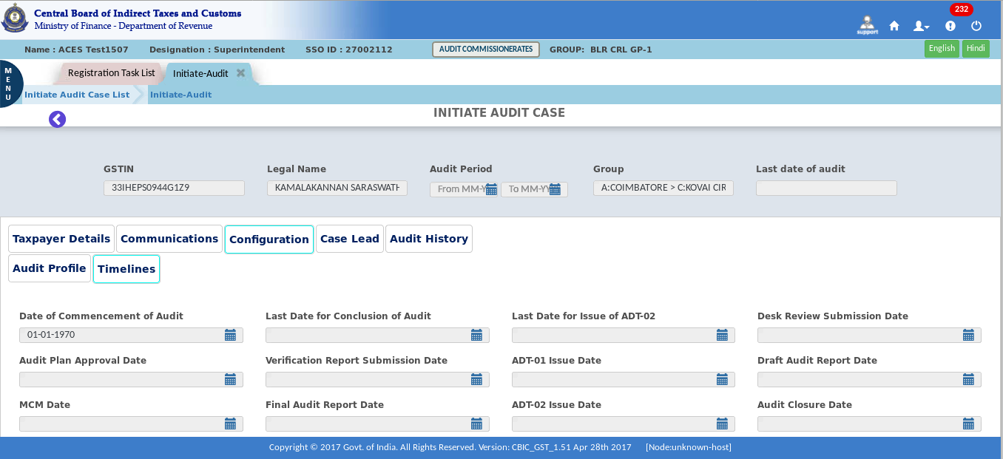

- After filling all the details Click on “Initiate Audit Case” button for confirmation.
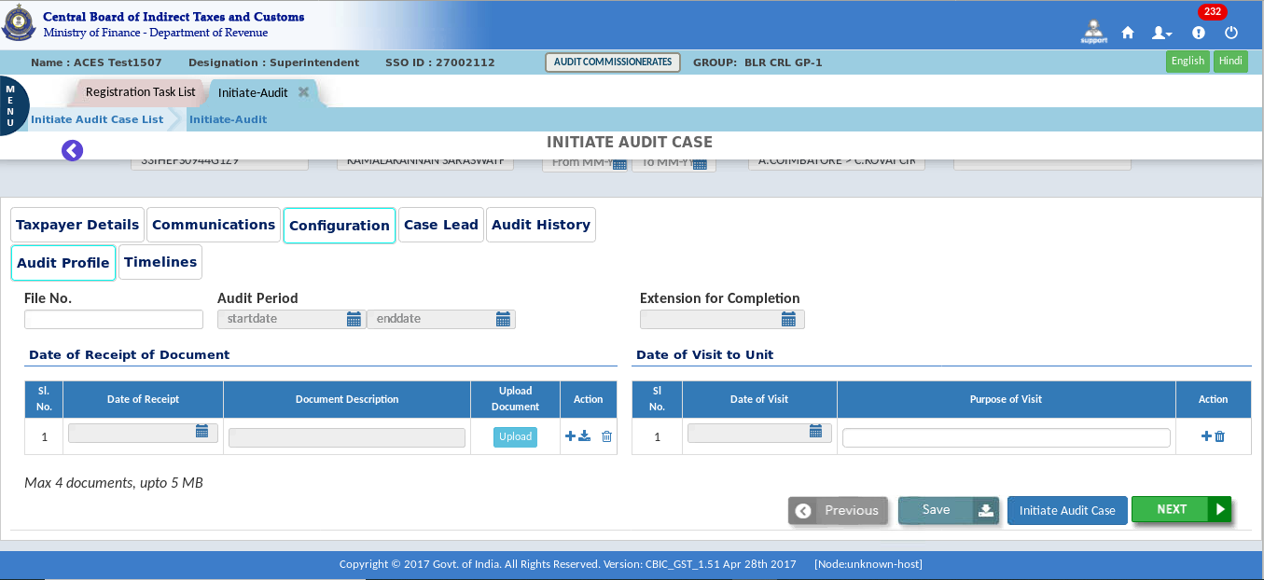
Note: The "Initiate Audit Page" displays the Taxpayer Details, Communications, Configuration, Case Lead, and Audit History tabs. The Configuration tab further displays the Audit Profile and Timeline tabs. Click on each tab to see the detailed information and fill in the required information in the blank tabs.
- The Confirmation pop-up appears.
- Click on the Submit.
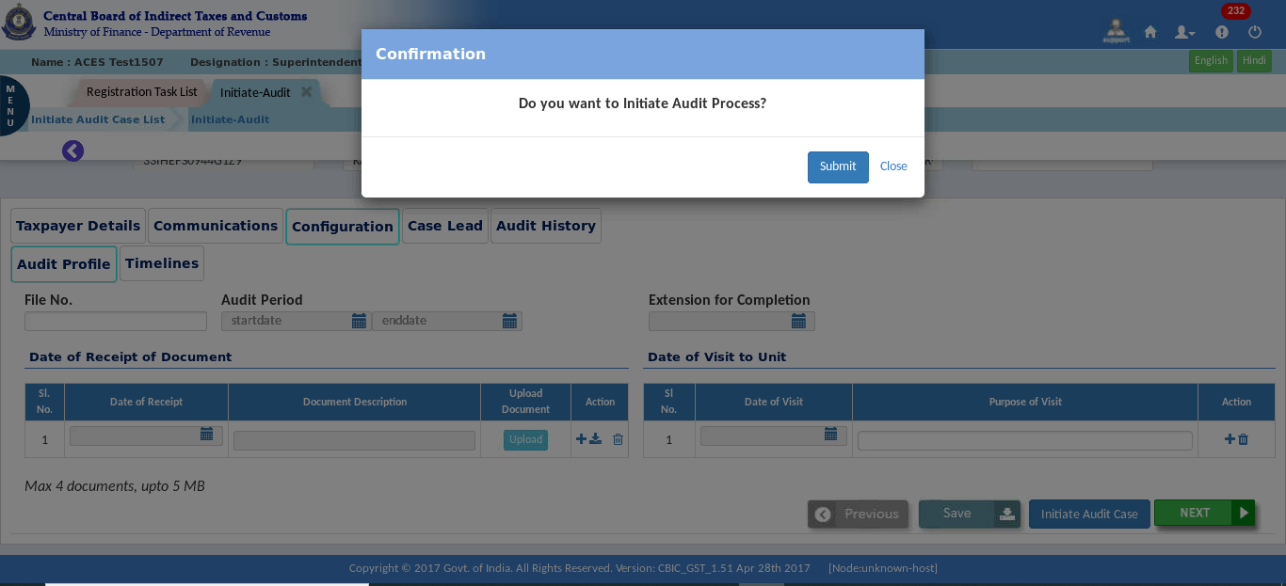

- The Success Message pop-up appears with the message ‘Desk Review task has been created. Accessible from dashboard’.
- Click on “OK”.
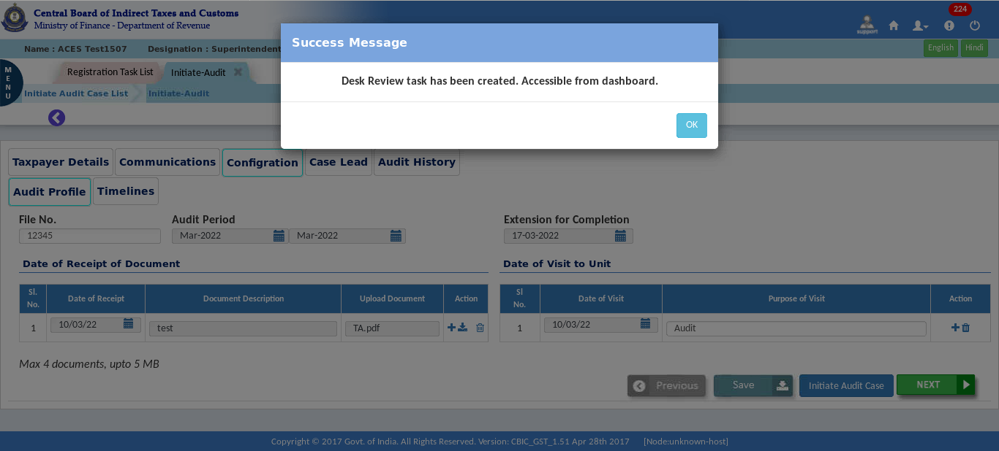

- Desk Review
Desk Review process will start once the audit case is updated and initiated, this process will include trend analysis, ratio analysis, verification financial account, etc. these will aid the auditor in taking decision to investigate further. Using these trends and ratios analysis, auditors can arrive different items to include in the audit plan.
- Click on the Menu > Task Lists > Audit.
- In the stage section for the Desk Review, click on " Desk Review – Pending for Submission."
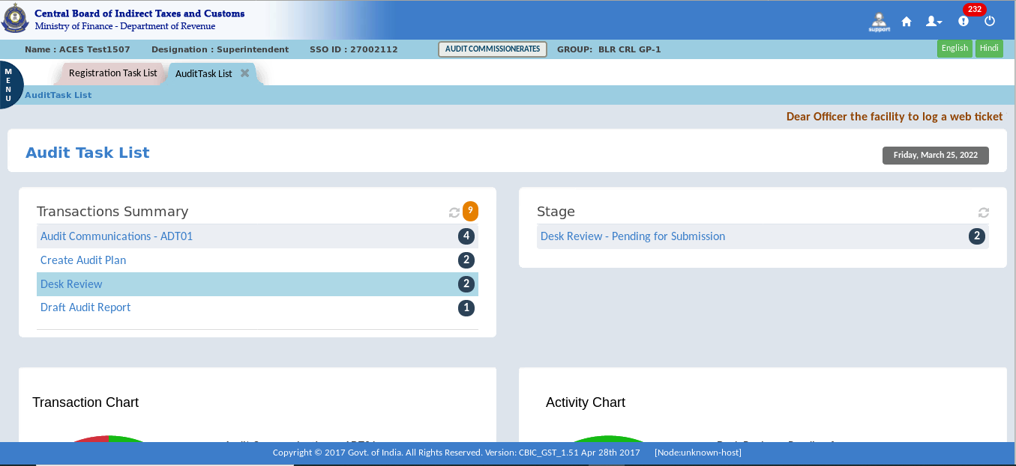

- Click on the “GSTIN”.
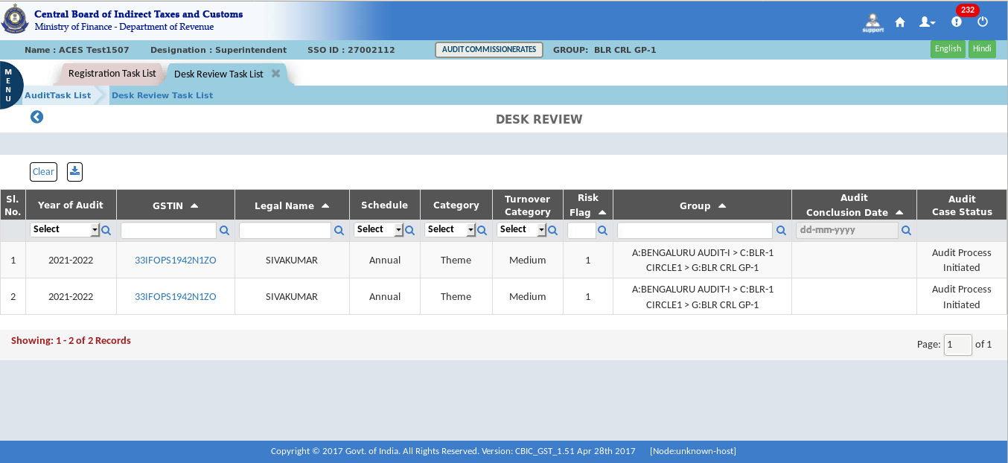
The Dashboard – Desk Review Task List screen displays as shown above.
Note: The Desk Review page displays the Taxpayer Details, Communications, Configuration, Case Lead, Desk Review and Audit History tabs. The Desk Review tab further displays the Trend Analysis, Ratio Analysis, Other Analysis and Other Desk Review Observations tabs. Click on each tab to see the detailed information, and fill in the required information in the blank tabs. The data for these analyses will be gathered from the returns module and the analysis will be displayed to the user.
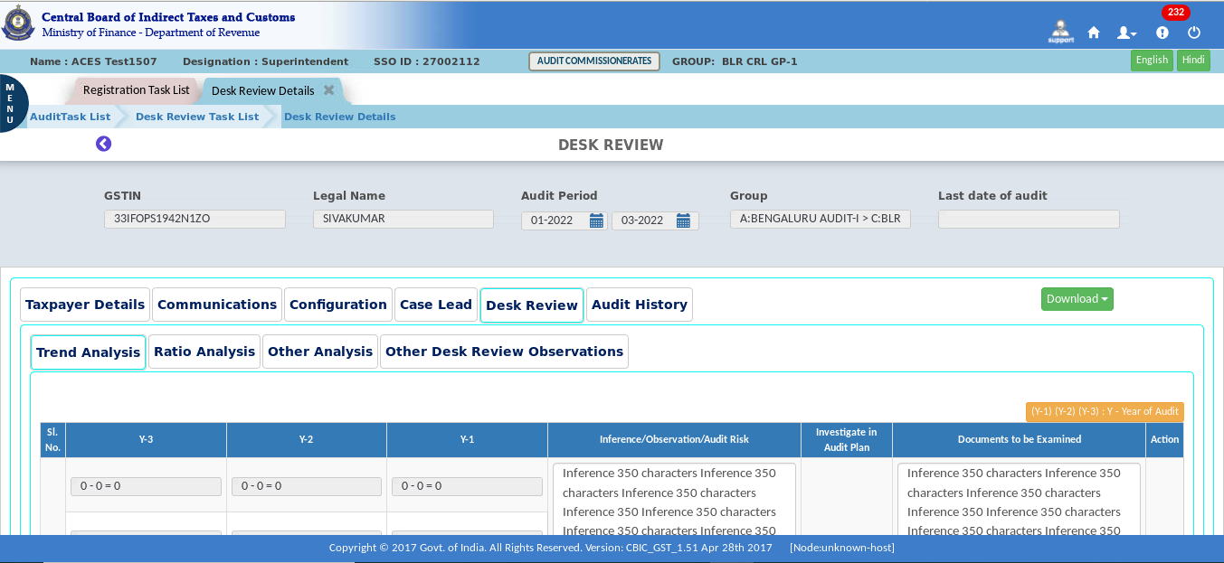
The Dashboard – Trend Analysis screen displays as shown above.

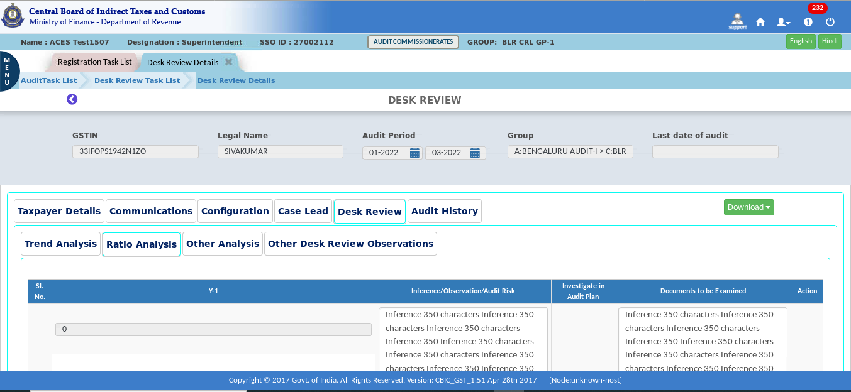
The Dashboard – Ratio Analysis screen displays as shown above.
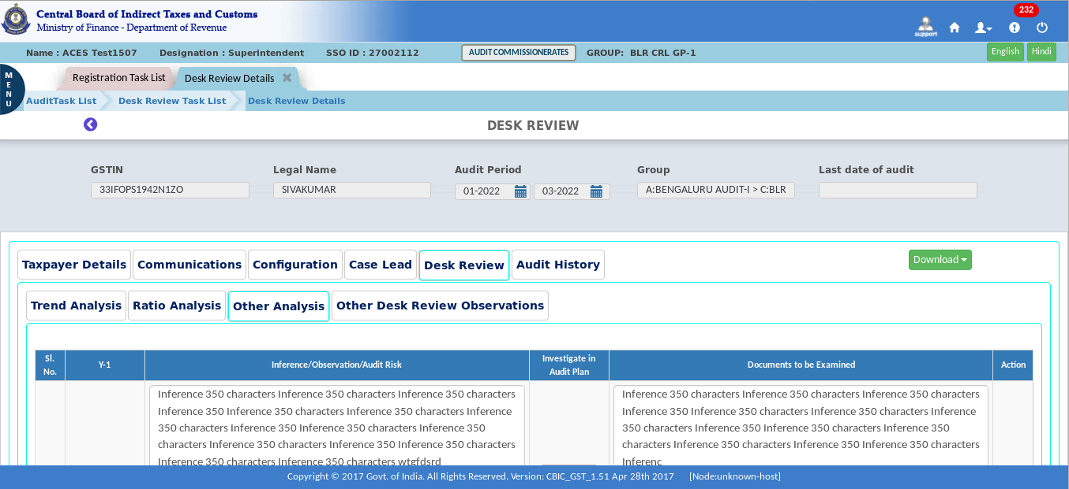
The Dashboard – Other Analysis screen displays as shown above.

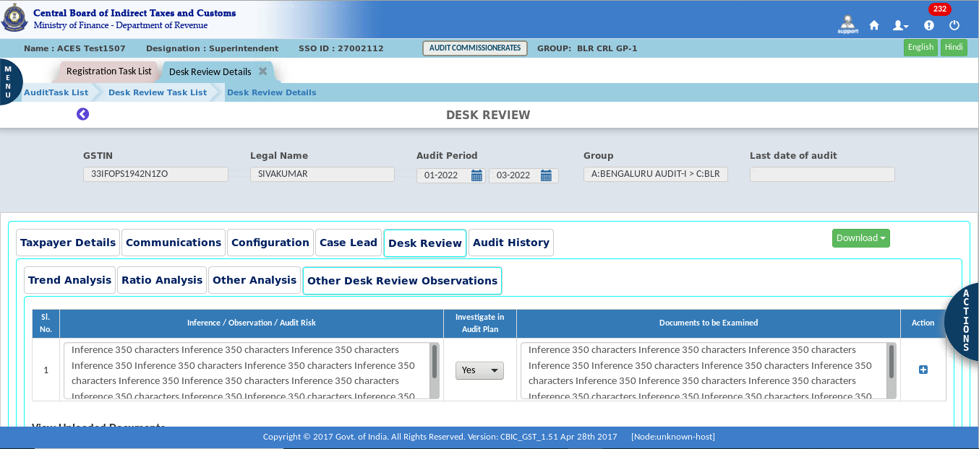
The Dashboard – Other Desk Review Observations screen displays as shown above.
- Click on the “Submit”.
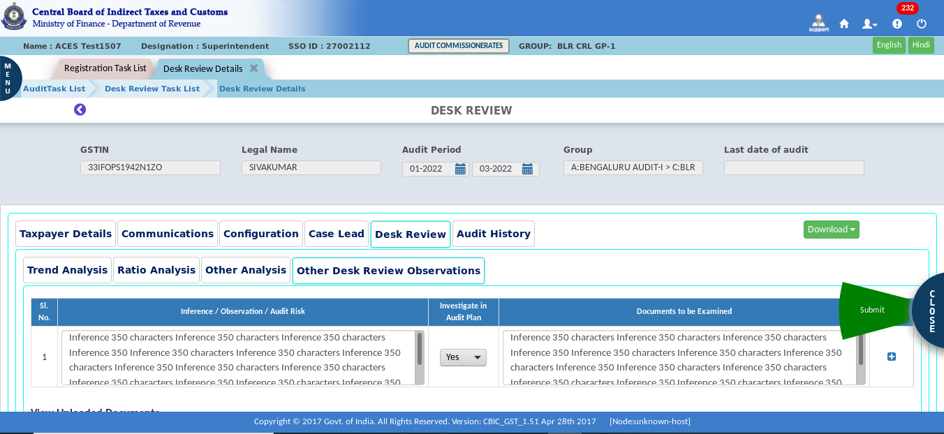

- Confirmation pop-up appears.
- Click on the Submit button.
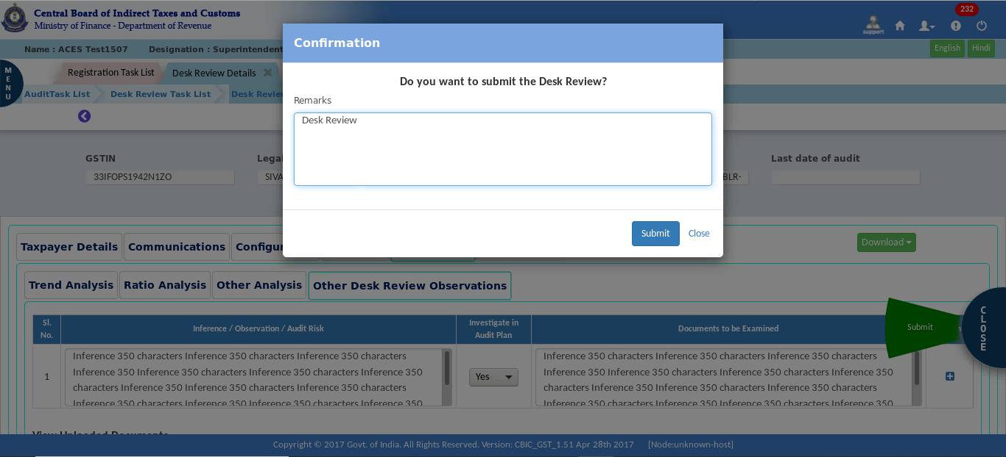
- After submission, a Success Message appears on the screen.
Note:
- This process is complete at the system level.
- Calculated values must be auto populated.
- If required, the tax officer will also upload the documents.
- This procedure does not necessitate approval. It is only the officer's responsibility to submit it.

- Create Audit Plan
Once the Desk Review is submitted successfully, CBIC GST system shall create a task for Creation of Audit Plan at Group Level. The tax officer at group level will create the Audit Plan and it will be forwarded to Proper Officer for Approval.
- In the stage section, click on "Create Audit Plan.
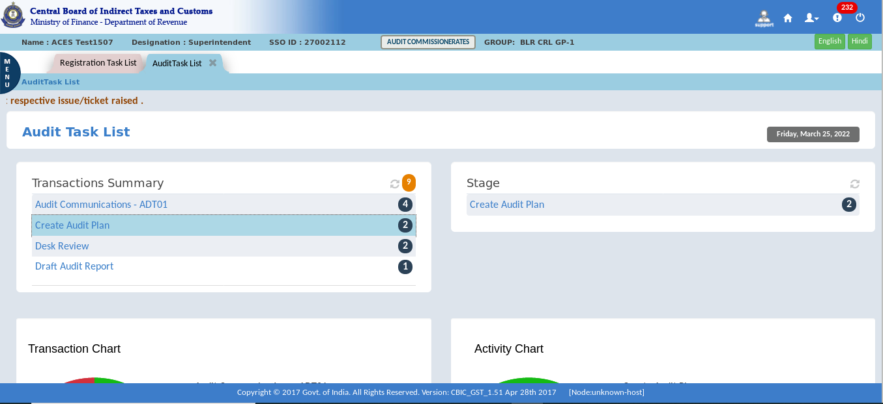
- Click on the “GSTIN” for creation of Audit Plan.
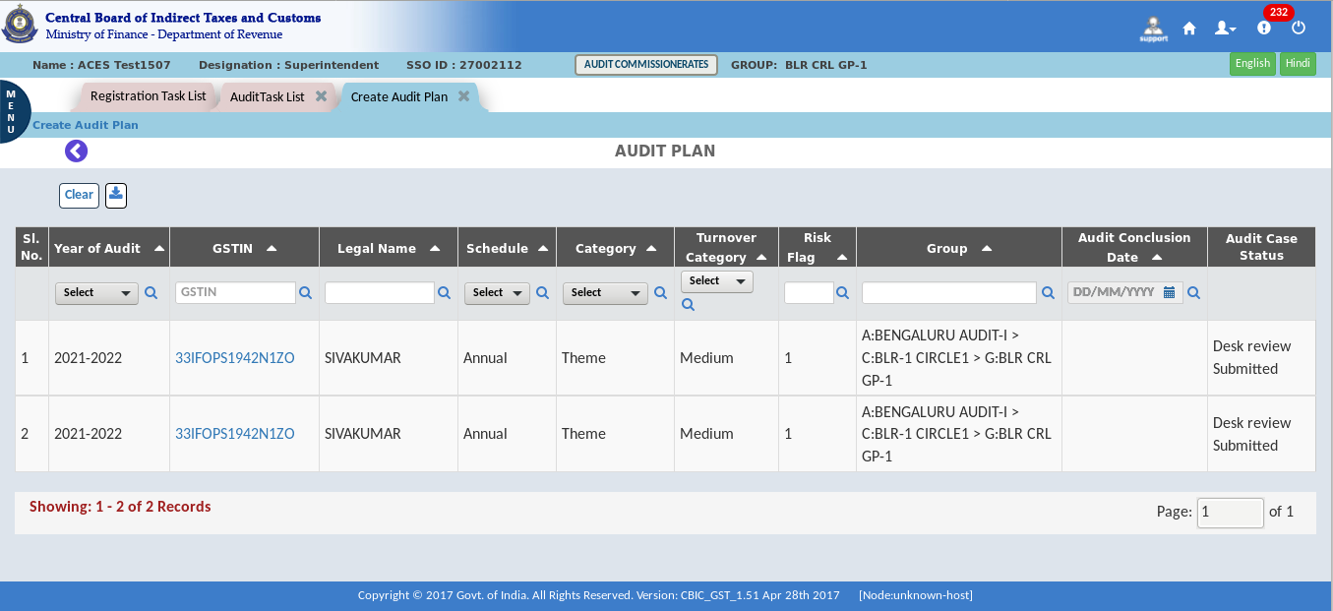
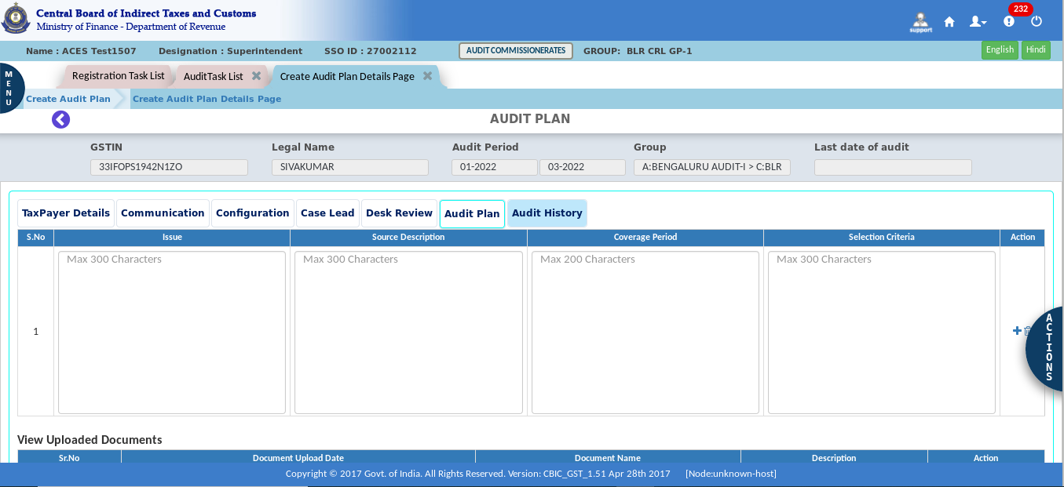
Note 1: After clicking GSTIN, audit plan form will open, and the officer must fill out the form with the required details.
Note 2: The officer must submit this form for approval. For this, he must mark one option in the "Approval By" tab and submit it for approval.
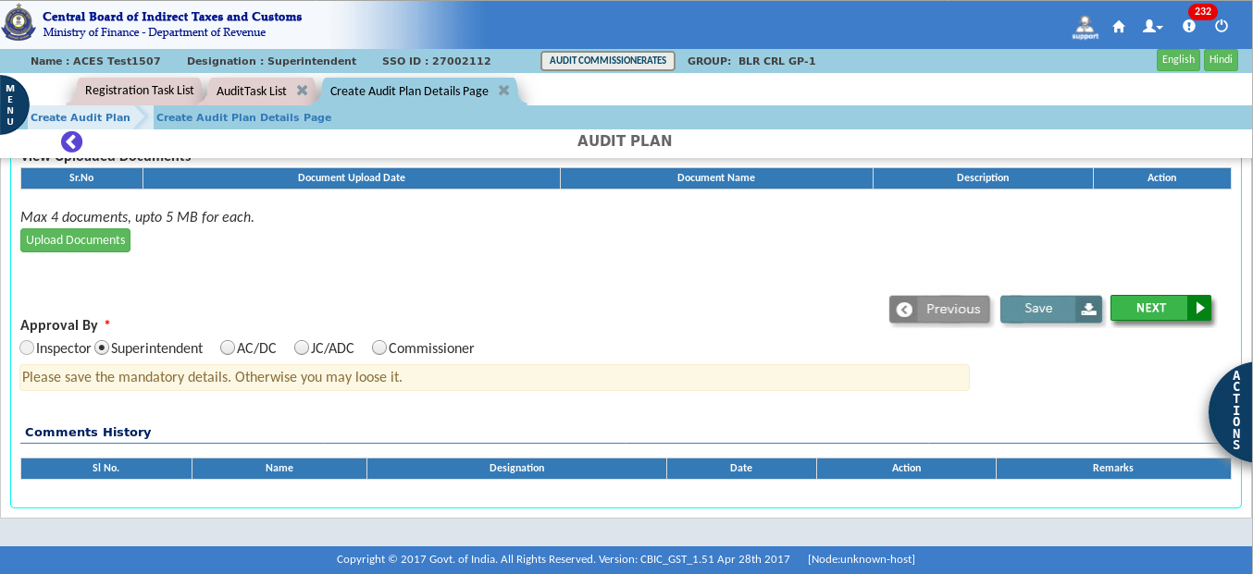

- Click on the “Submit”.
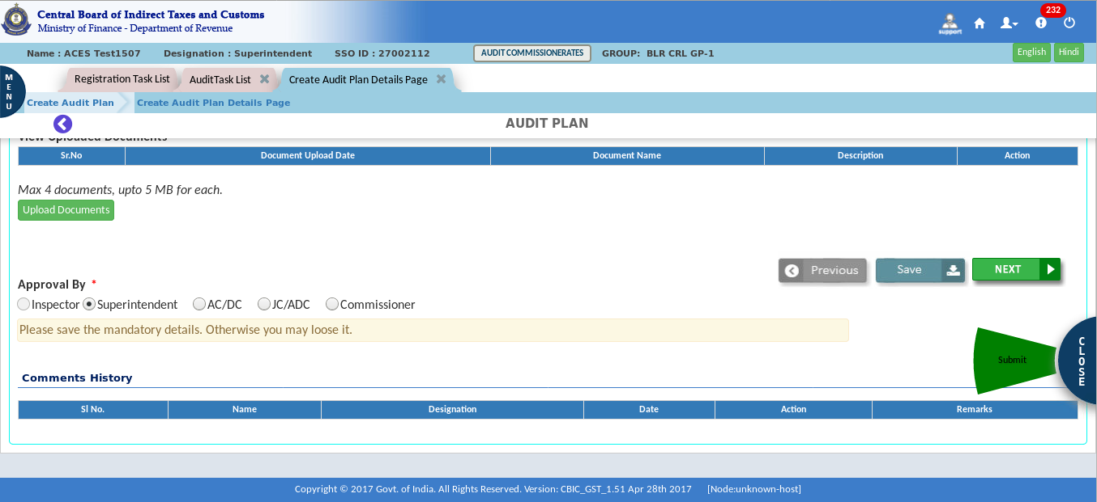
- A Confirmation pop-up appears.
- Click on “yes” for confirmation.
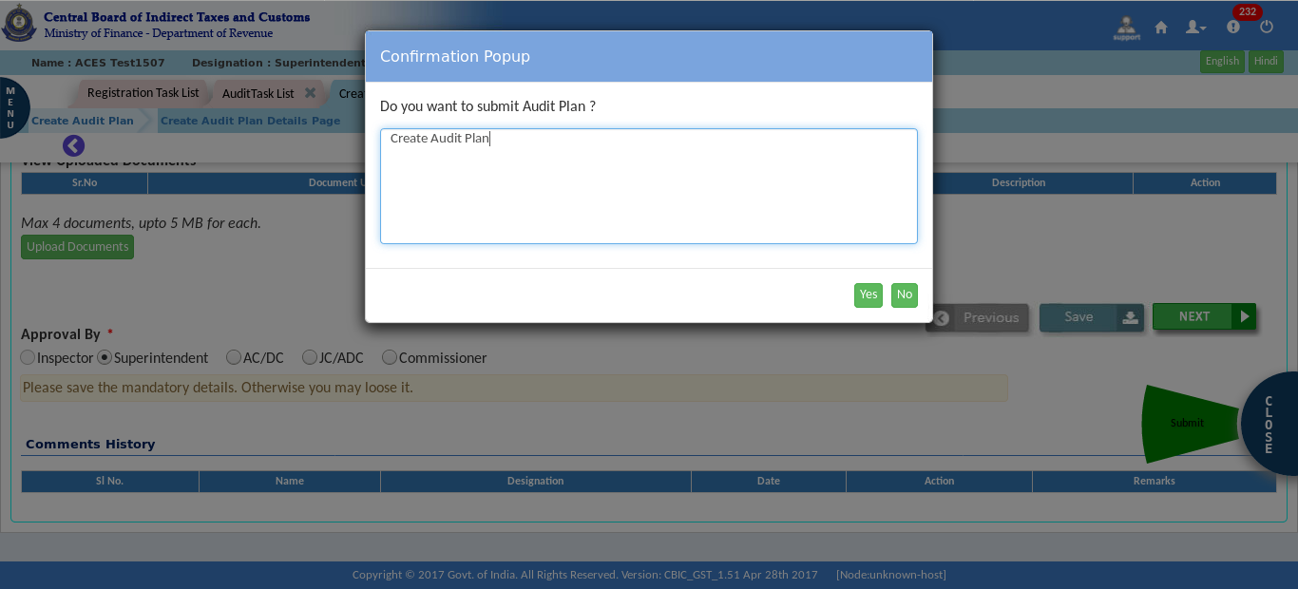

- After submission, a Success Message appears on the screen.
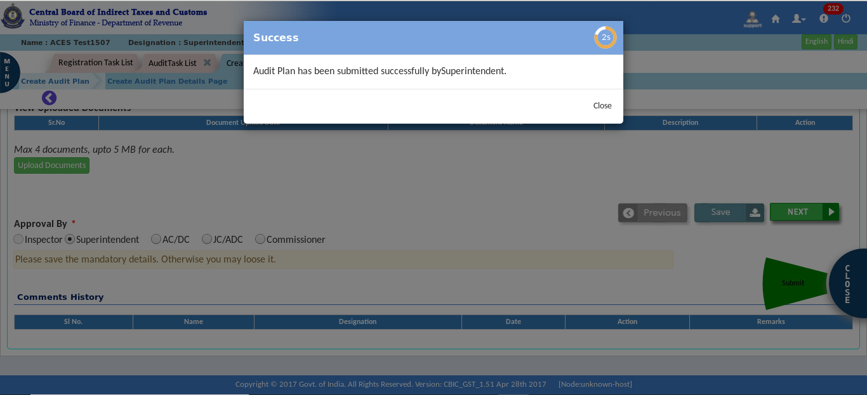
Note: Once an audit plan is created and submitted to SP or AC/DC, it is pending for approval. After their approval, the tax officer at the group level needs to create the verification report against each issue specified in the audit plan, or he can send it back for review.
- In the stage section, click on " Audit Plan - Pending for Approval"
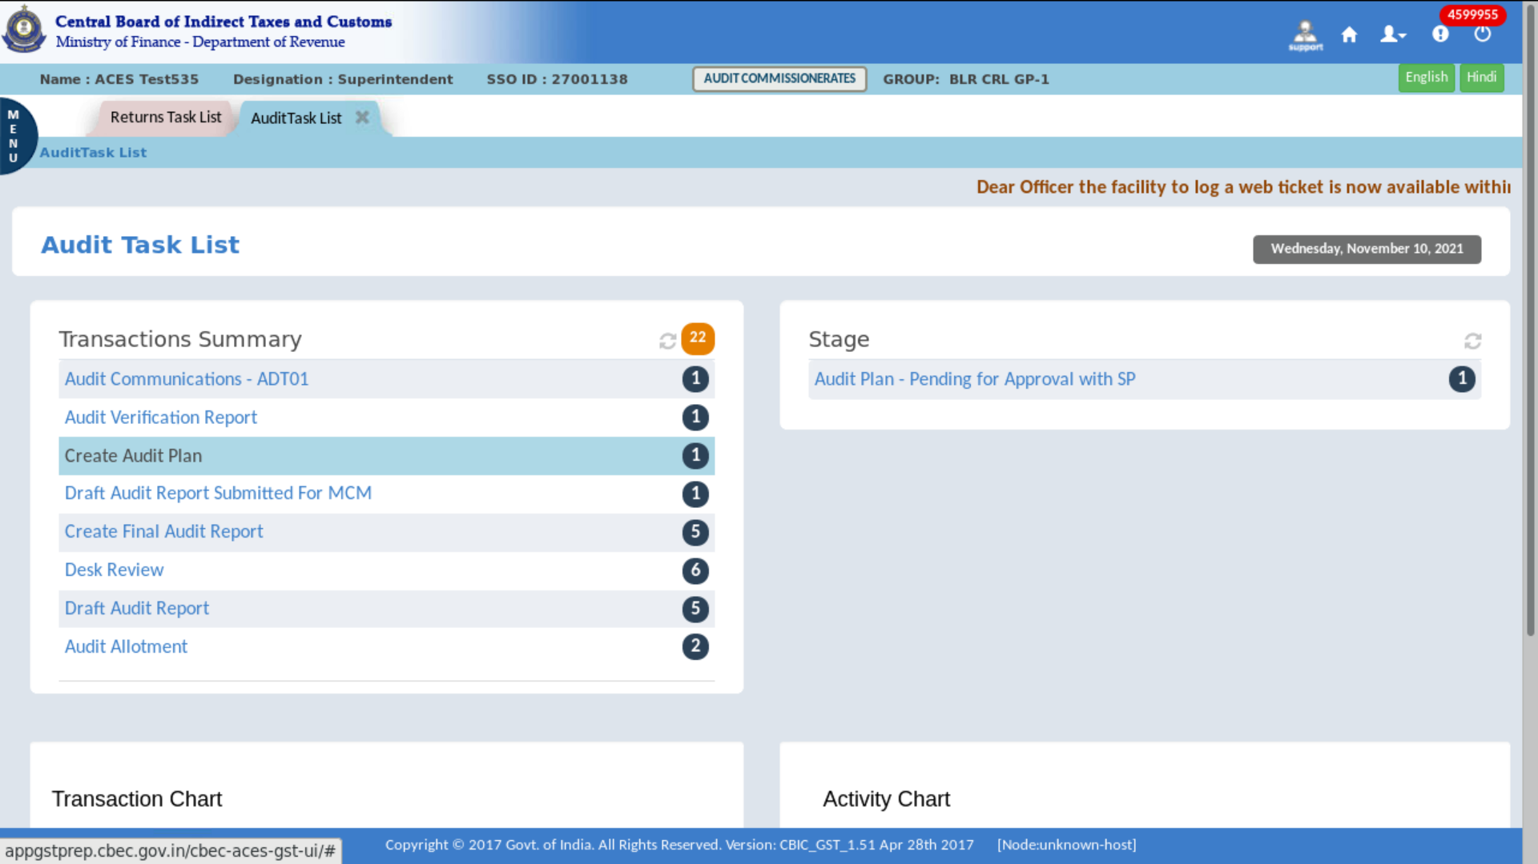

- Click on the “GSTIN”.
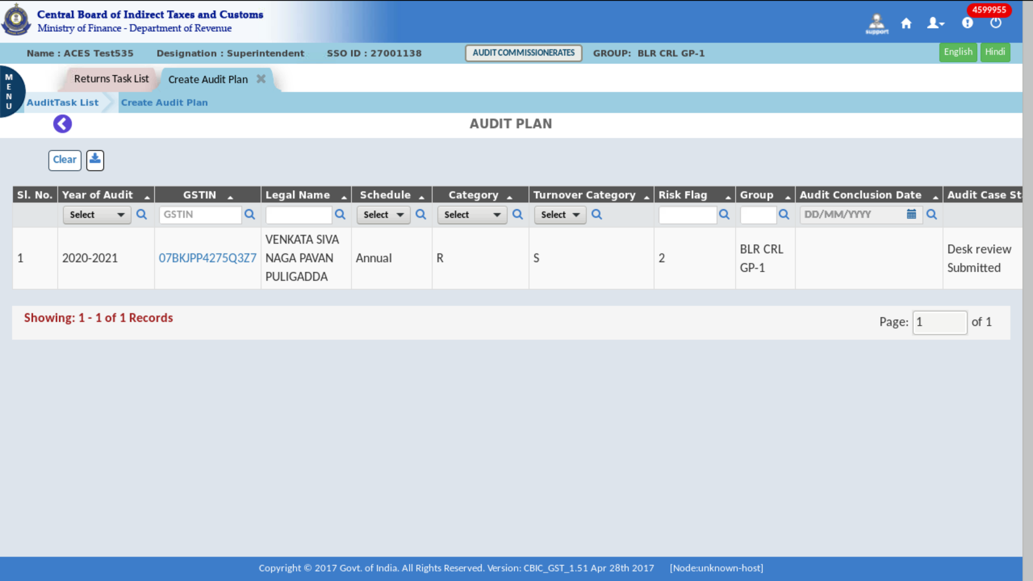
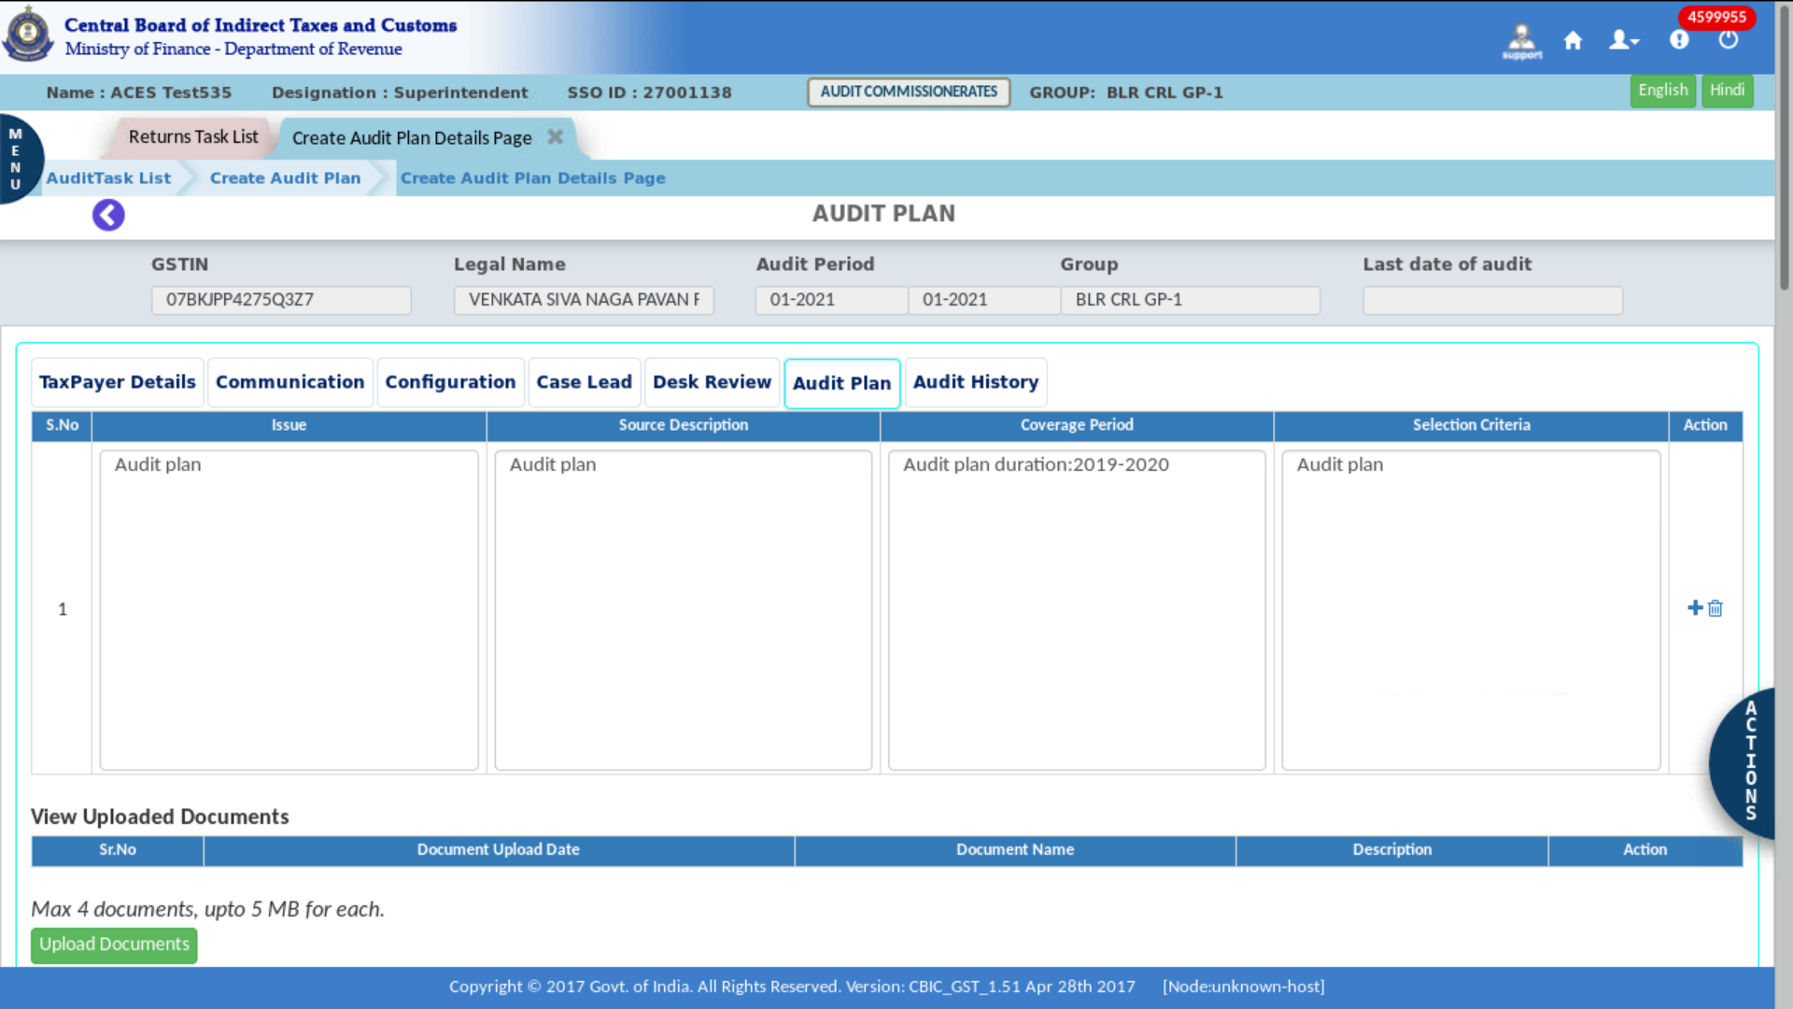
The Dashboard – Audit Plan screen displays as shown above

- Review all the details before approval.
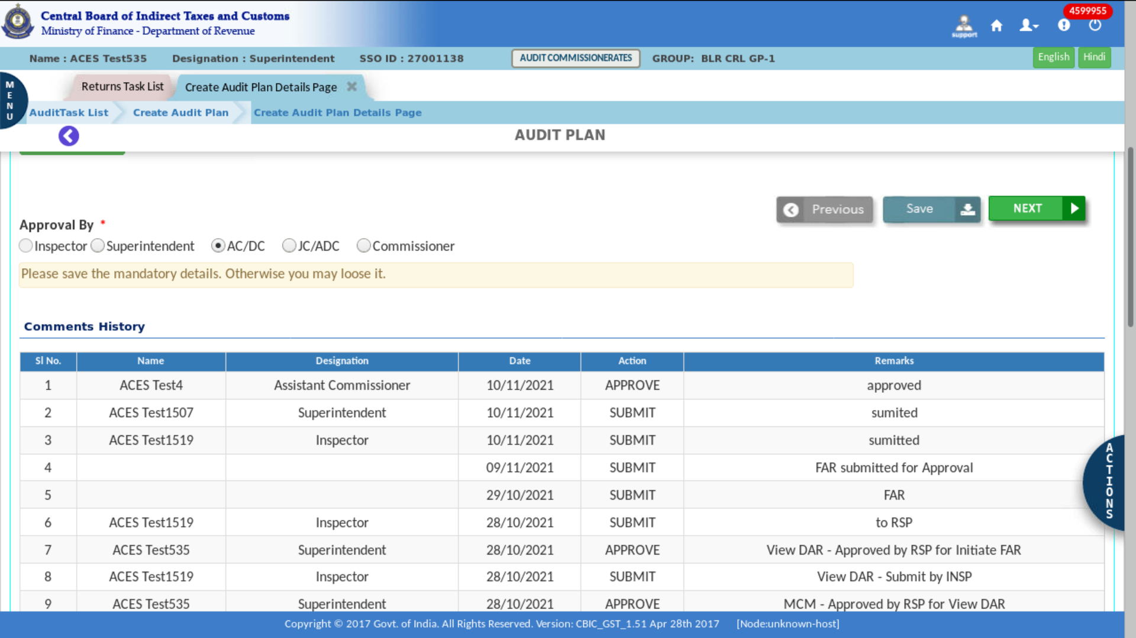
- In the Actions tab, click the Submit button.
- A confirmation pop-up appears, click on “yes” for confirmation.
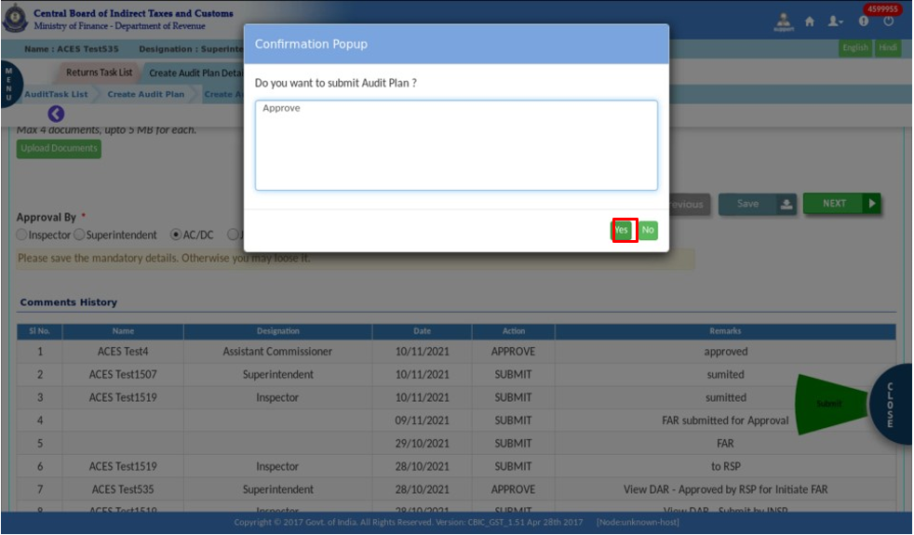
- After submission, a Success Message appears on the screen.
- Create Verification Report
Once the Audit Plan has been approved by the proper officer, the tax officer at the group level must create the verification report for each item listed in the audit plan.
One task will be created for the same at the group level and tax officer can create the verification report against the specific issue given in the audit plan. Tax Officer can add additional verification report also if required
- Click on the Menu > Task Lists > Audit.
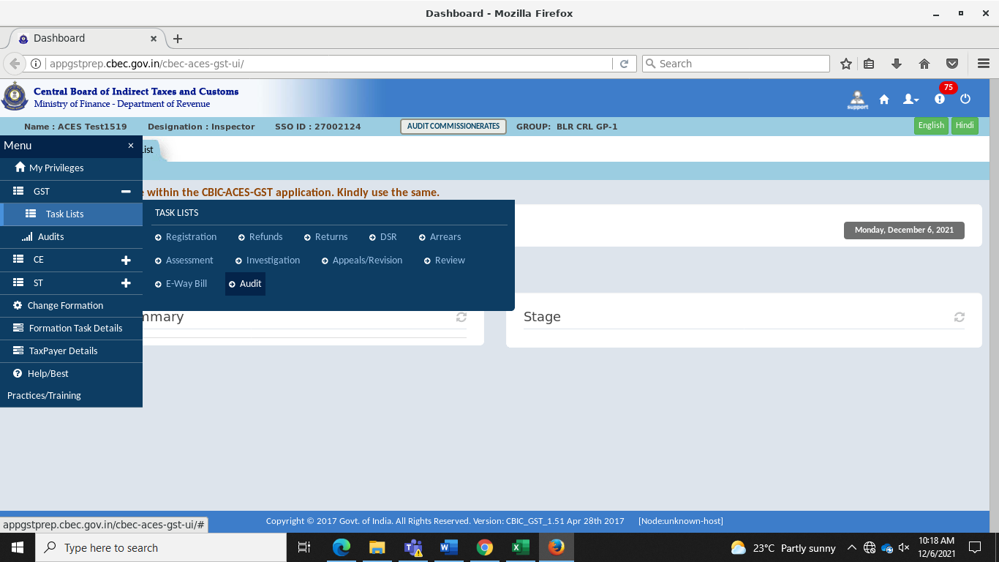
- In the stage section, click on “Create Verification Report”.
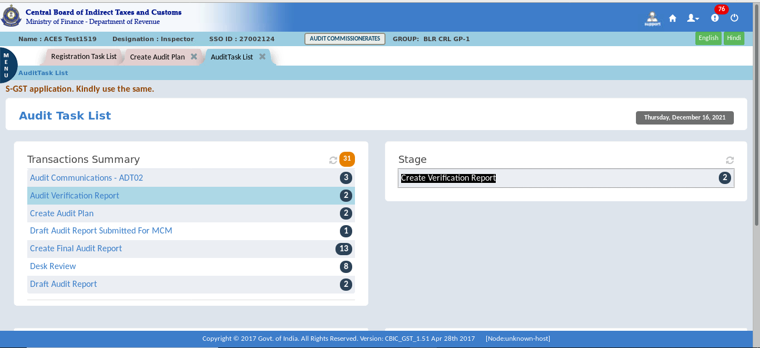

- Click on the “GSTIN”.
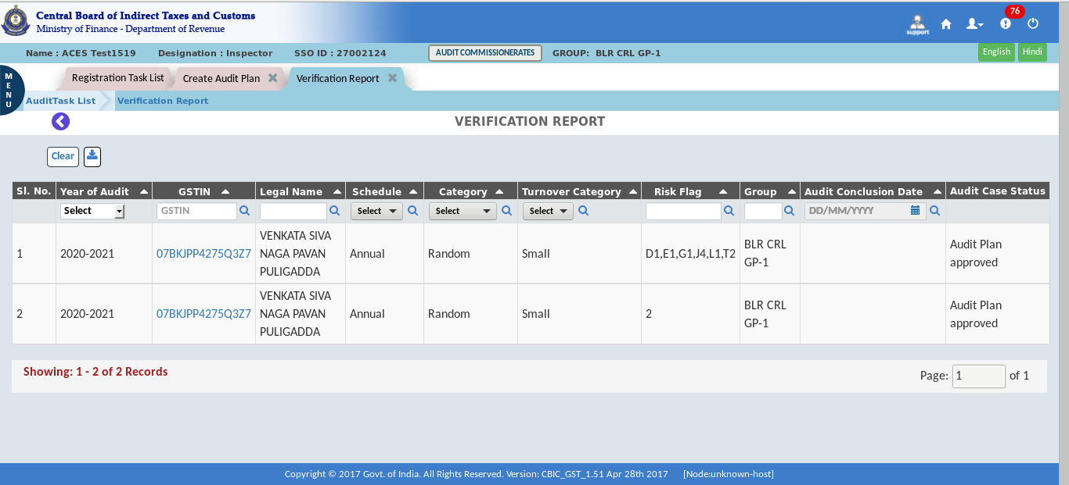
- Verification report tab is open.
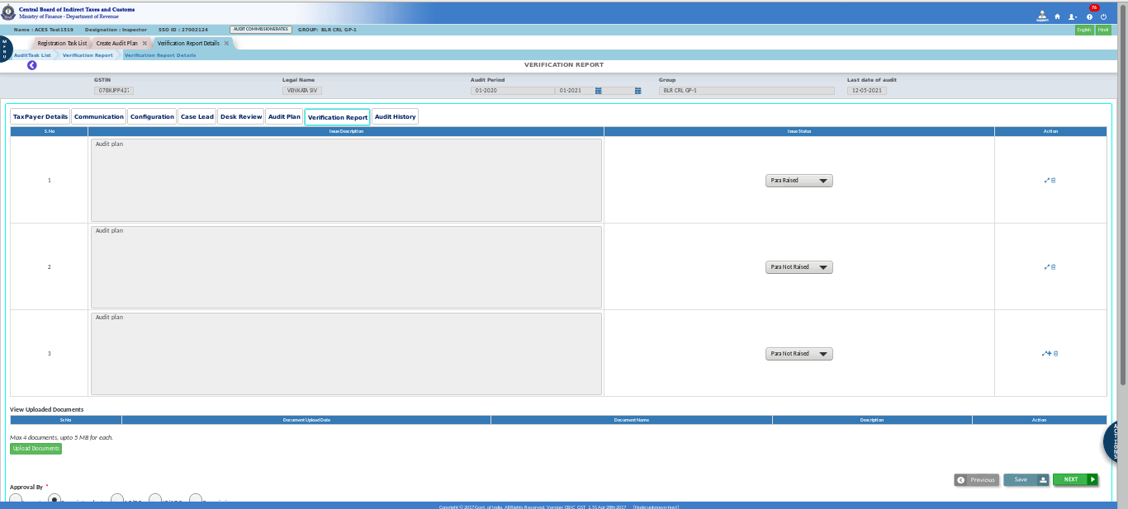

- Click on "Submit" to create a verification report.
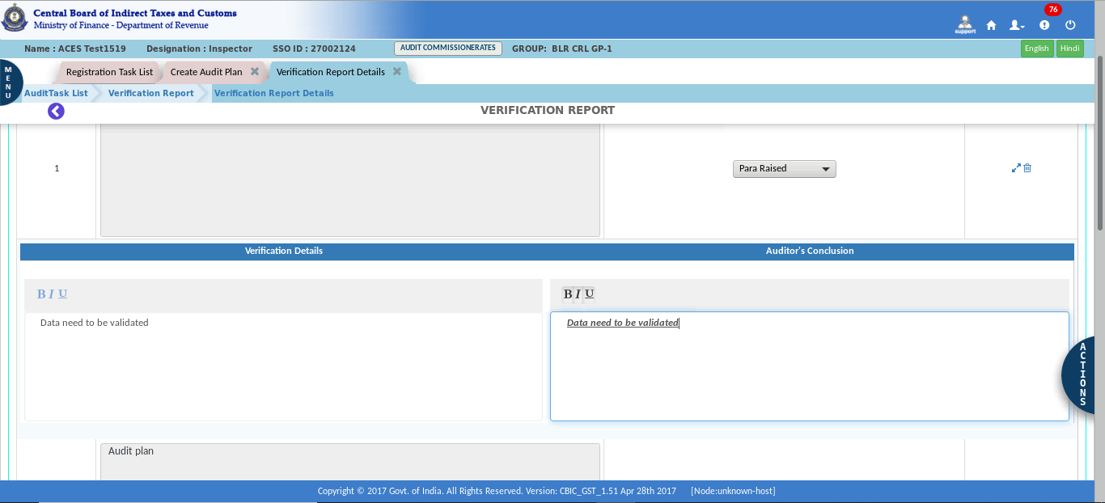
- Confirmation pop-up appears, click on Yes button for confirmation.
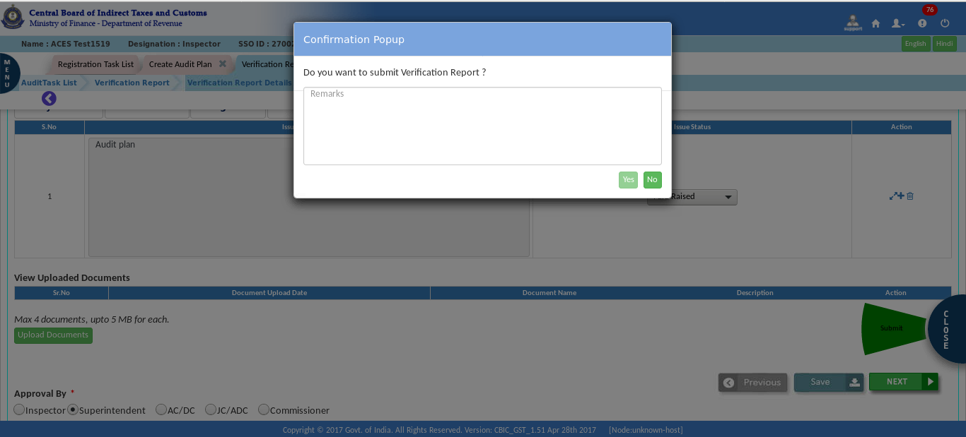

- A Success Message appears on the screen.
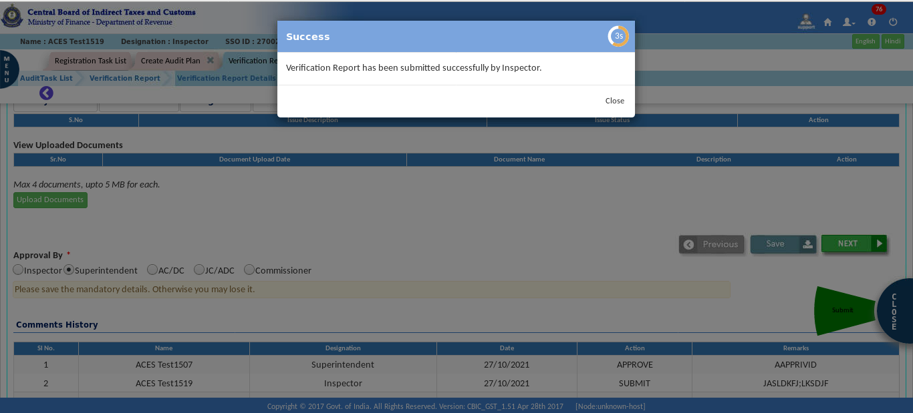
Approval process:
Note: It is awaiting approval after creating a verification report.
- In the stage section, click on “Audit Verification Report – Pending for Approval”.
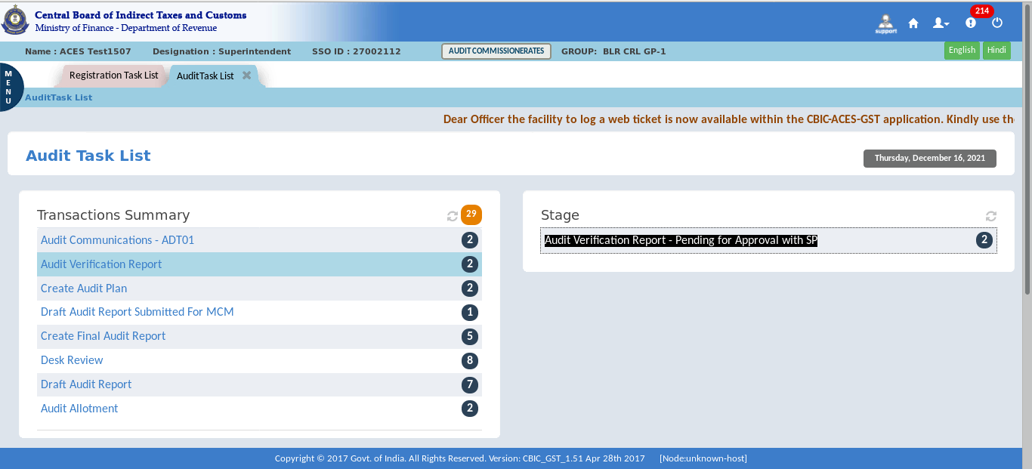

- Click on the “GSTIN”.
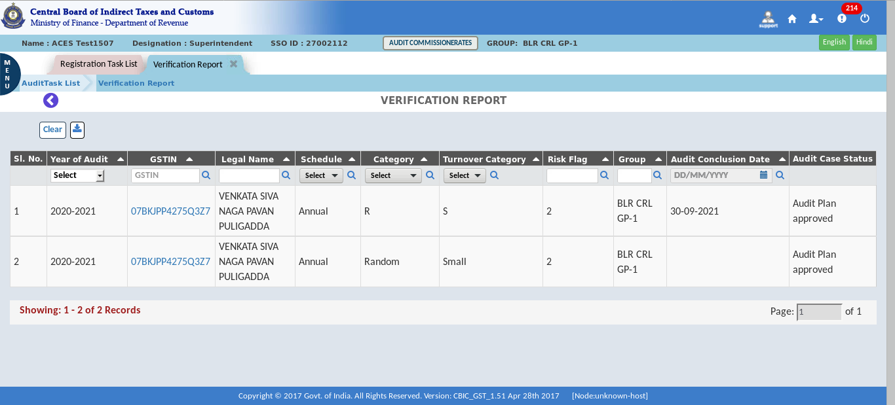
- Review/Examine the details in the verification report.
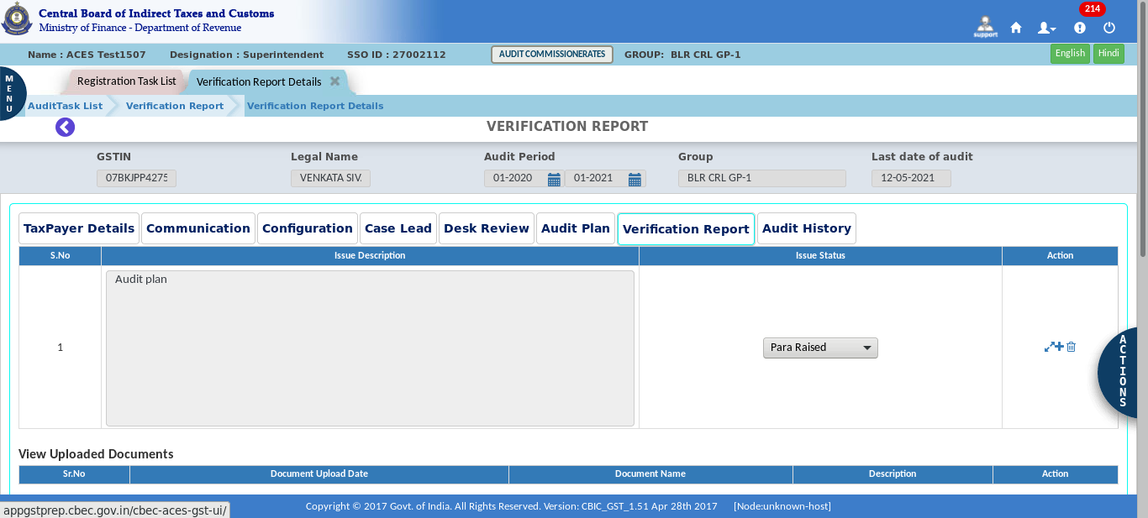

- Select the approving authority in “Approval by”.
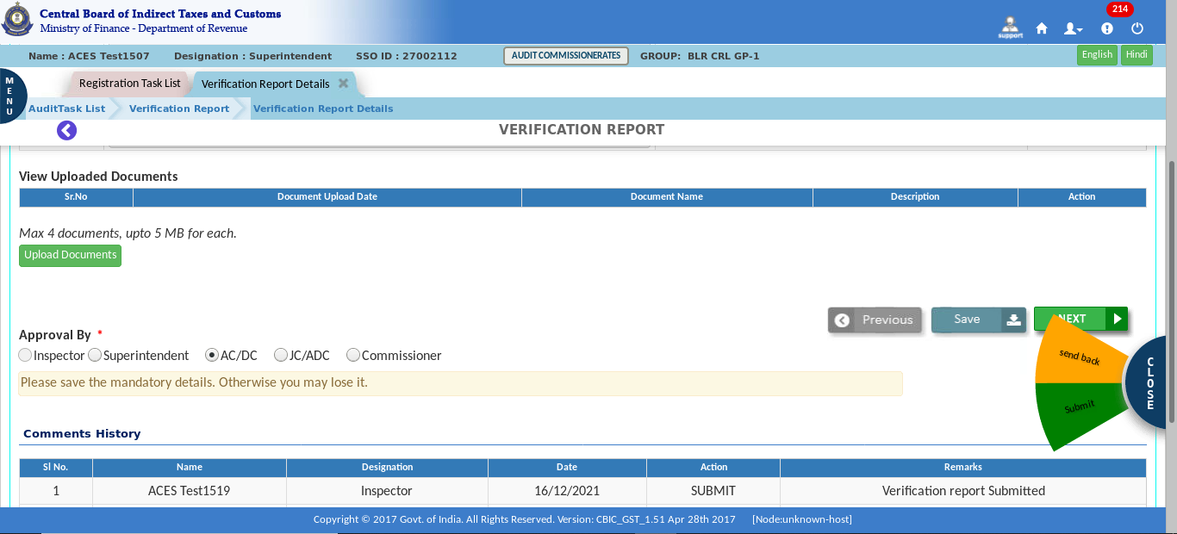
Note: If the superintendent himself selects/chooses to be the approving authority, he can himself approve the verification report. And he can also submit this verification report to his higher authority for approval.
- Click on “Approve” to approve the verification report or send back to officer.
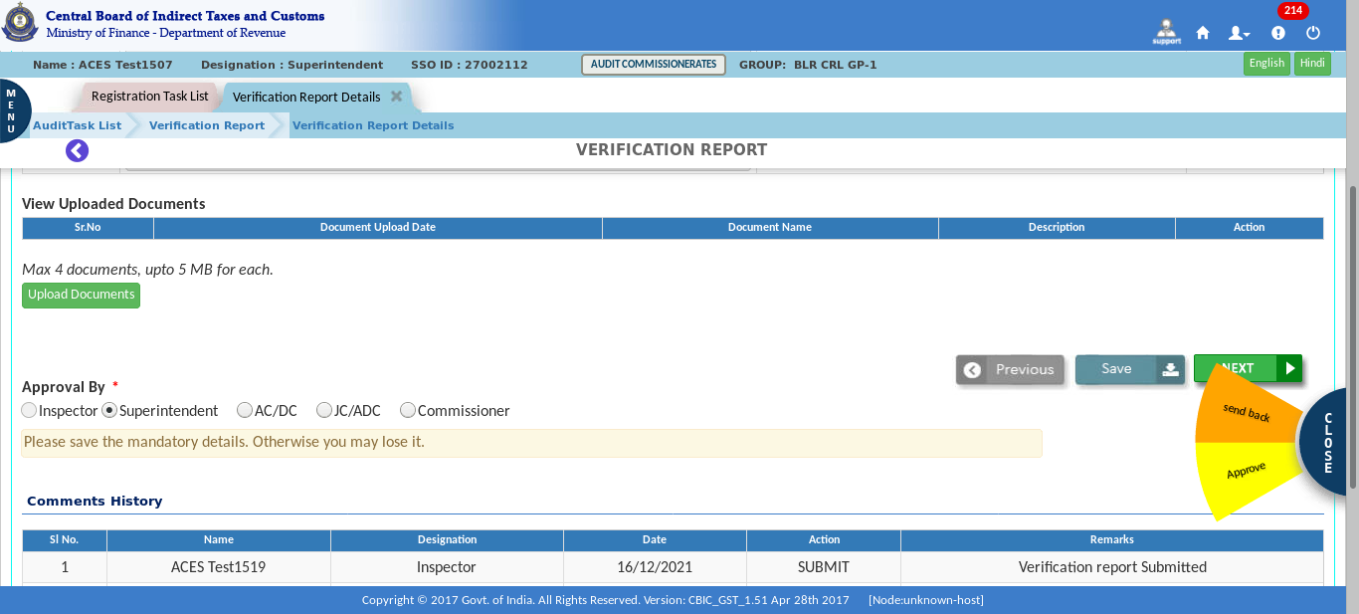

- A Confirmation pop-up appears, click on the “Yes” button to Approve the verification Report.
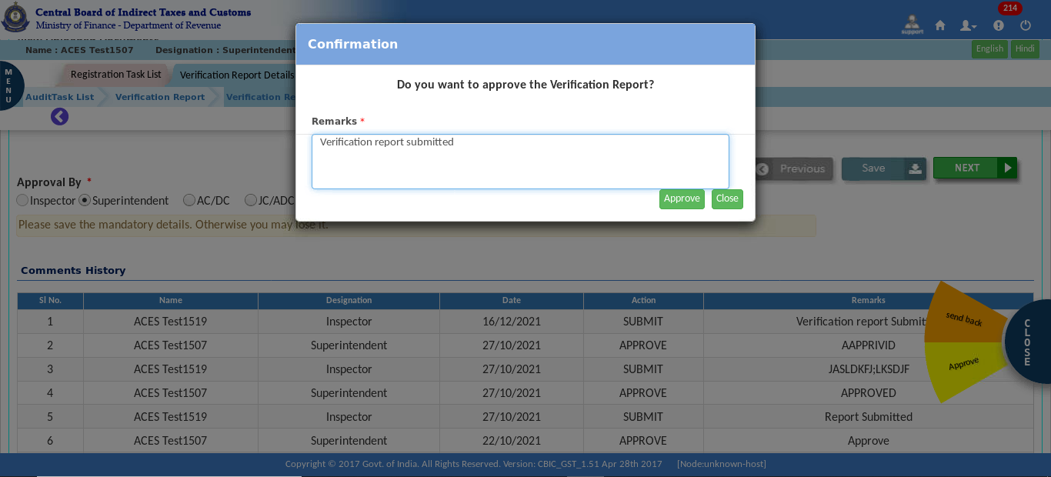
- A Confirmation pop-up appears, click on the “Yes” button to send back the verification Report.
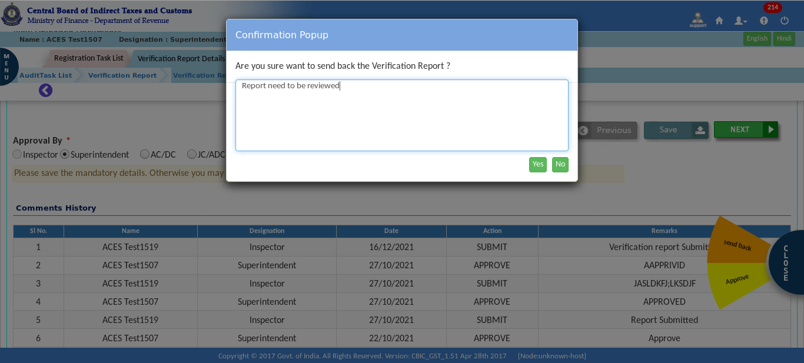

- After submission, a Success Message appears on the screen.
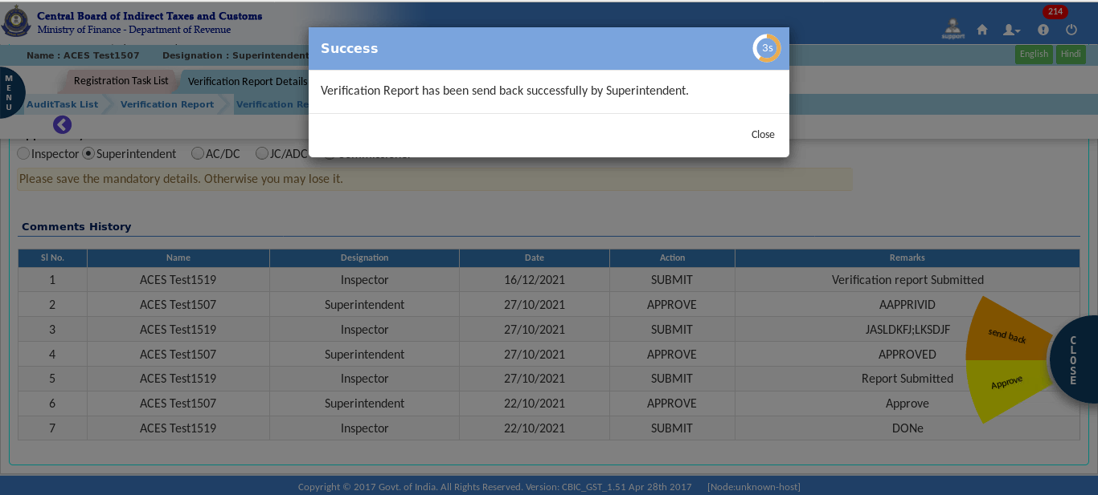
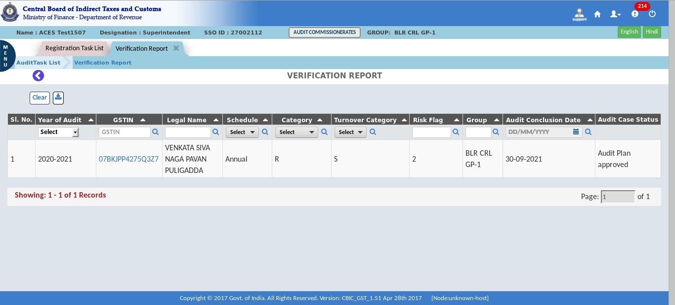
The Dashboard – Audit Case Status is approved as shown in the figure above

  - Create Draft Audit Report
Once verification report is submitted, CBIC GST System will create a task for Creation of Draft Audit Report.
- Click on the Menu > Task Lists > Audit.
- In the stage section, click on “Create Draft Audit Report”.
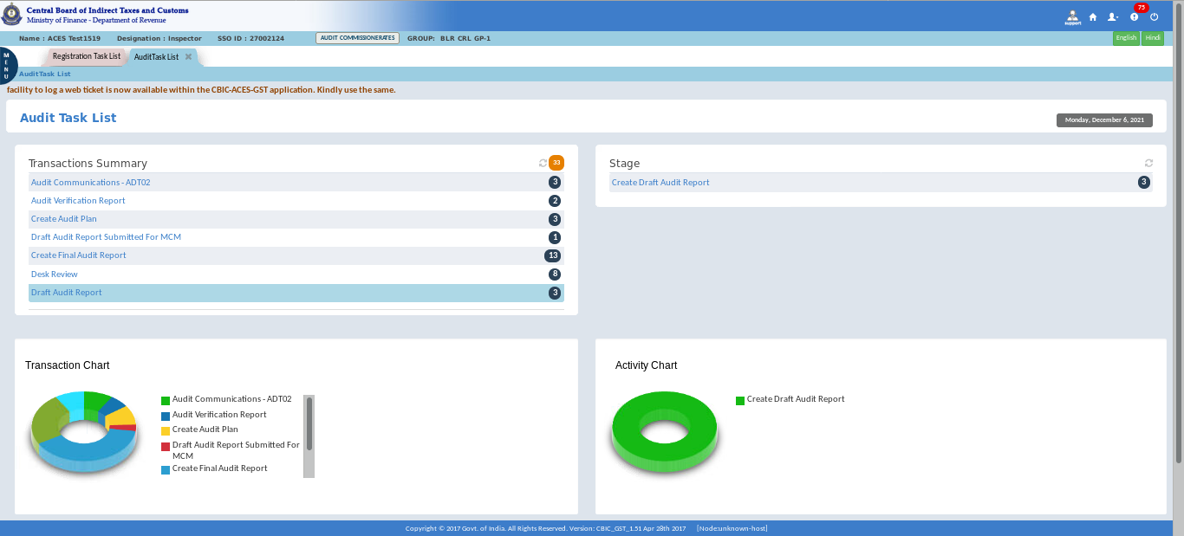

- Click on the “GSTIN”.
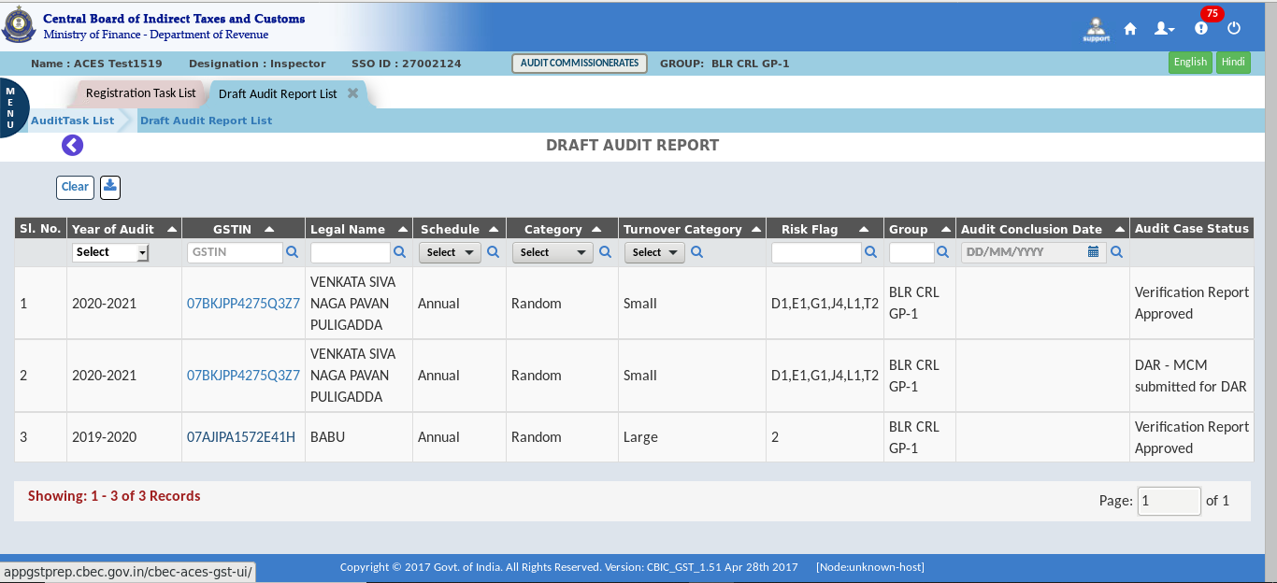
The Dashboard – Draft Audit Report screen displays as shown above.
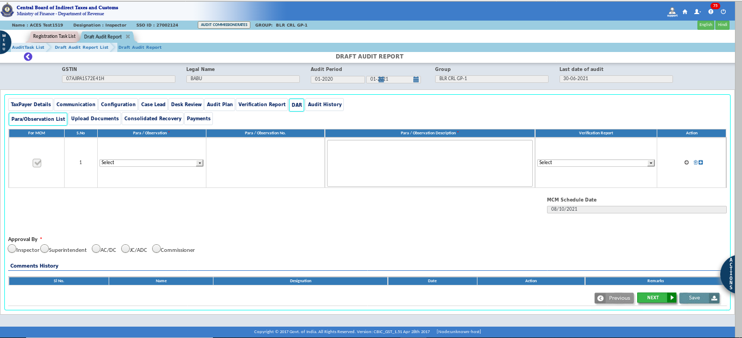
Note: "Draft Audit Report" displays the Para Observation List, Upload documents, Consolidated Recovery, and Payments tabs. The officer must complete all the paras and attach any needed documents, and all the tabs' additional information is auto populated.

- Click on “Submit DAR for MCM”.
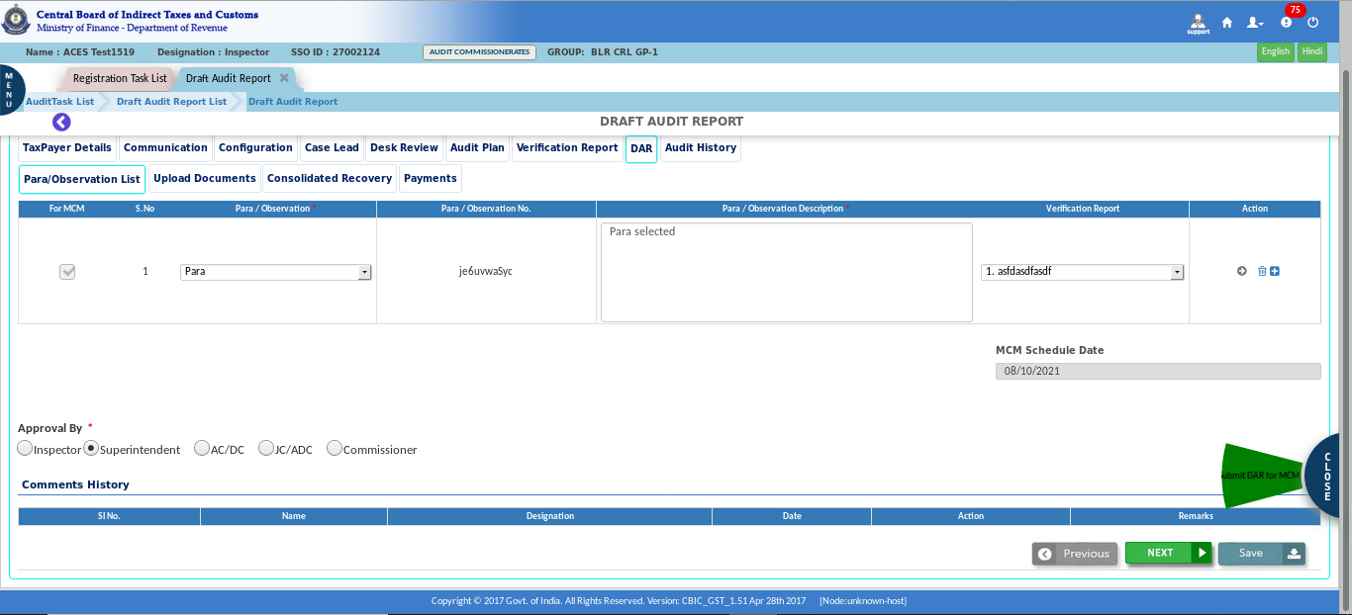
- Click on “Yes” for submit.
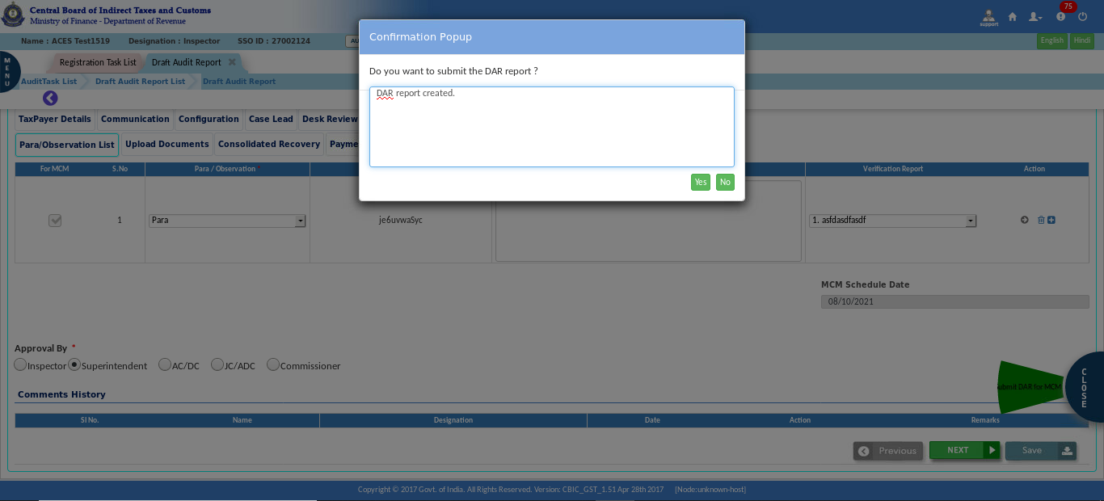

- A success message pop-up appears on the screen.
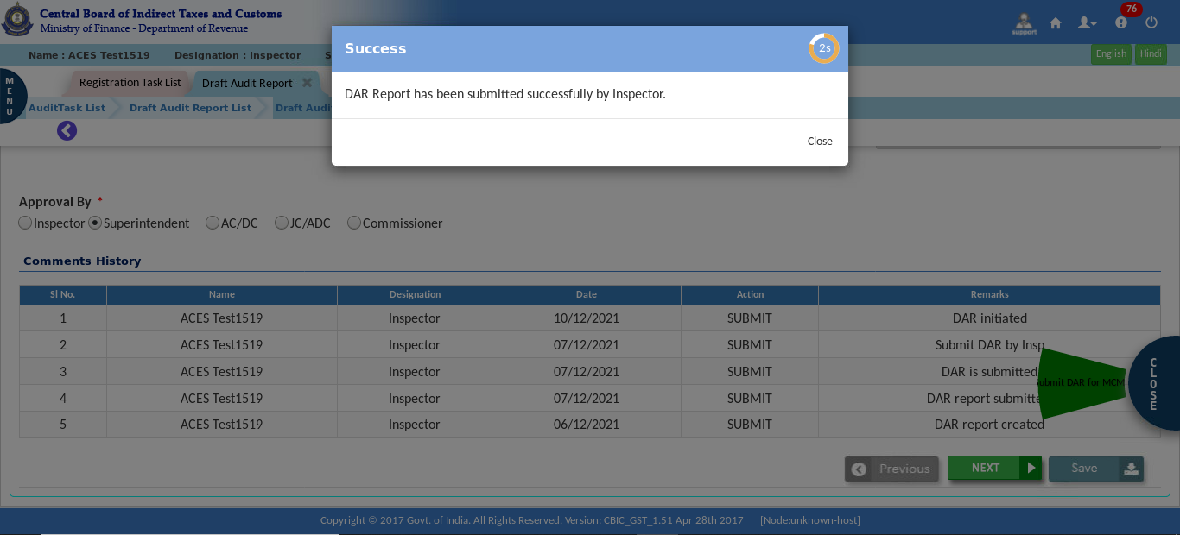
Note: It will go to the proper officer for Approval / Send Back with comments
Approval Process:
- Click on “Pending for Approval”.
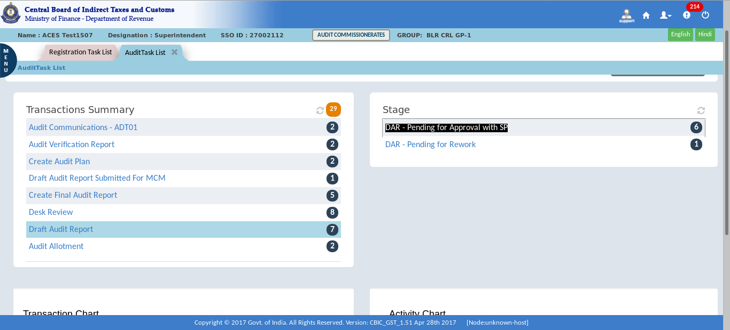

- Click on the “GSTIN”.
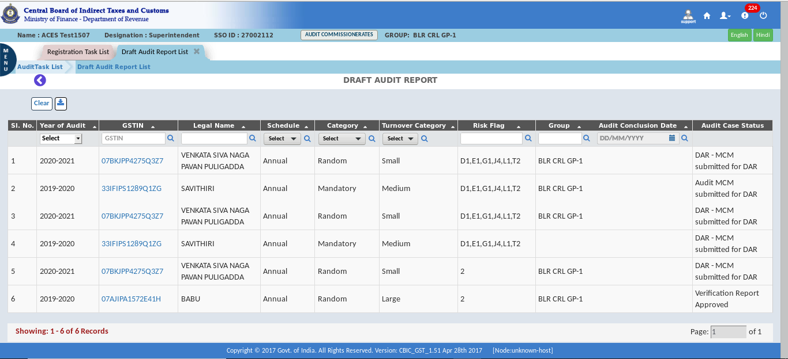
- Check all the details in each para.
- The “Actions” tab displays the Send Back, and Approve DAR to MCM.
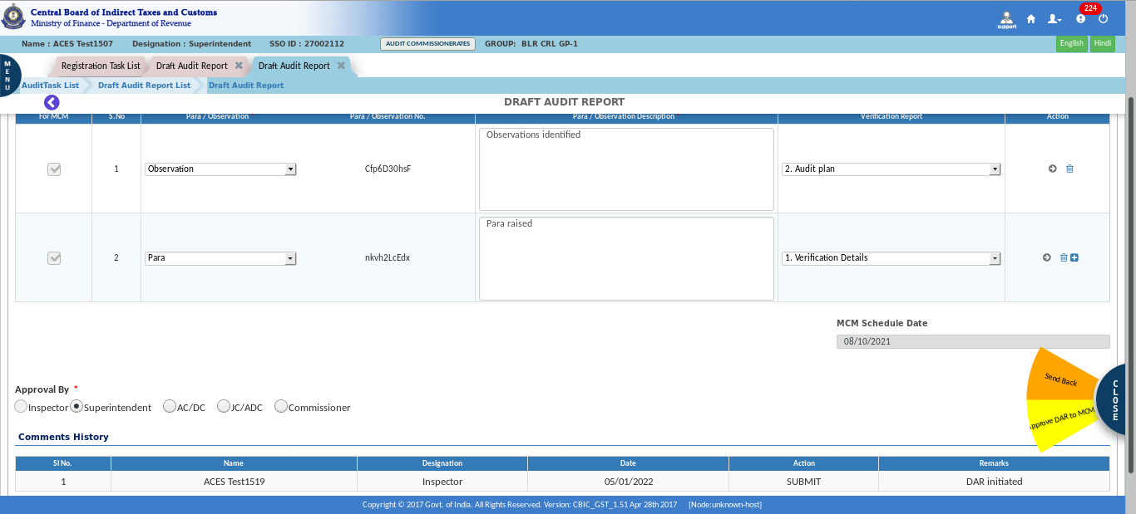

- Click on “Approve” to approve DAR for MCM.
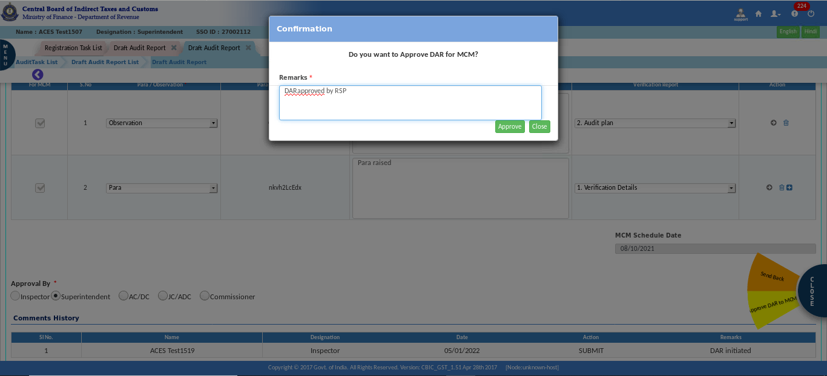
- A success message pop-up appears on the screen.
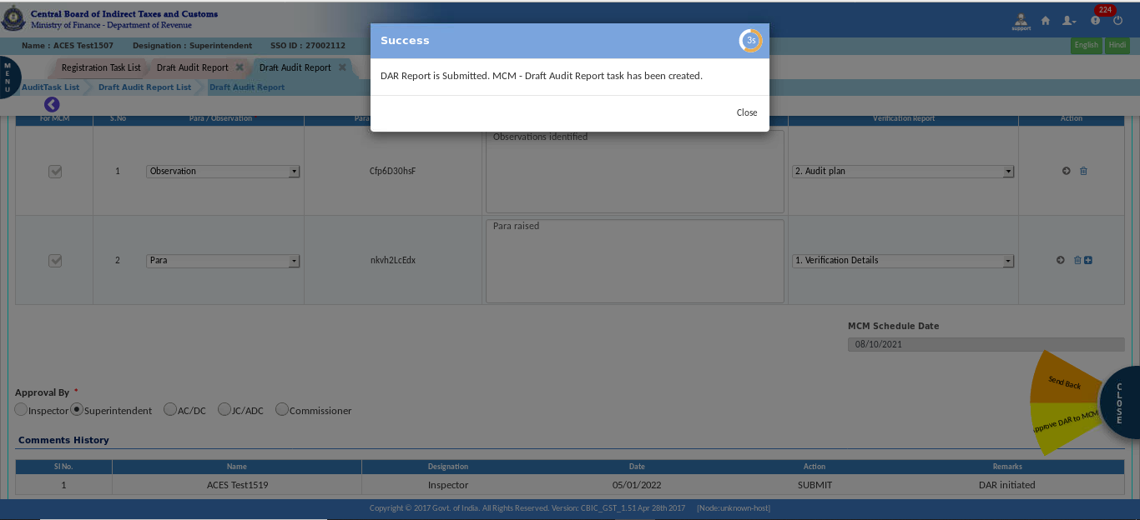
Note: DAR submit option will be enable only after capturing the MCM schedule date. Once the DAR is submitted to MCM, they will meet on a set day to discuss it and decide on it. They have the following options: Sustained, Deferred, Withdrawn, or Dropped. After that, the process is again transferred from MCM to DAR by submission. Again, the DAR is checked and approved by the officer and initiates the FAR.

MCM Date and Venue
Draft Audit Report Submitted For MCM
At regular intervals, MCM meetings will be conducted offline, and in such meetings, the MCM decision for each para will be decided. Capturing the MCM decision in the CBIC GST System will be an online activity.
Once the Planning Cell intimates the MCM Venue, Date & Time, the CBIC GST System will create a Task at Audit Commissionerate Level (Planning Cell) for capturing the MCM Decision for Each Para.
- Click on the Menu > Audit > MCM Date and Venue.
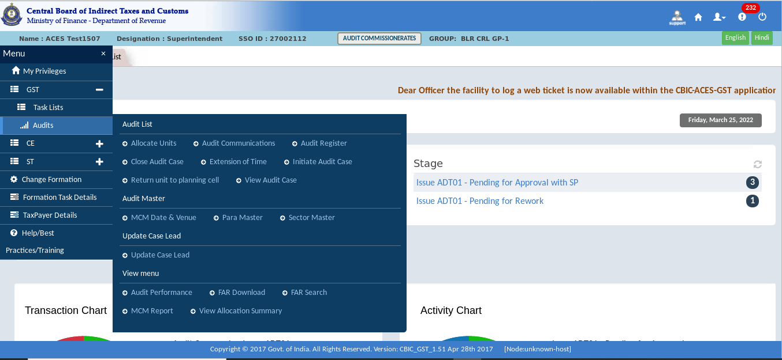

- Fill all required details and submit.
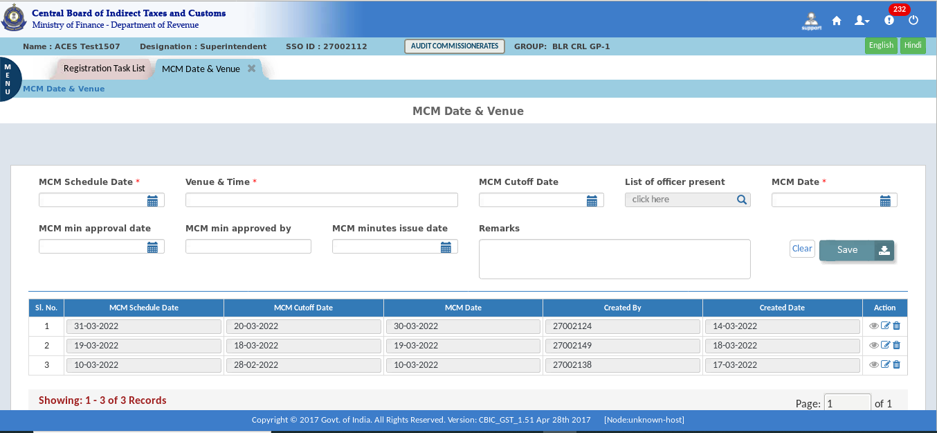
The Dashboard – MCM Date and Venue screen displays as shown above.
- A Confirmation pop-up appears, click on “yes” to submit.
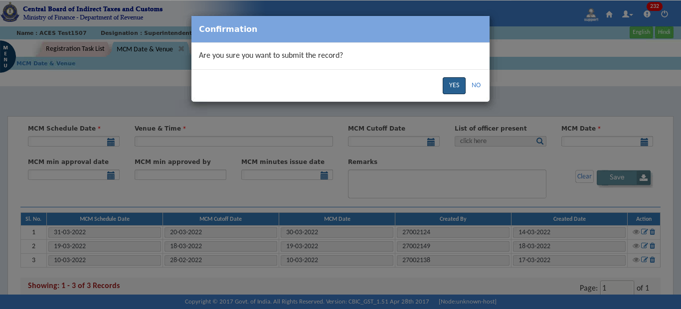

- A Success Message appears on the screen.
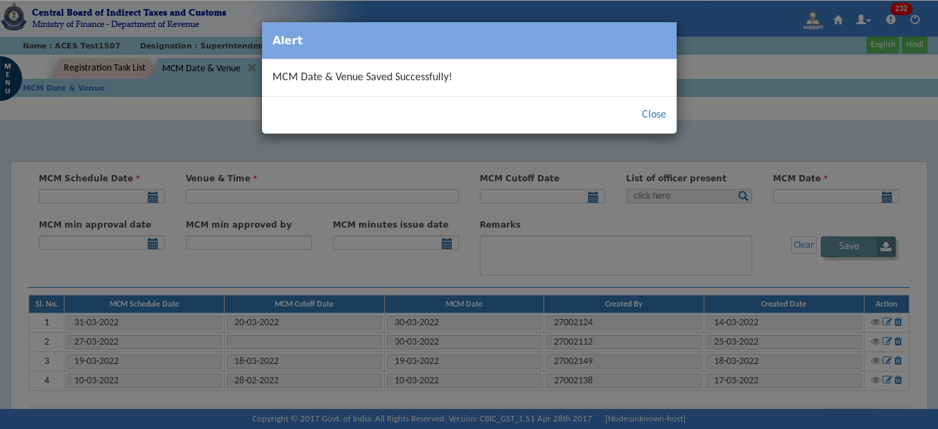

Pending for Approval
- Click on the “Pending for Approval”.
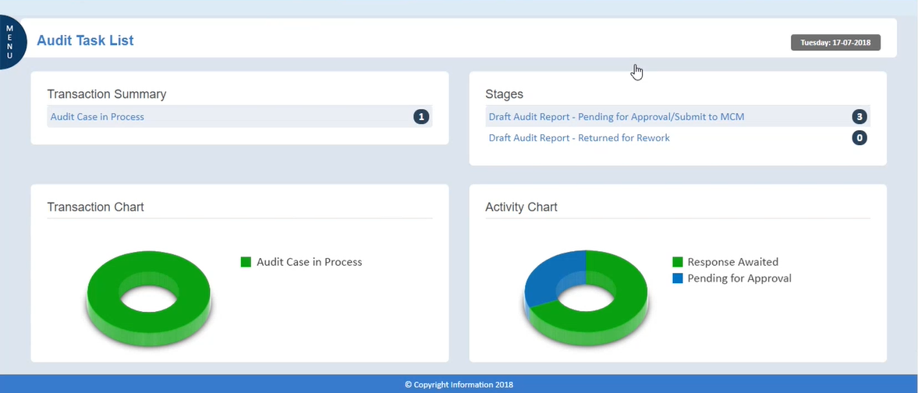
- Click on “GSTIN”.
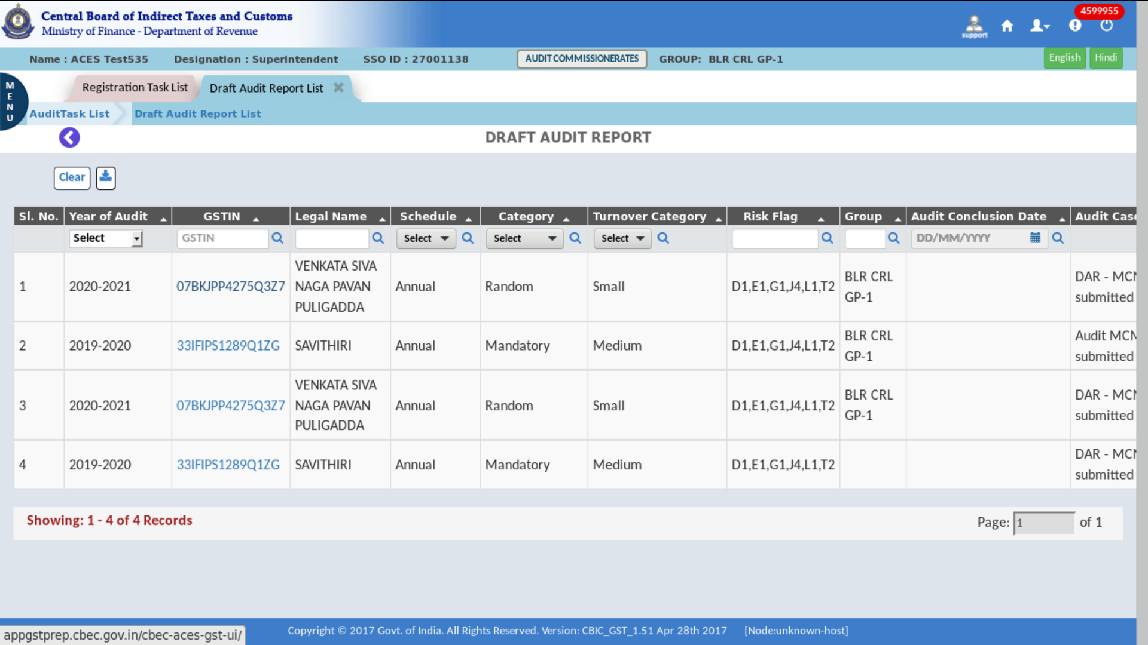

- Check all the details in each para.
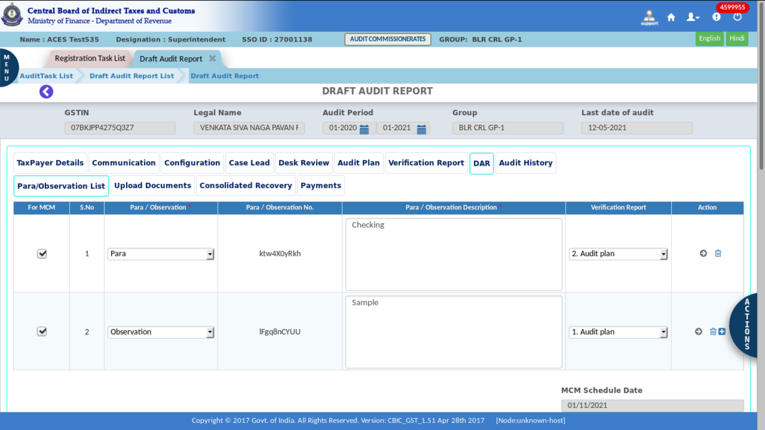
- Click on the suitable option in the Action tab.
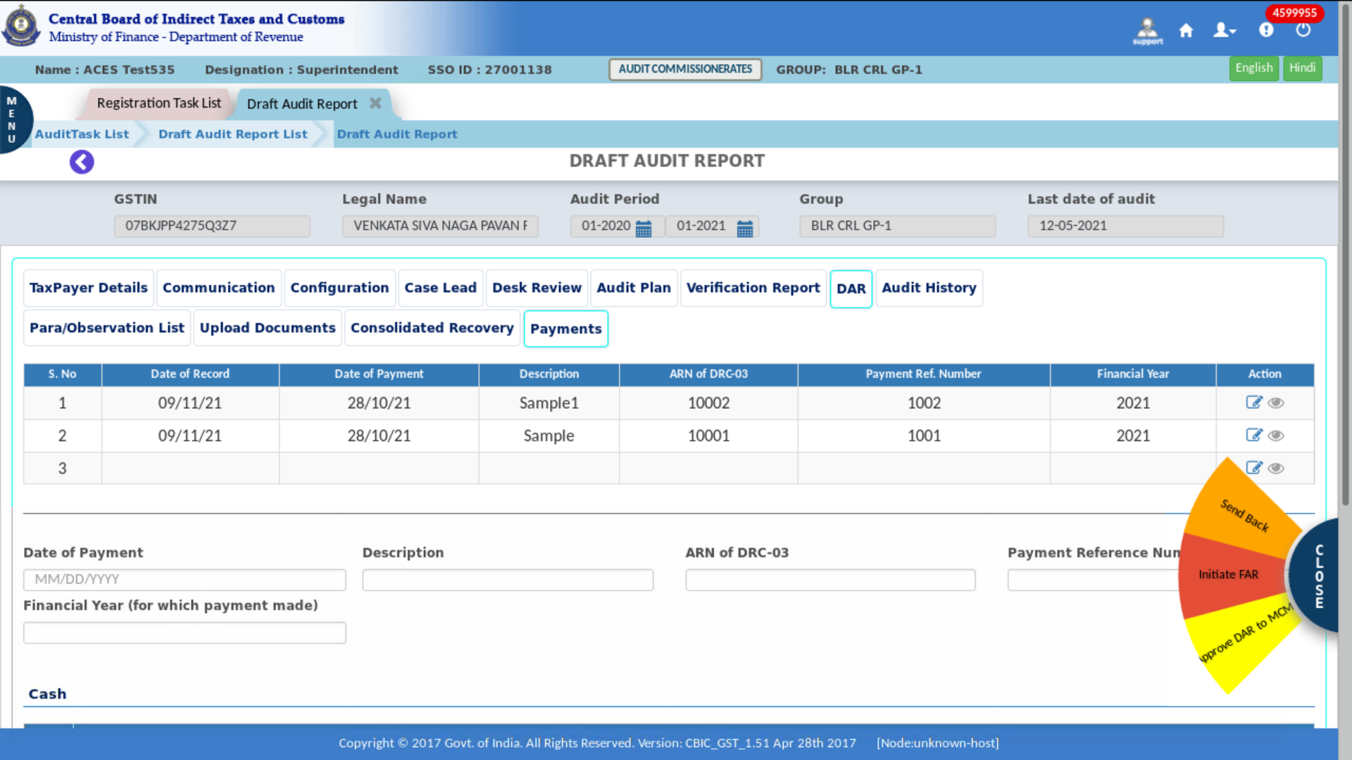
Note: The “Actions” tab displays the Send Back, Initiate FAR, and Approve DAR to MCM.

- Click on “yes” to send back.
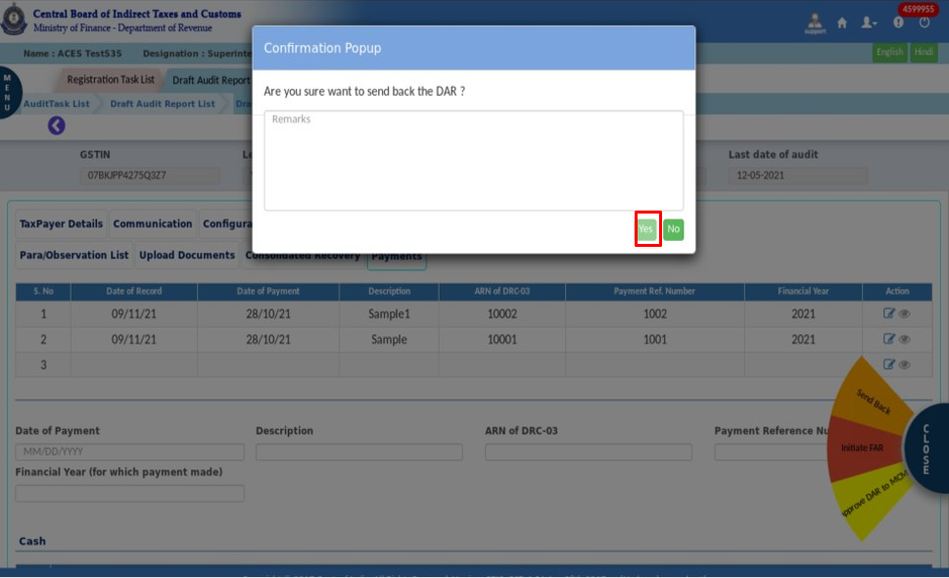
- Click on “Initiate” to Initiate FAR.
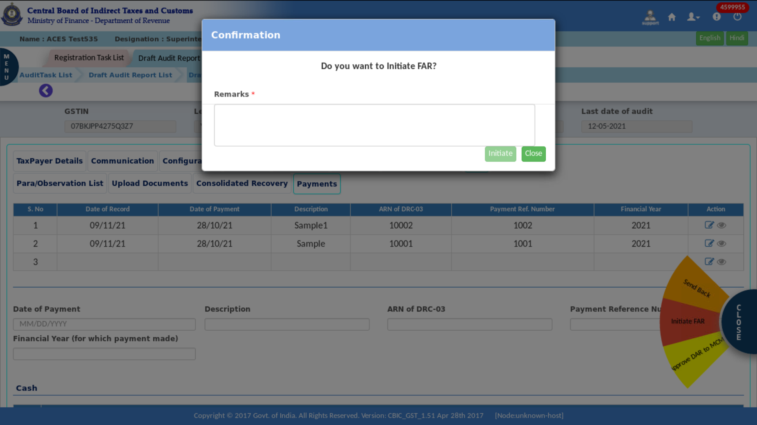

- Click on “Approve” to approve DAR for MCM.
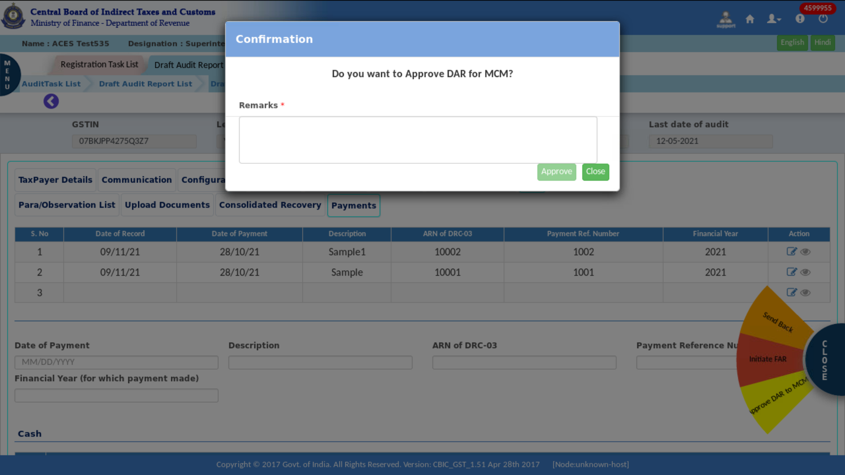

- View-DAR
- Click on the Menu >Task list > Audit.
- In the stage section for the Draft Audit Report, click on "Create Draft Audit Report."
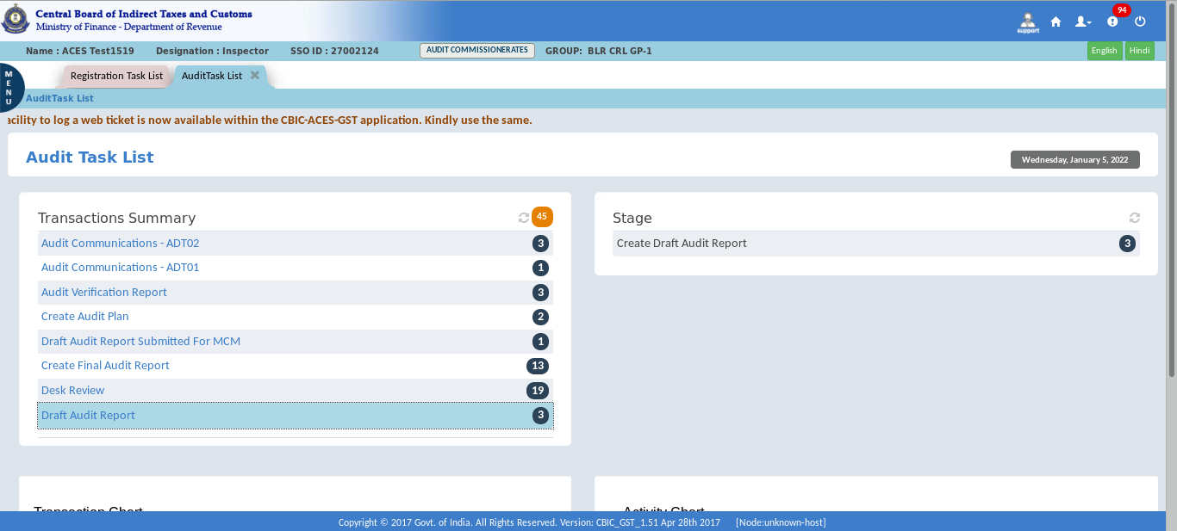
- Click on the “GSTIN”.
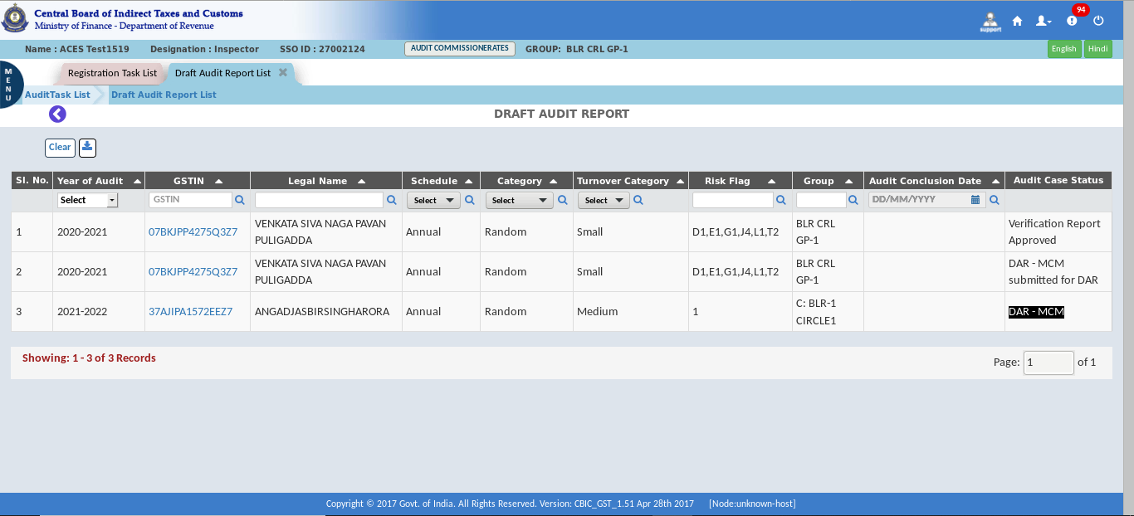

- Check all the details in each para.
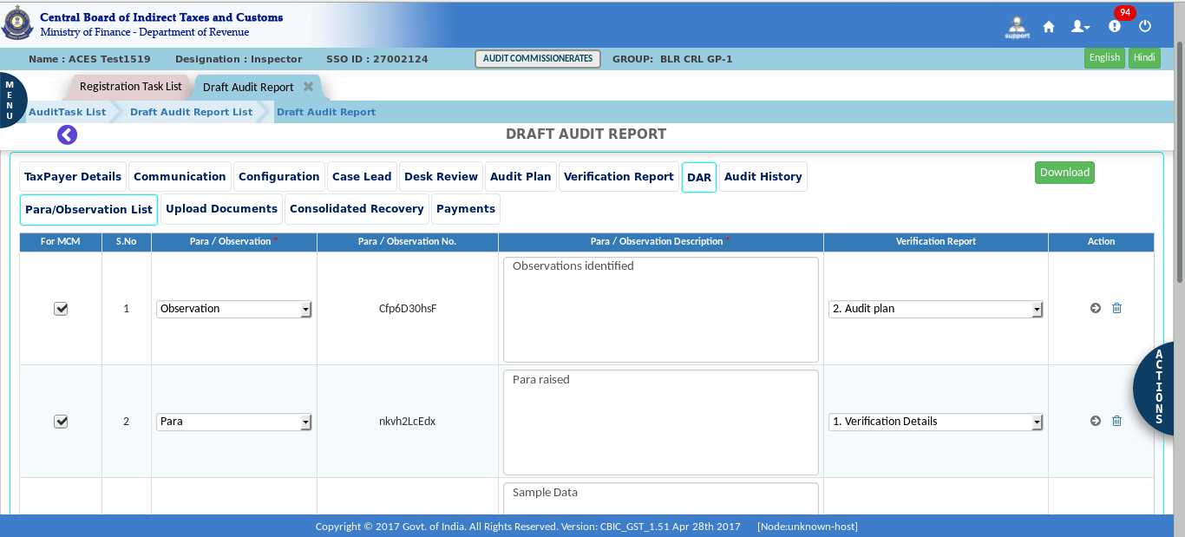
The Dashboard – Draft Audit Report screen displays as shown above.
Note: "Draft Audit Report" displays the Para Observation List, Upload documents, Consolidated Recovery, and Payments tabs. The officer must complete all the paras and attach any needed documents, and all the tabs' additional information is auto populated.
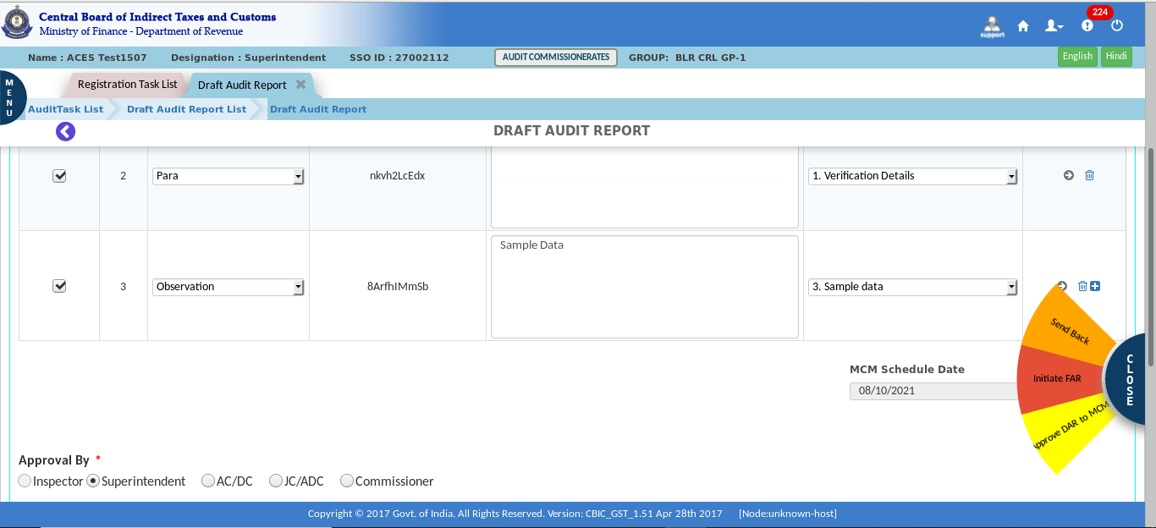
Note: The “Actions” tab displays the Send Back, Initiate FAR, and Approve DAR to MCM.

- Click on “Initiate” to Initiate FAR.
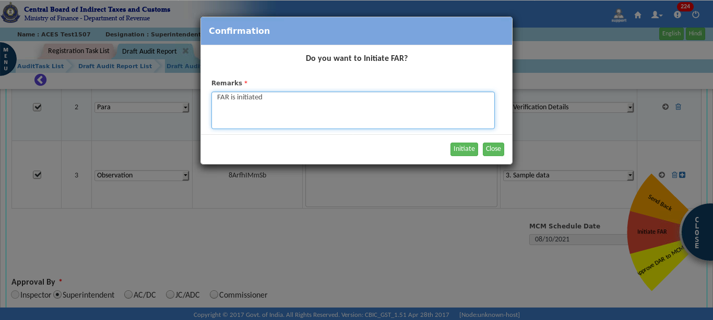
- After submission, a Success Message appears on the screen.
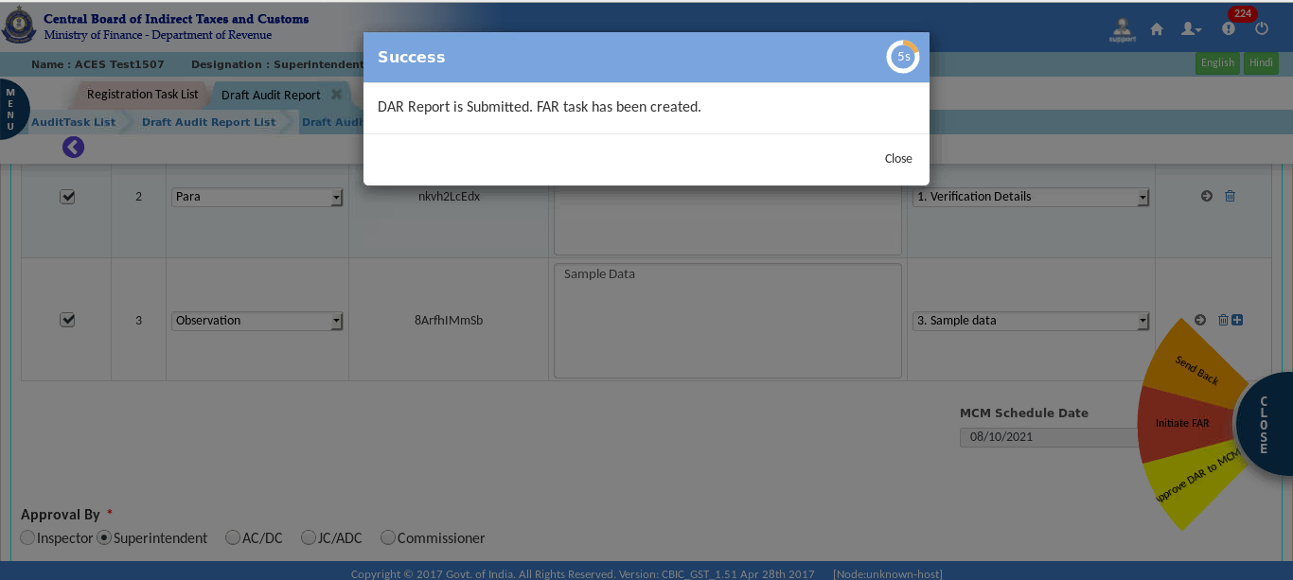

  - Capture MCM Decision
At regular intervals, MCM meetings will be conducted offline and, in such meetings, the MCM decision for each para will be decided. Capturing the MCM decision in CBIC GST System will be an online activity.
Once the Planning Cell Intimate the MCM Venue, Date & Time, CBIC GST System will create a Task at Audit Commissionerate’s Level (Planning cell) for capturing the MCM Decision for Each Para.
- Click on the Menu >Task list > Audit.
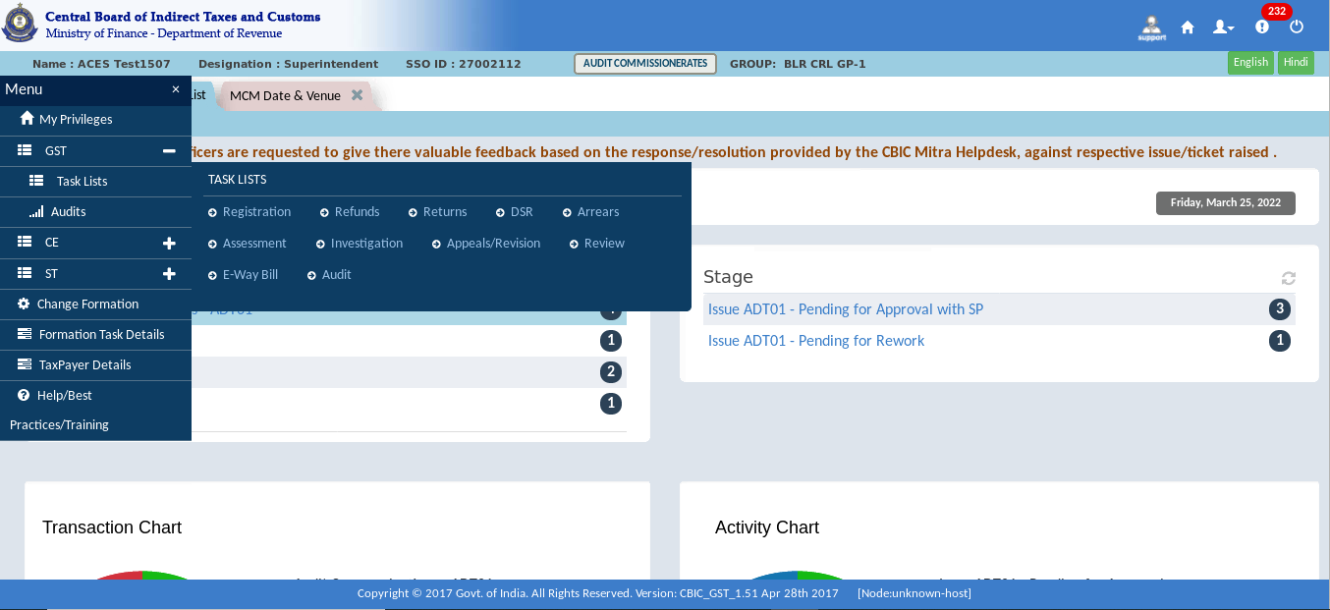
- Click on “Pending for Approval”.
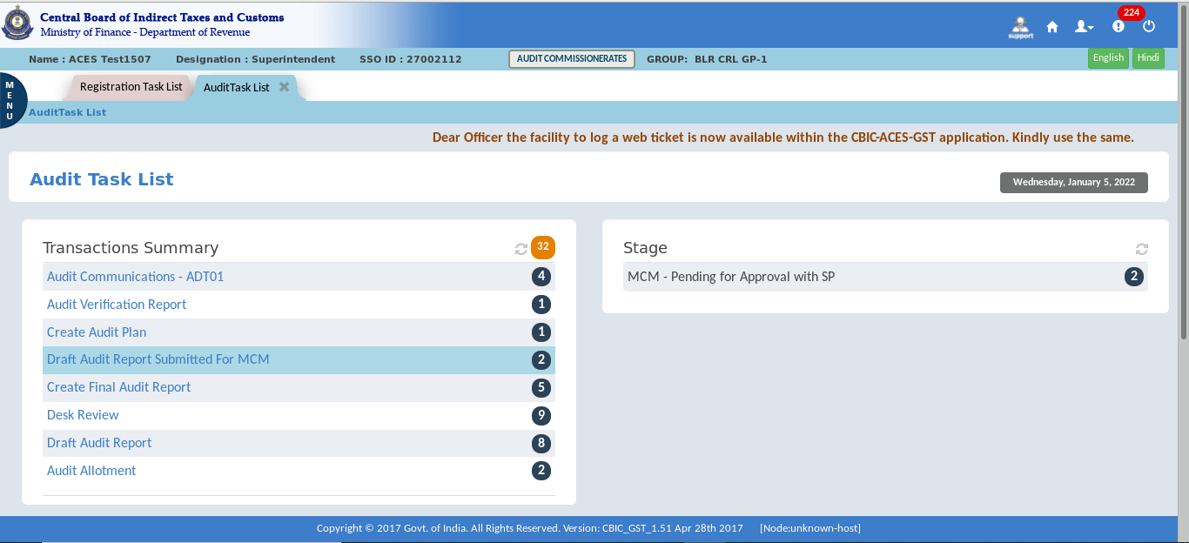

- Click on the “GSTIN”.
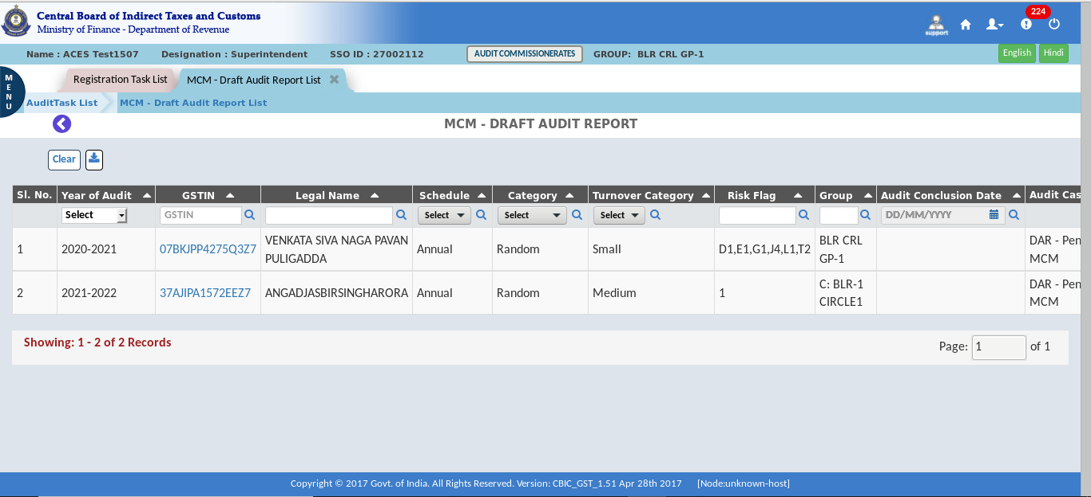
- Check all the details in each para.
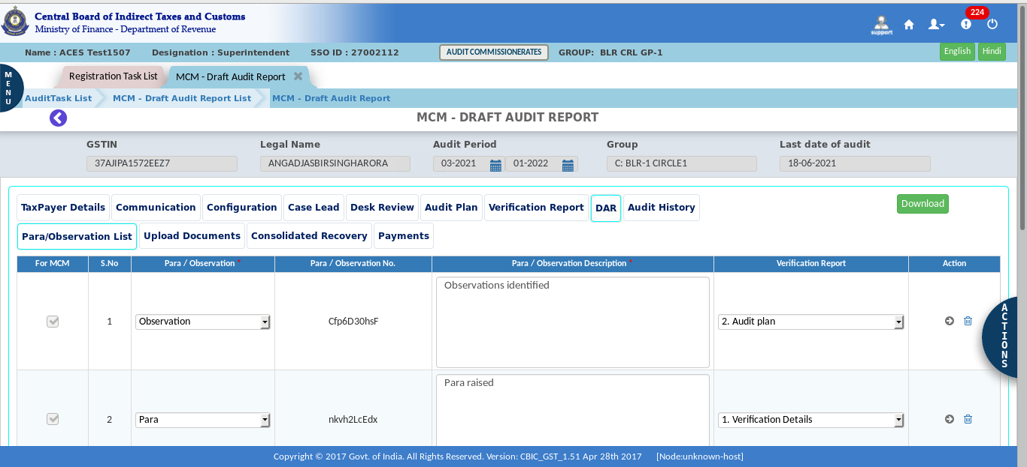
Note: Following the selection of GSTN, the "DAR" displays the Para Observation List, Upload documents, Consolidated Recovery, and Payments tabs. And the details are auto-populated for all the tabs. And they have the following option: Sustained / Deferred / Withdrawn / Dropped.

- Click on the Action Tab, select Send Back / Approve DAR for MCM.
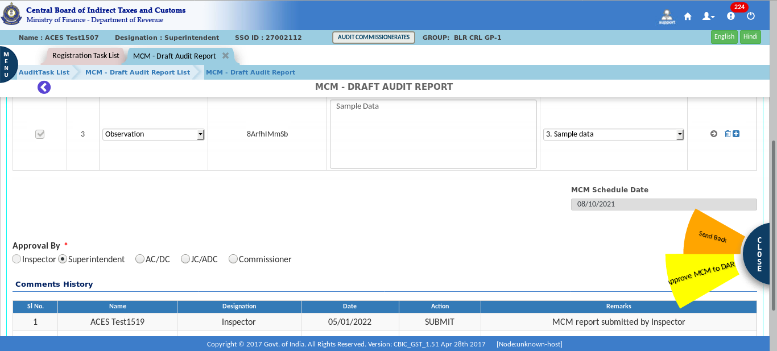
Note: The “Actions” tab displays the Send Back, and Approve DAR for MCM.
- Click on “Approve” for Approve DAR for MCM.
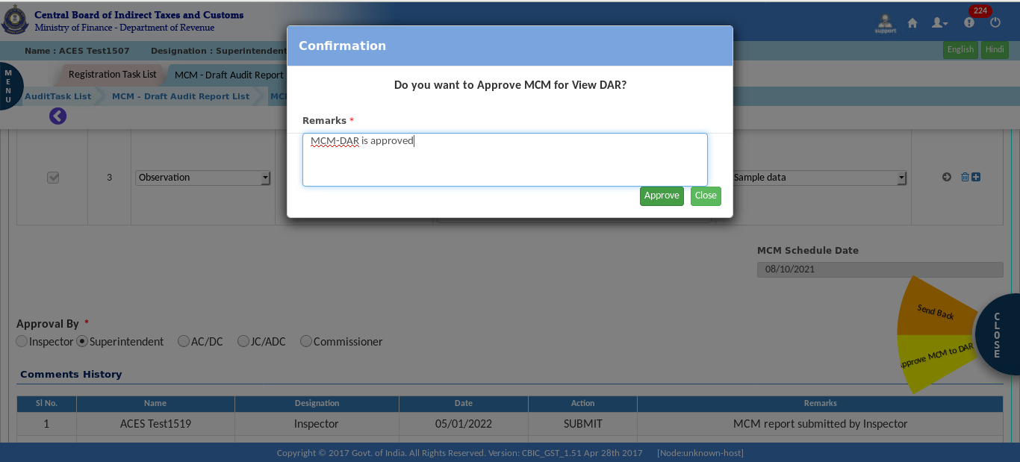

- After submission, a Success Message appears on the screen.
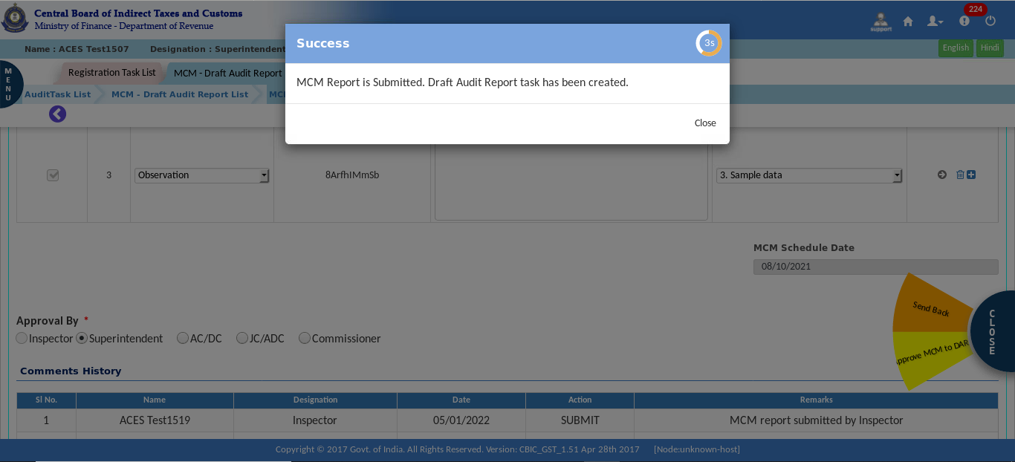

  - Create Final Audit Report
Once the MCM Decision is captured in the System, Inspector/SP/Auditor will create Final Audit Report if there is no Deferred Para for the given Audit Case. Only the para which are sustained will be listed in the FAR i.e., deferred/dropped/withdrawn paras will not be listed in FAR.
The Inspector/SP/Auditor will create the Final Audit Report and then click on Submit for Approval. After that Final Audit Report is pending for approval.
- In the stage section, click on “Create Final Report”.
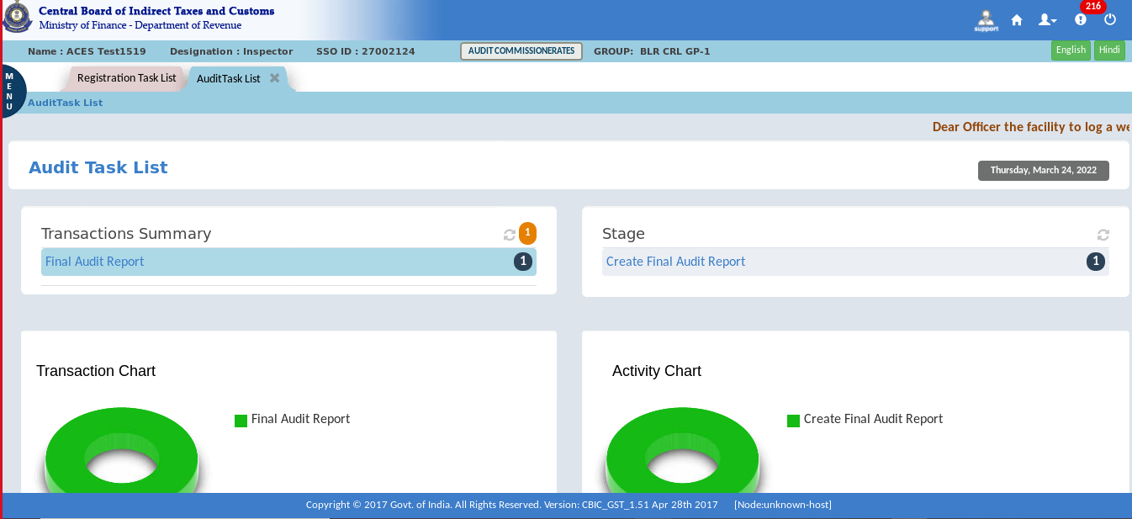
- Click on the “GSTIN” number.
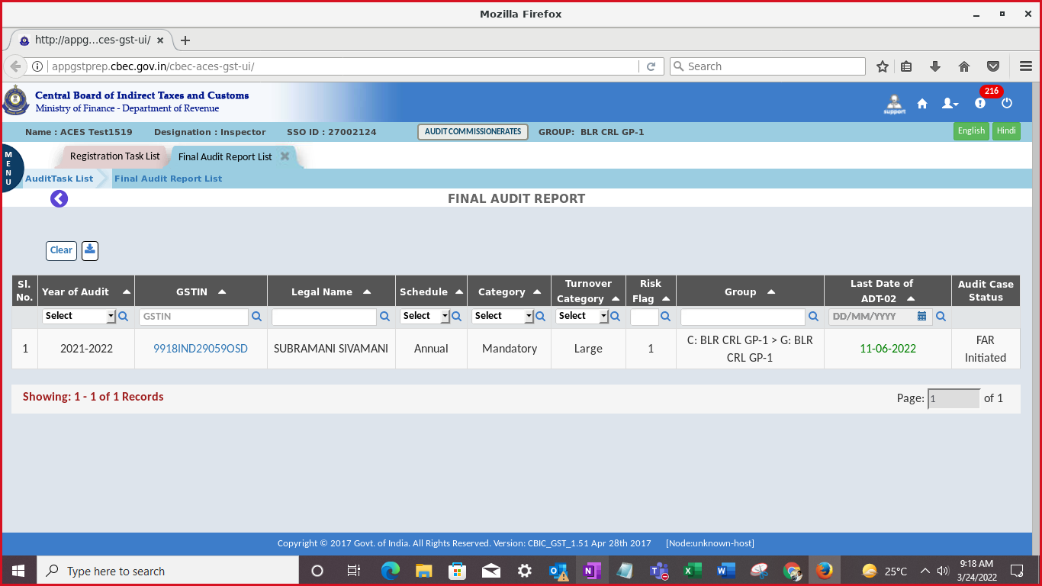
- The Final Audit Report tab displays the Taxpayer Details, Communication, Configuration, Case Lead, Desk Review, Audit Plan, Verification Report, DAR, FAR and Audit History tabs. Click each tab to view the detailed information.
- The FAR tab further displays the Para/Observation List, Upload Documents, Consolidated Recovery and Payments tabs. Check the paras and, if necessary, add or delete the necessary details.
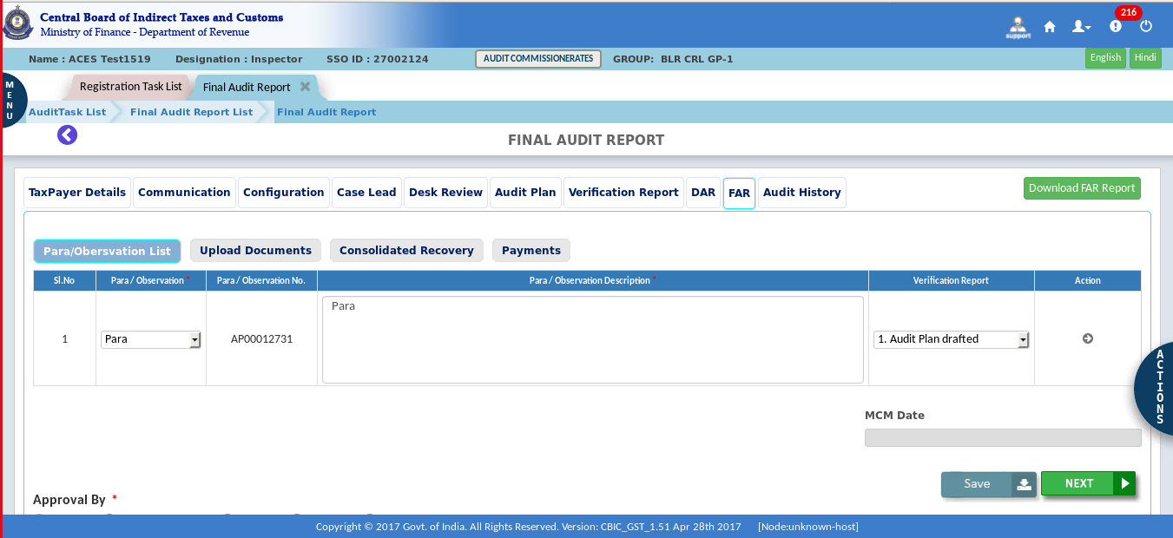
- Select officer as approving authority.
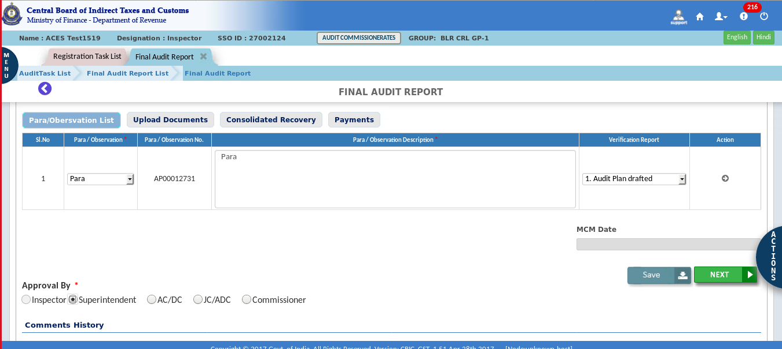

- Click on the “Submit button” for Approval.
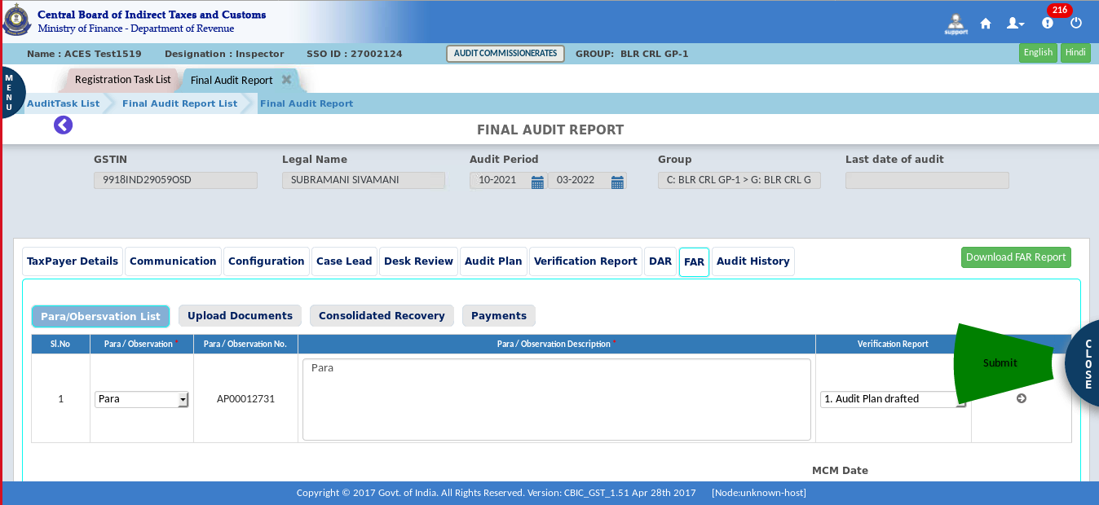
- A confirmation pop-up appears, click on “yes” for confirmation.
- After submission, a Success Message appears on the screen.
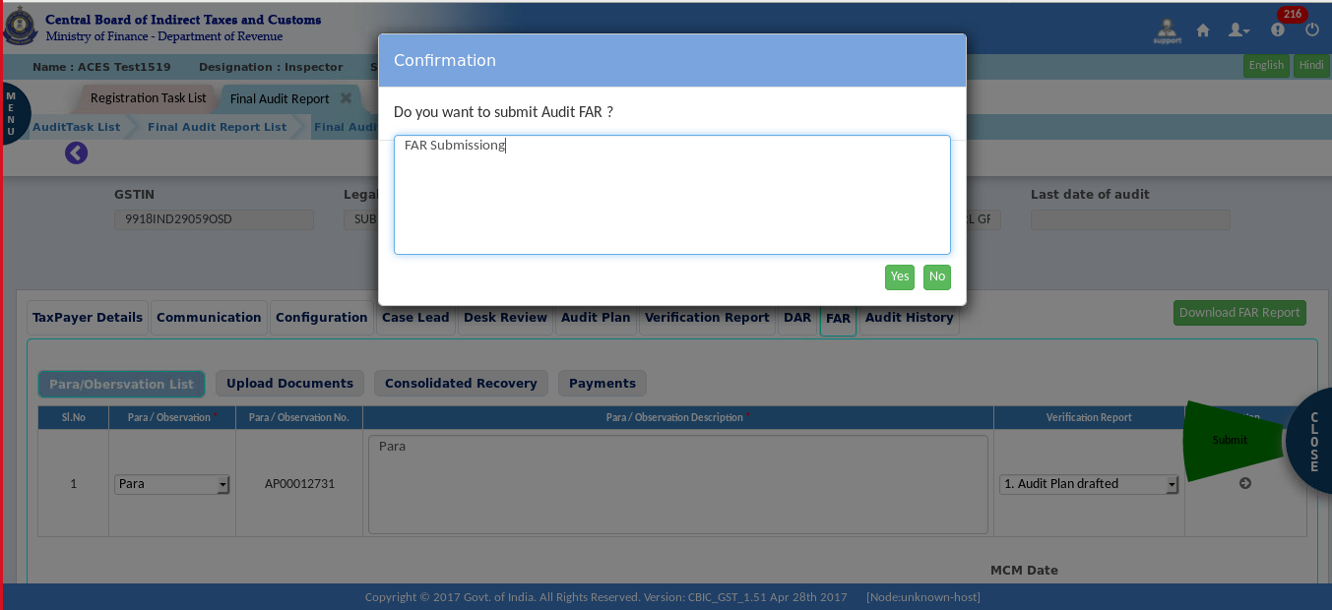

Approval Process:
- In the stage section, click on " Final Audit Report - Pending for Approval".

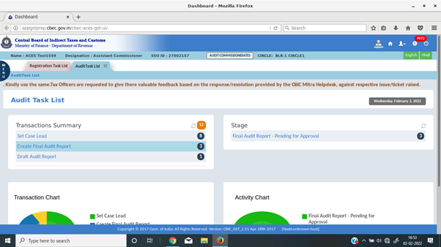
- Click on the “GSTIN” number.
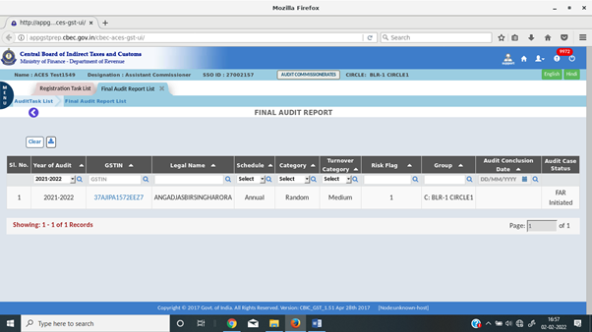

- Check the paras and, if necessary, add or delete the necessary details.
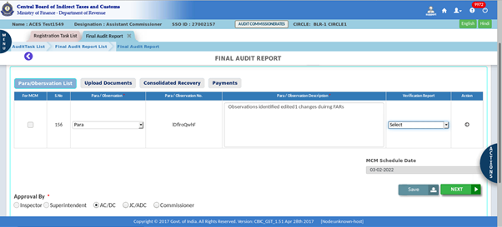
- Click on the "Approve" button for the final audit report.
- Click "yes" to send back the Audit FAR.
- Click on the "Yes" button for the approval of the final audit report.
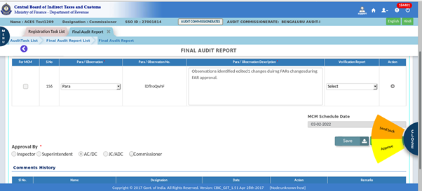
Note: In the Final Audit Report, the officer must examine or edit the details in all the paras. There are two options in the "actions tab": either “Send back” or “Approve”. Click "yes" to send it back or click on the "Approve" button for the final audit report.

  - Issue ADT 02
Once the Final Audit Report is Approved, System will create a Task to Issue ADT 02 to Taxpayer.
- Click on Audit > Audit Communication.
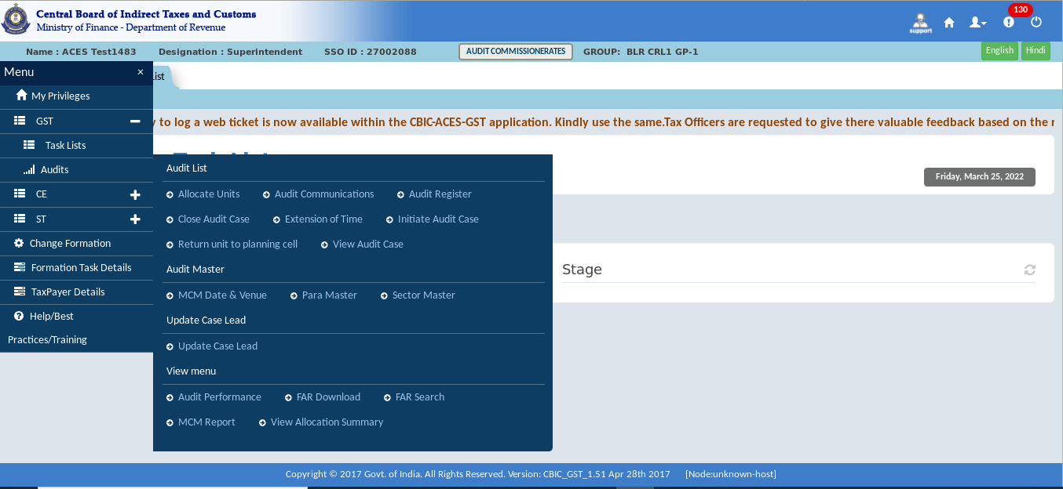
- To issue ADT 02, click Select Form and then ADT – 02.
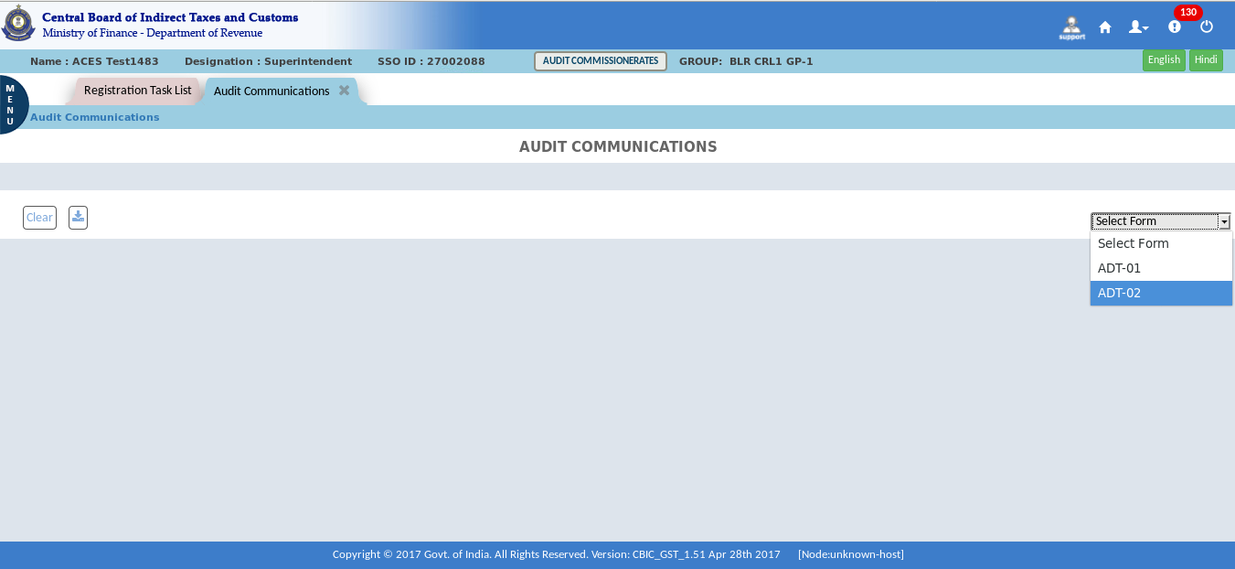

- Click on “GSTIN” for issuing ADT 02.
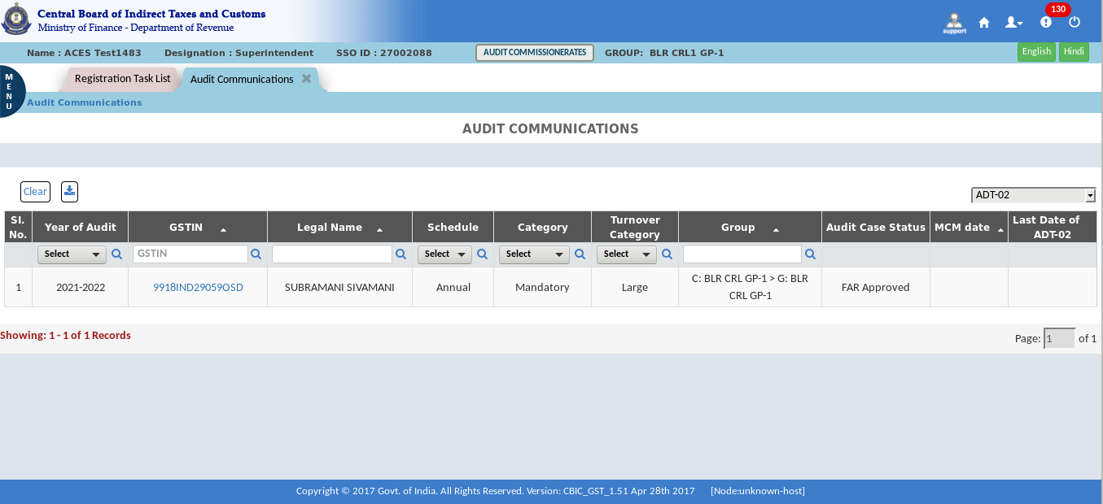
The Dashboard – Audit Communication screen displays as shown above.
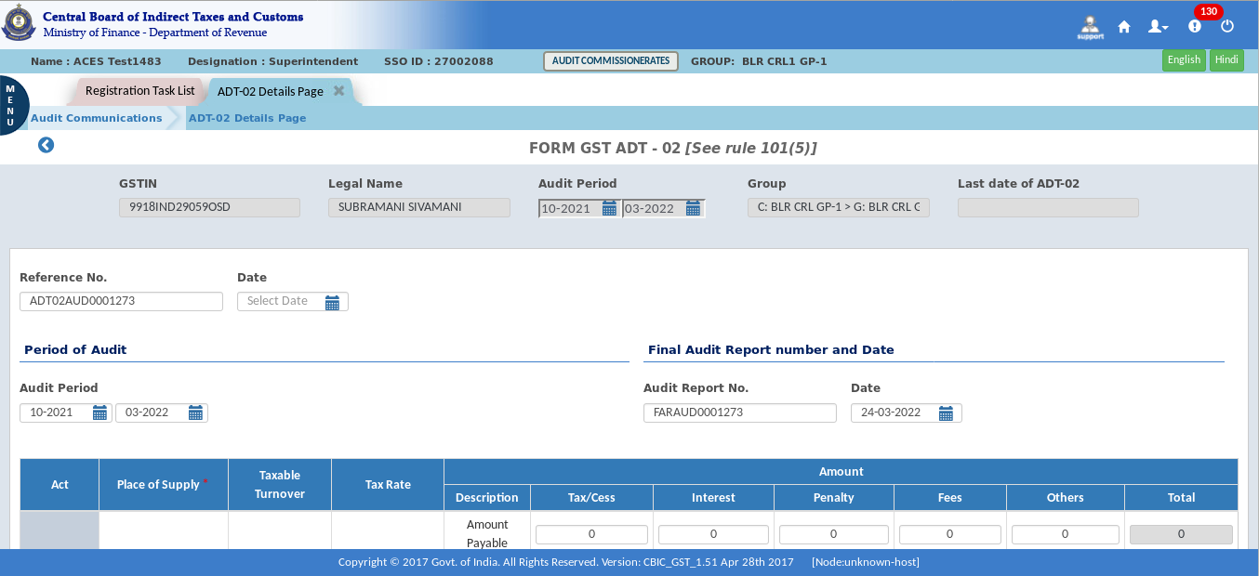
Note: The ADT-02 form is open, and the officer must fill in all the required information and attach any necessary documents.

- Click on “Submit” for approval.
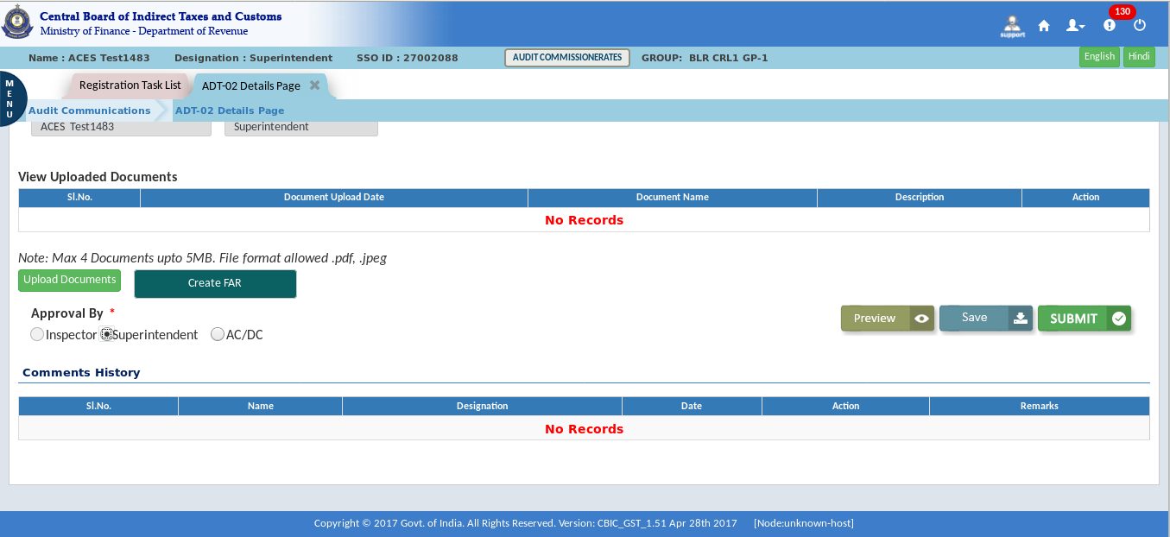
- A confirmation pop-up appears, click on “Submit” Button for confirmation.
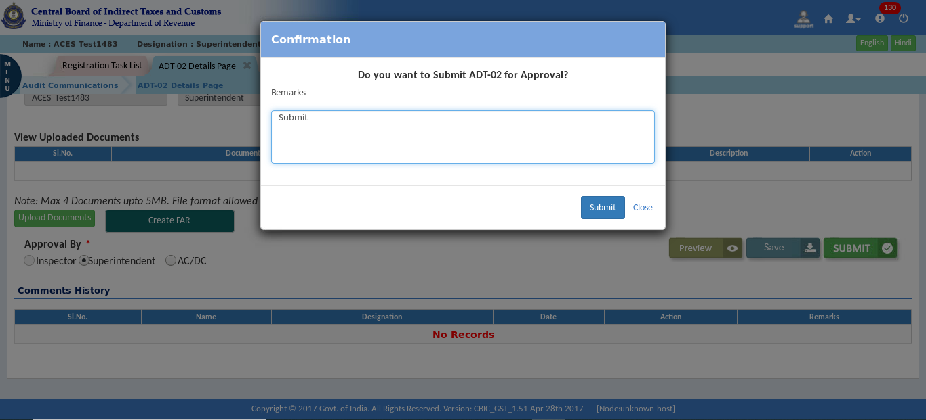
- After submission, a Success Message appears on the screen.
Note: On the approving authority's screen, a Pending Alert appears.

- In the stage section, click on "Pending for Approval."
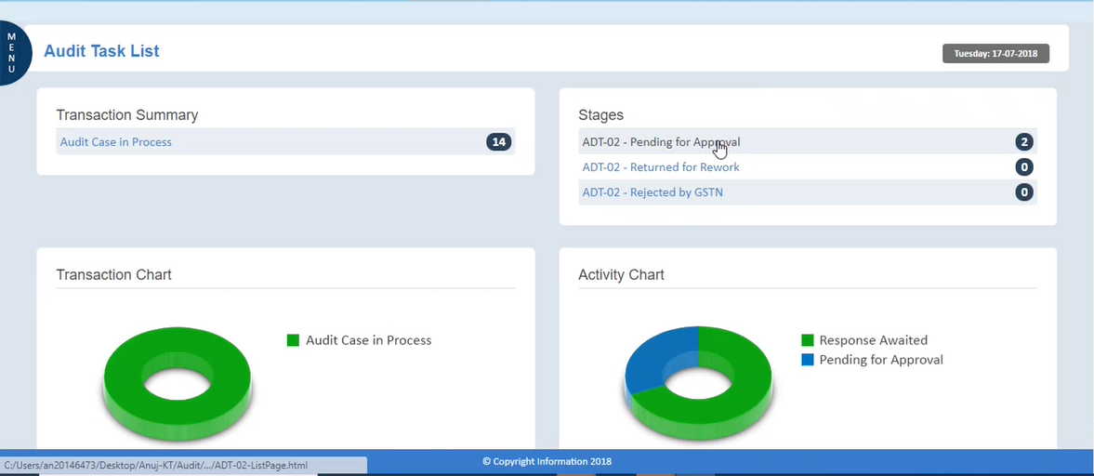
Note: After clicking on Pending for Approval, ADT-02 is displayed for approval.
- Click on the “GSTIN”.
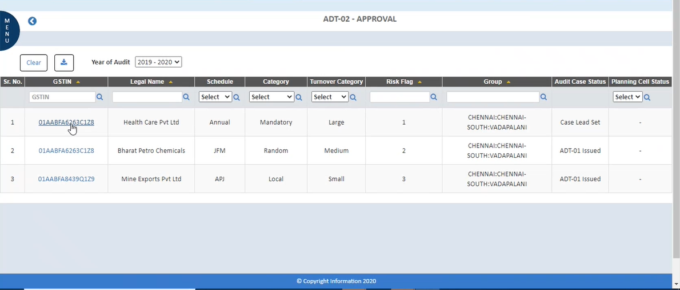
Note: All the details are displayed on the screen of the approving authority. The officer will check the details.

- Click on the "Approve" button for approval.
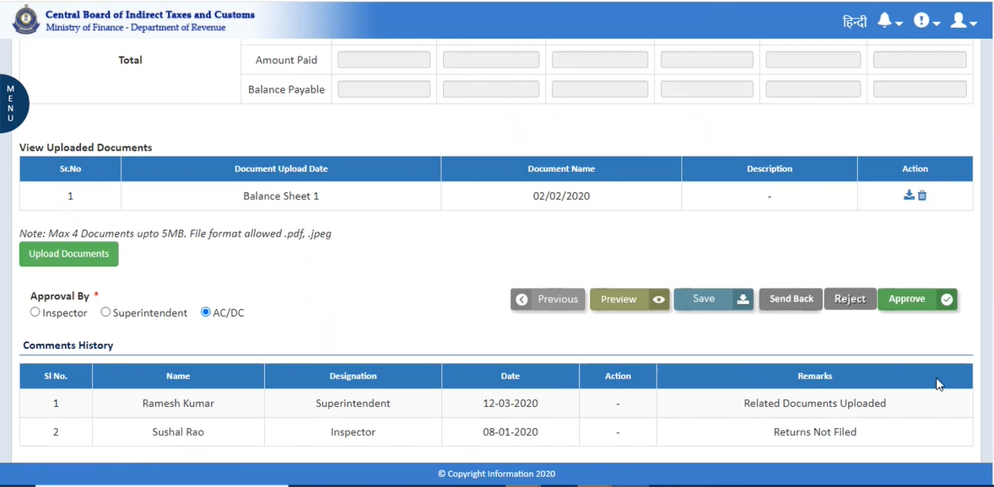
- A Confirmation pop-up appears, click on “Approve” for confirmation.
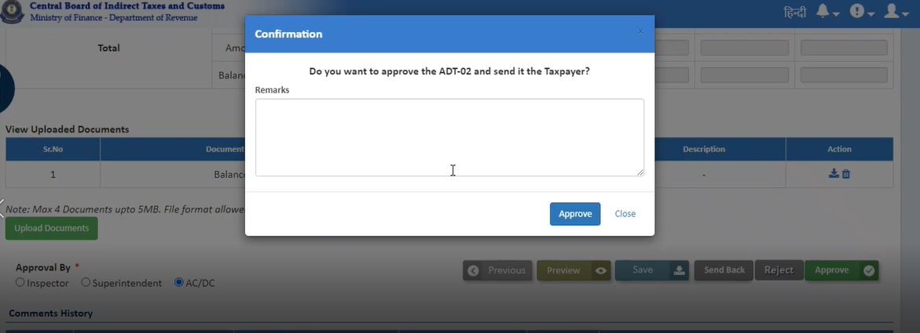
- After submission, a Success Message appears on the screen.

  - Audit Closure
Tax Officer can close the Audit File once ADT 02 is issued to the taxpayer.
- Click on the Audit > Close Audit Case.
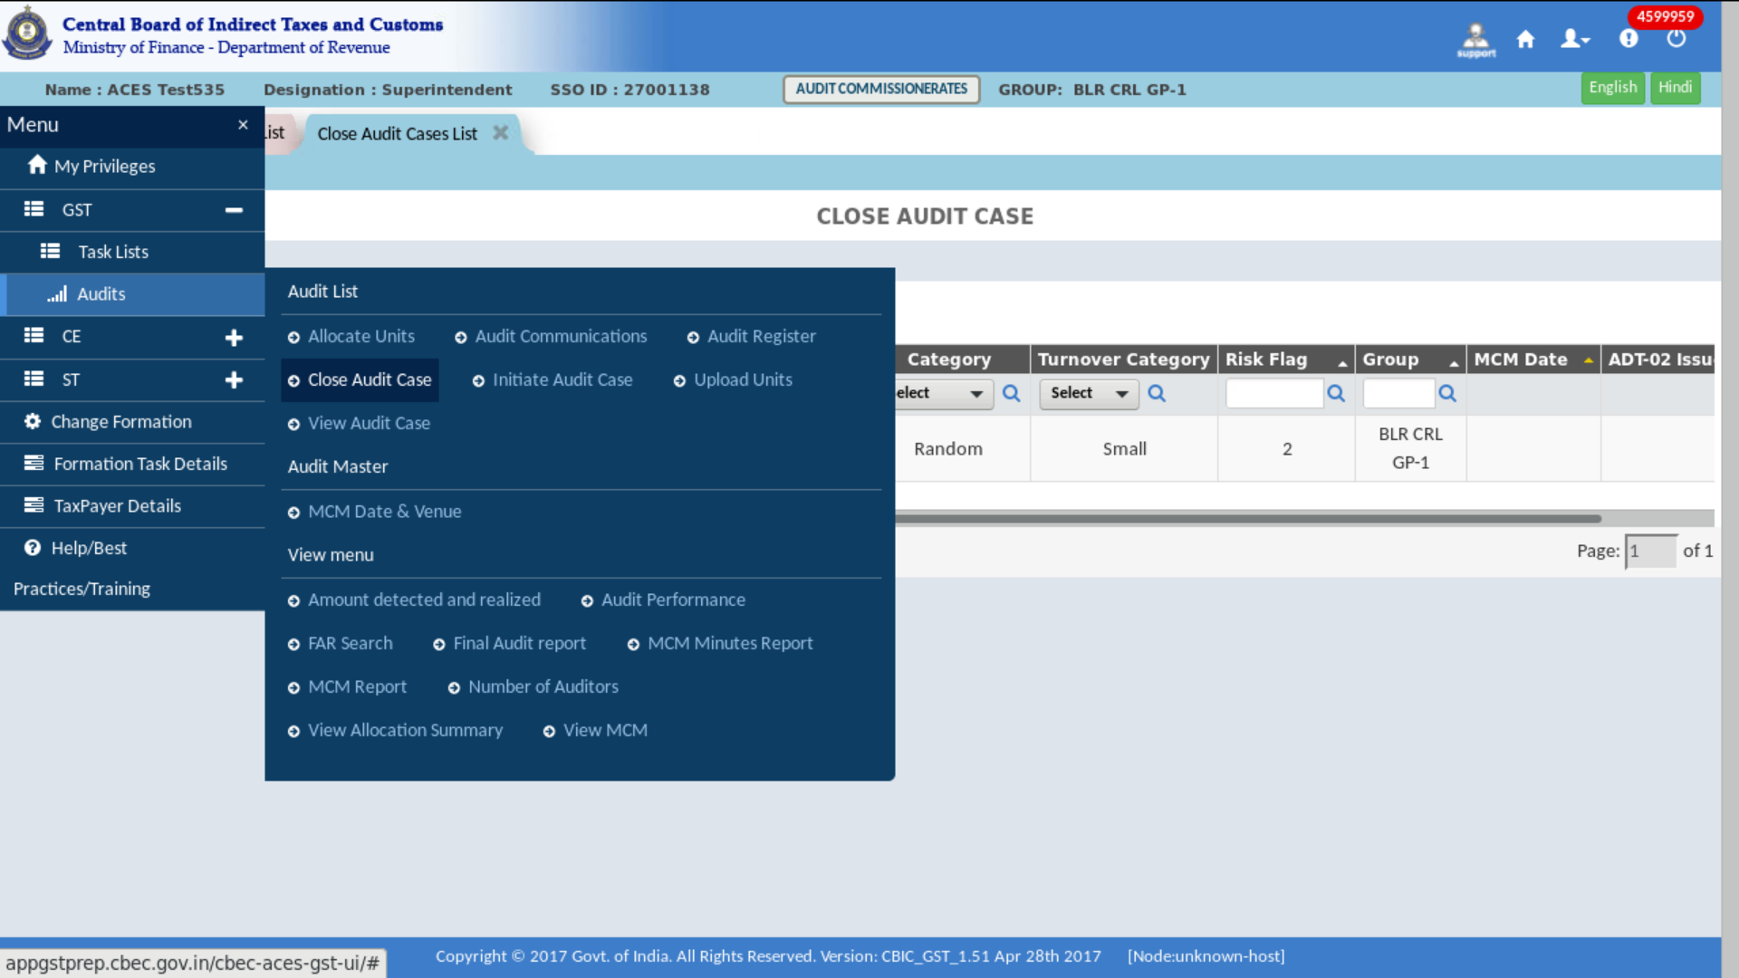
- Click on the “GSTIN” for close the audit file.
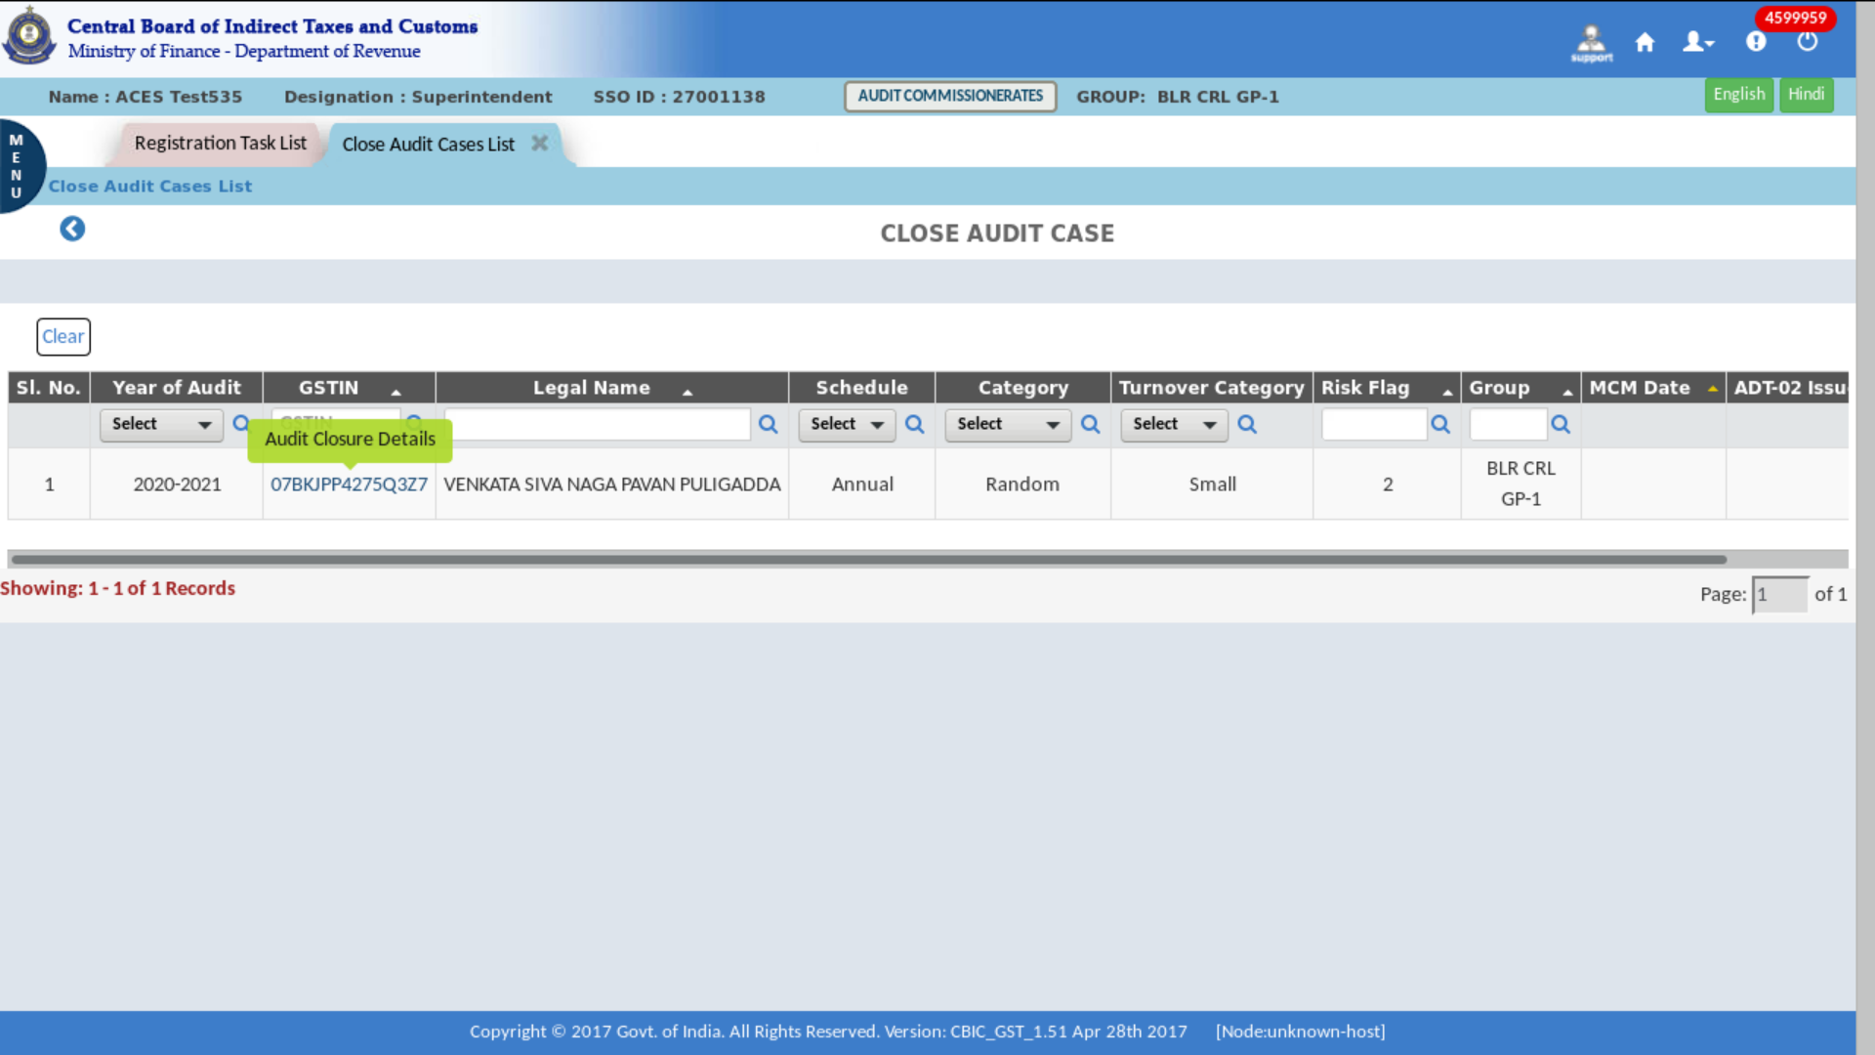
The Dashboard – Close Audit Case screen displays as shown Above

- Click on “Close Audit Case” button.
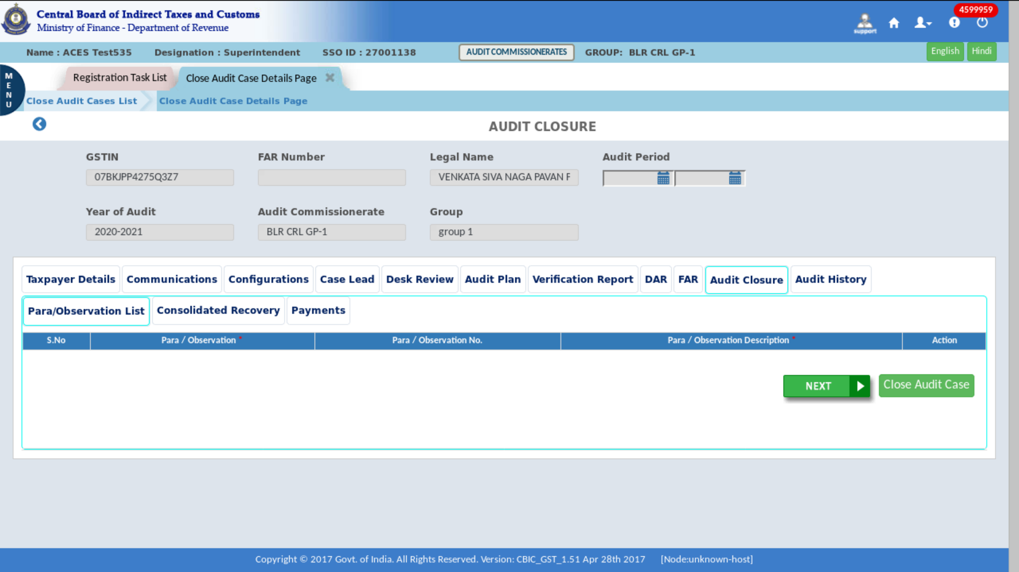
The Dashboard – Audit Closure screen displays as shown Above
Note: Following the selection of GSTN, the "Audit Closure" displays the Para Observation List, Consolidated Recovery, and Payments tabs. And the details are auto-populated for all the tabs.
- A Confirmation pop-up appears, click on “Close Audit Case” for confirmation.
- After submission, a Success Message appears on the screen.
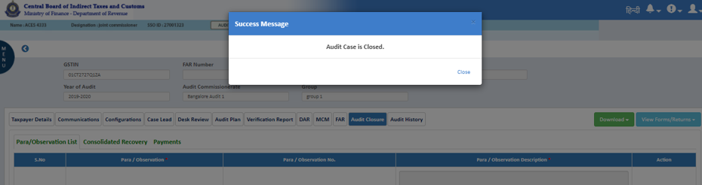

  - View Audit Case
Tax Officer can view the progress of the audit case created in CBIC GST System by Accessing Audit Menu View Audit Case
Using the same, tax officers can view the entire history of the audit case beginning from the creation of the audit case to the audit closure.
- Click on Menu > Audit > View Audit Case.
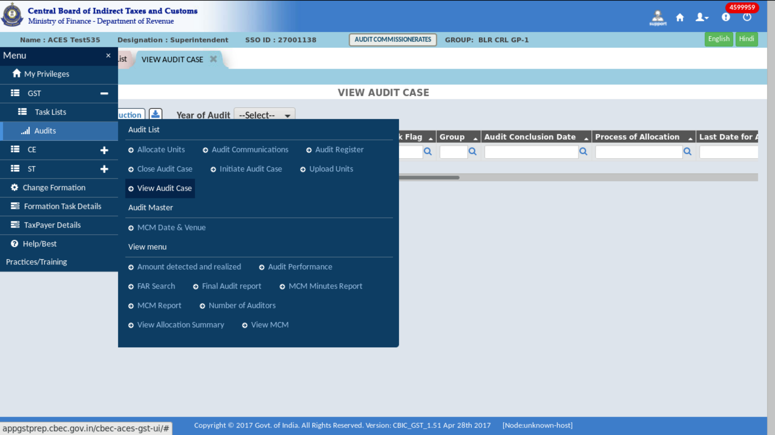
The Dashboard – View Audit Case screen displays as shown in the figure below.
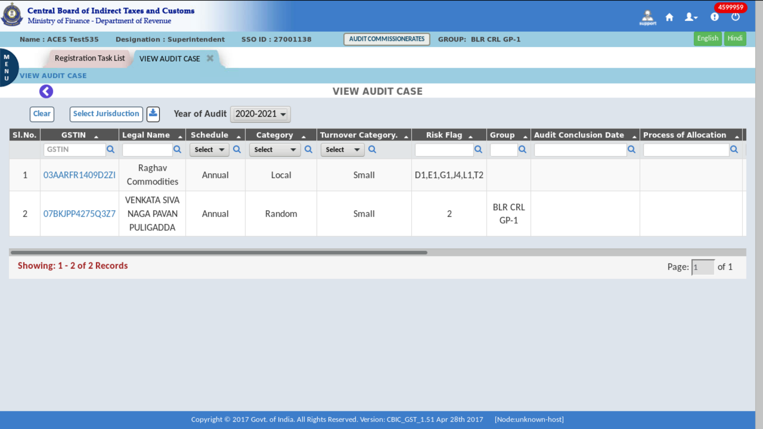
Note:
Once the audit case is created and audit case number is generated, then system will display all audit case on “View Audit Case” Menu.
This transaction will be permission based, so whoever given permission will be able to access and perform actions.

- Document Control Information
Document Version Control
Version | Date | Created By | Basis/Nature of Change(s)
1.0 | 25/03/2022 | Ravi Singh Gurjar | Initial Release – To have a Standard Operating Procedure
2.0 |  |  | Annual Review of Standard Operating Procedure; no updates required.
2.1 |  |  | Revision – As Requested

Document Review History [SME/Management]
Version | Date | Reviewer’s Name | Reviewer’s Title/Role
1.0 |  | [SME]
1.0
2.0 |  | [SME]
2.0

Document Approvals [CBIC]
Version | Date | Reviewer’s Name | Reviewer’s Title/Role
1.0 |  | [CBIC Reviewer]
2.0 |  | [CBIC Reviewer]

